Eco-Audit blurb for life cycle analysis.
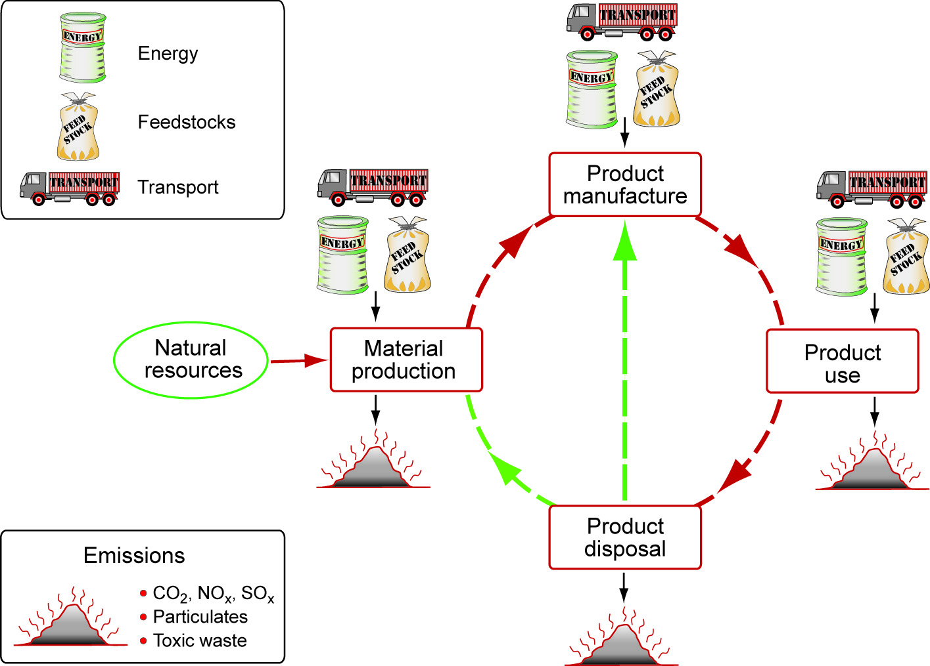
A life-cycle assessment documents resources consumed and emissions produced during each phase of life for a particular item. These phases include material production, product manufacture, product use, and product disposal. For the life cycle assessment (LSA) portion of our project we will be using the Eco-audit component available in the CES software. As the purpose of this assessment is to compare how each of the actuating materials performs in terms of environmental impact, to start off we will use a simplified version of the standard eco-audit tool. This will allow an initial decision to be made of which actuator is a higher performer environmentally, on which a full assessment can be performed.
For the purposes of initial selection, the simplified life cycle analysis will not take into account attributes that will be the same between the prototypes with the respective actuators, such as transportation of materials from the manufacturing facility to Austin or anything related to frame components. Rather, it will focus on resources needed and emissions produced for the manufacture, use and disposal of the actuators themselves.
Once we have selected which of the two actuators we will implement in our product, we will produce a more complete life cycle analysis for the entire blind unit. This selection will take Eco-audit results into account, along with several other factors. A more complete analysis will allow for a direct comparison between the amount of energy used throughout the lifetime of the blinds and the amount of energy spent on traditional air conditioning. This assessment will form the basis for the cost analysis portion of the project.

