Key Features: Chest Pain

- History: Given a patient with undefined chest pain, take an adequate history to make a specific diagnosis (e.g., determine risk factors, whether the pain is pleuritic or sharp, pressure, etc.).

History: OPQRST

- Onset
  - Acute onset with greatest intensity pain at onset = pneumothorax, PE or aortic dissection
  - Gradual onset = ischemic event or esophageal disease.
  - Vague onset = “Functional” or musculo-skeletal chest pain

- P1 - Provocation - Aggravating factors may include:
  - Post-prandial = GI or cardiac
  - Exertion = Ischemic
  - Swallowing = Esophageal
  - Respiration/Pleuritic pain = PE, pneumothorax, viral/idiopathic pleurisy, pneumonia or pleuropericarditis

- P2 - Palliation - Alleviating factors may include:
  - Antacids/Food = Likely GI
  - Sublingual nitroglycerin - NOT helpful in distinguishing ischemic vs. non-ischemic
  - GI cocktail (“Pink Lady/White Knight”) - NOT helpful in distinguishing
  - Rest = Ischemic
  - Sitting up/leaning forward = Pericarditis

- Quality
  - “Squeezing”/ “Tight” / “Pressure” = Ischemic
  - “Ripping”/ “Tearing” = Aortic dissection
  - Pleuritic = PE, pericarditis/myocarditis
  - Levine sign (fist over their sternum to describe pain) = ischemia

- Radiation
  - Ischemic = Neck, lower jaw, shoulder, teeth, throat, arms
  - Aortic dissection = between scapulae
  - Acute cholecystitis = R shoulder
  - Pericarditis = one or both trapezius ridges

- Severity
  - not a useful predictor of pathology, but use 0- 10 scale to determine if patient’s symptoms are worsening or improving.

- Timing/Duration
  - Lasting seconds or consistent over weeks = NOT ischemic
  - Years w/out progression = Functional
  - Minutes to hours = Possibly ischemia/infarction

Risk Factors for Coronary Artery Disease and Acute Coronary Syndrome
- Past medical history of CAD/stroke/MI
- Diabetes
- Hyperlipidemia
- HTN
- Smoking
- FHx (Positive family history is: first degree relative with MI, M<55, F<65)
- LVH
- Cocaine use
- Recent infection
- Recent chest trauma

Associated Symptoms of ACS:
- Diaphoresis
- N/V
- Shortness of breath
- Syncope
- Palpitations
- Psychiatric symptoms - Panic attacks, anxiety, depression, somatization

- Diagnosis & Treatment: Given a clinical scenario suggestive of life-threatening conditions (e.g., pulmonary embolism, tamponade, dissection, pneumothorax), begin timely treatment (before the diagnosis is confirmed, while doing an appropriate work-up).

- Pulmonary Embolism
- Clinical Features - Acute onset dyspnea, pleuritic chest pain, cough, hemoptysis, tachycardia, tachypnea, signs of DVT, orthopnea, jugular venous distention

- Acute Treatment -
  - Respiratory support: Supplemental oxygen +/- intubation and mechanical ventilation
  - Hemodynamic support: IV Fluids, Vasopressors
  - Anticoagulation: If no contra-indications start IV UFH or SC LMWH
  - Thrombolysis: If persistent hypotension despite adequate resuscitation

- Work-up -
  - Labs: CBC, ABG, Troponin, D-dimer
  - ECG (S1Q3T3)
  - CXR
  - Imaging: V/Q scan, Angiography, Spiral CT

- Tamponade
- Clinical Features - Beck’s Triad (Hypotension, Elevated JVP, Muffled Heart Sounds), Sinus tachycardia, Pulsus paradoxus, Pericardial rub.

- Acute Treatment - In the setting of hemodynamic instability a patient may require urgent removal of pericardial fluid by needle pericardiocentesis, open surgical drainage or video-assisted thoracoscopic pericardiectomy.

- Work-up -
  - ECG: sinus tachycardia w/ low voltages
  - CXR: enlarged cardiac silhouette
  - Echocardiography: 2D and Doppler can assess hemodynamic stability
  - CT: Not necessary if echo available

- Aortic Dissection
- Clinical Features - Acute onset “tearing” chest pain radiating to mid back between scapulae +/- syncope, pulse deficit.

- Acute Treatment -
  - Lower SBP to 100-120 mmHg: 1st line is IV beta blockers (propranolol, labetalol), 2nd line is IV nitroprusside, verapamil, or diltiazem.
  - Pain control w/ IV morphine
  - If hemodynamically unstable may require intubation

- Work-up -
  - ECG: Normal, non-specific ST changes, LVH/strain patterns w/ HTN, ischemic changes
  - CXR: widening of the aorta
  - CT/TEE/MRI

- Pneumothorax
- Clinical Features - Sudden onset dyspnea and pleuritic chest pain w/ decreased excursion of chest wall on affected side, diminished breath sounds, and hyper-resonant percussion. Hemodynamic compromise indicates possible tension pneumothorax requiring immediate decompression.

- Acute Treatment -
  - Supplemental oxygen
  - Needle Decompression
  - Chest tube insertion

- Work-up -
  - CXR: separation of visceral pleural line from parietal pleural line
  - CT: more sensitive than CXR
  - US: can be done at bedside in emergent situations

3. In a patient with unexplained chest pain, rule out ischemic heart disease.

Step 1: Hx and Physical

Step 2: If ACS suspected give ASA 162 mg PO chewed and swallowed, supplemental oxygen, SL Nitroglycerin 0.4 mg/spray q 5 min x 3 (as needed), and/or morphine IV to treat the pain. **This may precede Step 1 if strong suspicion of ACS.

Step 3: ECG, CXR, Cardiac blood work (CBC, Lytes, BUN, Creatinine, Troponin, Glucose)

Step 4: If the initial ECG is not diagnostic but the patient remains symptomatic and clinical suspicion for ACS remains high, the ECG should be repeated at least every 20-30 minutes.

Step 5: Repeat troponin 6 hours after first drawn.

** In a patient with no ECG changes and two consecutive negative serum troponins drawn at least 6 hours apart ACS can be ruled out.

4. Diagnosis and Investigation: Given an appropriate history of chest pain suggestive of herpes zoster infection, hiatal hernia, reflux, esophageal spasm, infections, or peptic ulcer disease:
a) Propose the diagnosis.
b) Do an appropriate work-up/follow-up to confirm the suspected diagnosis.

a. Herpes Zoster Infection
- history
  - previous primary infection with chickenpox
  - unilateral and dermatomal eruption typically occurring day 3-5 after pain and paresthesia of a dermatome begins (although symptoms may precede rash by weeks)
    - thoracic and lumbar dermatomes most common
  - rash begins as maculopapular but quickly progresses to vesicular (identical to lesions of chickenpox)
  - time course typically 2 weeks but may persist for a month
  - pain and paresthesia can last months to > 1 year with post-herpetic neuralgia
- risk factors
  - old age
  - immunosuppression
  - occasionally associated with dermatologic malignancy
- diagnosis
  - almost invariably clinical
- may need additional diagnostic information if
  - atypical rash in an immunocompromised host
  - possible disseminated disease in an immunosuppressed host without cutaneous lesions
    - methods include
      - viral culture
      - direct immunofluorescence testing
      - polymerase chain reaction assay (most sensitive)

b. Hiatal hernia
- types
  - 4 types but ~95% are type I (both stomach and LES herniate above diaphragm)
- history
  - majority are asymptomatic
  - symptoms of GERD
    - epigastric or substernal pain, postprandial fullness, substernal fullness, nausea, and retching; all usually 1-3 hrs post-prandial
    - relief with standing, water, antacids
- risk factors
  - previous diaphragmatic surgery
  - age (over 50)
  - weakening of myofascial structure
  - increased intraabdominal pressure (pregnancy, obesity)
- diagnosis
  - majority are found incidentally
  - when dx suspected
    - upper GI series or barium swallow
    - Esophagogastroduodenoscopy (EGD) with biospy
      - If worried about Barett’s/CA/Esophagitis
      - Document type and extent of tissue damage
c. Reflux
- history
  - waterbrash (sudden hypersalivation)
  - heartburn (retrosternal burning radiating to mouth)
  - non-specific chest pain
  - dysphagia (abnormal motility or esophagitis, reflux-induced stricture)
  - pharyngitis, laryngitis (with hoarseness)
  - respiratory (chronic cough, asthma, aspiration pneumonia, wheezing)
  - symptoms aggravated by
    - position (lying or bending)
    - increase in intra-abdominal pressure (pregnancy or lifting)
    - agents that decrease LES pressure (caffeine, fatty foods, alcohol, peppermint, cigarettes, nitrates, beta-adrenergic agonists, calcium channel blockers (CCB’s), theophylline, benzodiazepines, anticholinergics, morphine)
    - foods that delay gastric emptying (alcohol, coffee, chocolate)
- diagnosis
  - practical approach is to observe for resolution with PPI
  - 24-hour pH monitoring
    - Gold standard for determining if reflux is present
  - endoscopy
    - determines if reflux has damaged the esophagus
  - barium swallow
    - determines if stricture present
d. Esophageal spasm
- history
  - intense substernal pain increased by swallowing
  - decreased by NTG or CCB
  - diagnosis of exclusion when unexplained chest pain and dysphagia occur
- diagnosis
  - barium swallow
    - Corkscrew pattern/”rosary bead” esophagus
    - Tertiary waves
  - manometry
e. Infections (pneumonia)
- history
  - depends on infectious organism but generally speaking, includes some combination of
    - fever
    - dyspnea
    - cough
    - pleuritic chest pain
    - sputum production
- diagnosis
  - chest xray +/-
    - pulse ox, cbc, renal fn, blood cultures, sputum cultures, ABG if ill-appearing
    - sputum gram stain rarely changes therapy
    - consider CT scan or bronchoscopy if failing to respond to appropriate therapy
f. Peptic ulcer disease
- history
  - history not reliable in establishing diagnosis but duodenal ulcer is supposed to have 6 classical features:
    - epigastric location
    - burning
    - develops 1-3 hours after meals
    - relieved by eating and antacids
    - interrupts sleep
    - periodicity (tends to occur in clusters over weeks with subsequent periods of remission)
  - gastric ulcers have more atypical symptoms (always require biopsy to exclude malignancy)
    - may present with complications
      - bleeding 10% (especially severe if from gastroduodenal artery)
      - perforation 2% (usually anterior ulcers)
      - gastric outlet obstruction 2%
      - penetration (posterior) 2% - may also cause pancreatitis
- risk factors
- NSAID use
- smoking
- COPD, renal failure, cirrhosis

- diagnosis
  - consider H. Pylori testing first (present in approx 80% of gastric and 95% of duodenal ulcers)
  - upper GI series or EGD for definitive diagnosis

5. Hypothesis generation, diagnosis and treatment: Given a suspected diagnosis of pulmonary embolism:
a) Do not rule out the diagnosis solely on the basis of a test with low sensitivity and specificity.
b) Begin appropriate treatment immediately.

Pulmonary Embolism
- ALWAYS determine pretest probability of PE in patients with suspected diagnosis
- pretest probability can be subjectively determined by clinician (though accuracy requires clinical experience) or by using clinical score systems and decision rules (eg. Well’s criteria and Well’s modified criteria, PERC score) that incorporate symptoms, signs and risk factors to stratify patients into different categories of overall risk
- diagnostic tests
  - pulmonary angiography
    - “gold standard”
    - not commonly used anymore as invasive and has morbidity and mortality rate of 1 to 5%
  - D-dimer
    - sensitivity depends on type of assay but anywhere from ~85-96%
    - low specificity
    - most published research restricts use of D-dimer to patients with low pretest probability
    - positive d-dimer must be followed by confirmatory testing for PE (pulmonary angiography, CT-PA or V/Q scanning)
  - CT-PA (CT with pulmonary angiography, aka “spiral CT”)
    - sensitivity anywhere between 70-90%
    - specificity ~ 90%
    - has emerged in most centers as imaging test of choice for evaluation of PE (as it often detects alternative pulmonary abnormalities that explain patient’s symptoms)
  - V/Q scan
    - traditionally used as first imaging modality used in dx of PE
    - problem is that it is often inconclusive
    - may be useful in people who have an allergy to iodinated contrast or in pregnancy due to lower radiation exposure than CT, or in centers with no CT-PA
  - Do not use ECG or ABG alone in diagnosis of PE!
  - Deciding what test to use:
    - If you are in a CT-PA capable center:
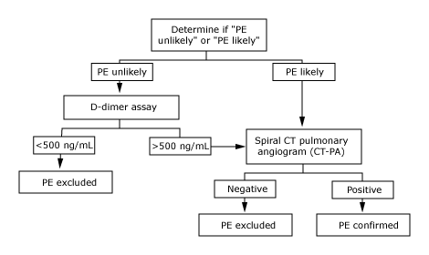

    - If you only have V/Q available:
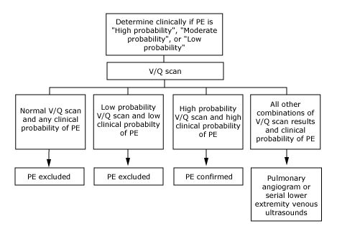
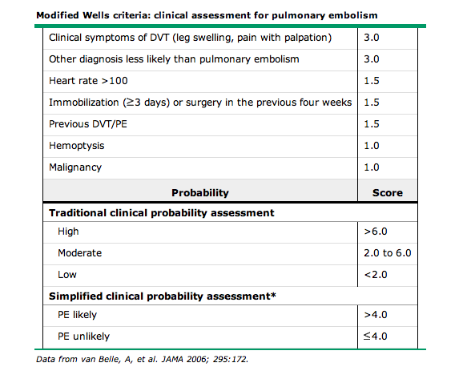

PERC rule: Should use first to determine if any further testing is warranted
Acute PE can probably be excluded without further diagnostic testing if the patient meets all PERC criteria AND there is a low clinical suspicion for PE, according to either the Wells criteria or a low gestalt probability determined by the clinician prior to diagnostic testing for PE.
- Age less than 50 years
- Heart rate less than 100 bpm
- Oxyhemoglobin saturation ≥95 percent
- No hemoptysis
- No estrogen use
- No prior DVT or PE
- No unilateral leg swelling
- No surgery or trauma requiring hospitalization within the past four weeks

