Assignment 1, Part 1

Regardless of the measure, there is inherent ambiguity in the practice of measuring and defining poverty. According to Amartya Sen, there are various approaches including the inequality approach, the value-judgement approach, and the biological approach, amongst others. For this assignment, I will mainly focus on the biological approach as it is hits on one of the keenest determinants of poverty: the individual experience of starvation. This approach is beneficial for several reasons. To begin, one of the least contentious statements regarding the poor is that they don’t have enough to eat. Starvation is a clear sign of deprivation. Furthermore, unlike other approaches which might focus on the aggregate well-begin of the population (e.g. GDP or GNP), starvation is not experienced by whole states and is thus a greater indicator of the individual’s experience with poverty, not the state’s overall development. Distinguishing between the two is paramount as some states will have overwhelming inequality which disguises the prevalence of poverty in measures such as GDP per capita. If one were to say, for example, that Canadians are rich, one would overlook many of Canada’s poor including some First Nations groups that live in squalid northern communities. This definition would not define poverty in any meaningful way. The measurement of poverty is best defined and understood when it focuses on the individuals who experience it.
That being said, how does one determine who is poor? Can you determine a universally acceptable income line under which any and all of the world’s poor must fall? Would all of the world’s people who are ‘not-poor’ find themselves above the line? According to the United Nations Development Programme, a poor person has an income of less than $1.25 PPP (purchasing power parity) per day. But is an exact numerical value meaningful? Is $1.25 not remarkably arbitrary? It can be argued that when measuring poverty, one must make room for subjectivity and imprecision given the ambiguous nature of the concept of poverty.
Furthermore, another difficulty with this approach is that income is not easily measured for many of the world’s poor. Although underdevelopment and poverty are not logical equivalents, they are closely linked. Underdeveloped, weak states will have poverty but will not be likely to have accurate income records. Aside from potential issues with the state’s ability and willingness to collect and present accurate information, another contributing factor will be the employment patterns of the poor, which do not lend themselves to easy recording. Many of the world’s poor do not have a single, reliable source of employment for their entire working lives. Some will have an array of jobs to insure themselves against risk. Many others will gain income from illicit and conspicuous sources which will not be accounted for in official records, if such records exist. As such, it can be more helpful to measure poverty, not in terms of income, but in terms of consumption, which can be measured in house-hold surveys. Such a measure would allow one to distinguish between expenditure on things like private health care, festivals, and food. Although an income below the $1.25 PPP poverty line undoubtedly demonstrates poverty, the biological approach to poverty is not fully understood from a strictly income-based approach.

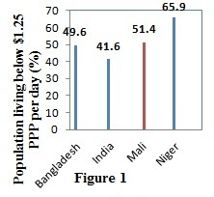
Part 2
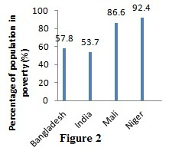
I have employed two measures to determine the percentage of a population in poverty using data from the United Nations Development Programme (UNDP) Human Development Index (HDI). The first, which is represented in figure 1, measures the percentage of the population below the poverty line ($1.25 per diem, purchasing power parity). I have supplemented this income-based approach with figure 2, measuring the percentage of the population in poverty (with a weighted deprivation score of 33%). This score is measured using surveys to determine household deprivations in areas such as eductaion, health, and living standards. Both measures demonstrate the same trend and indicate higher percentages of poverty in the two African states than the South-Asian states.
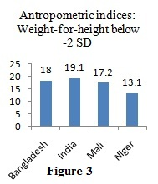
To measure undernourishment, I have demonstrated wasting in figure 3 and stunting in figure 4. Wasting, which demonstrates a weight-to-height ratio is a measure of the thinness of a child. This is a startling indicator of starvation as it represents a child that is literally wasting away. Wasting can also be a short-term indicator that is inflated in countries where there are frequent incidences of diarrehea amongst children; therefore, I have also included stunting which is a long-term indicator of chronic undernourishment. Stunting is a ratio of height-to-age below -2 standard deviations from the norm amongst healthy children. Children who are chronically undernourished will likely be stunted
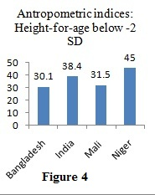
Surprisingly, there is an inverse relationship between the poverty measurements and wasting. India, which has the highest percentage of wasting children, has the smallest percentage of its population in poverty and Niger, with the lowest percentage of wasting children, has the highest percentage of population in poverty. Niger, however, has the highest percentage of stunting, which is what you might expect given its high percentage poverty. India, however, which is the country with the lowest percentage of its population in poverty, has the second highest percentage of stunting—higher than both Bangladesh and Mali where a greater proportion of the population of each state is in poverty. In this case, the causes of malnourishment in India cannot be fully understood using the UNDP’s weighted deprivation score or poverty line.

