[company logo here]
[company name here] |  |  |  | [city, state here] |  | [company url here] |  |  |  |  |  |  | Sustainability Report
[name] ∙ | [title] | ∙ ∙ [email address] ∙ | (###) ###-####
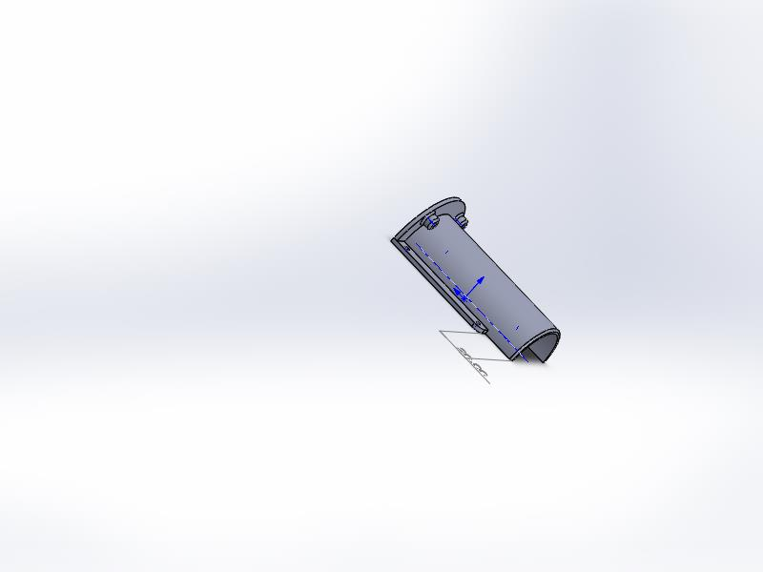 |  |  |  |  |  |  |  |  |  |  | Model Name: heater gaizi  Material: Acrylic (Medium-high impact)  Recycled content: 0.00 %  Weight: 23.15 g  Manufacturing process: Injection Molded  Surface Area: 16980.60 mm²  Built to last: 1.0 year  Duration of use: 1.0 year
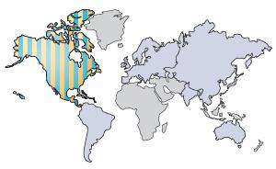 |  |  |  |  |  |  |  |  |  |  | Manufacturing Region  The choice of manufacturing region determines the energy sources and technologies used in the modeled material creation and manufacturing steps of the product’s life cycle.
Use Region
The use region is used to determine the energy sources consumed during the product’s use phase (if applicable) and the destination for the product at its end-of-life. Together with the manufacturing region, the use region is also used to estimate the environmental impacts associated with transporting the product from its manufacturing location to its use location.

Summary

Learn more about Life Cycle Assessment
 | Sustainability Report
 | Model Name: |  | heater gaizi |  | Material: |  | Acrylic (Medium-high impact) |  |  |  |  | Weight: |  | 23.15 g | Manufacturing process:
 |  |  |  |  |  |  |  |  |  |  |  | Surface Area: |  | 16980.60 mm² | Injection Molded
 |  |  |  |  | Recycled content: |  | 0.00 % |  |  |  |  | Built to last: |  | 1.0 year
 |  |  |  |  |  |  |  |  |  |  |  | Duration of use: |  | 1.0 year
Material | Acrylic (Medium-high impact) | 0.00 %
Material Unit Cost | 2.80 USD/kg

 | Manufacturing  Region: North America  Process: Injection Molded  Electricity consumption: 1.8E-3 kWh/lbs  Natural gas consumption: 0.00 BTU/lbs  Scrap rate: 2.0 %  Built to last: 1.0 year  Part is painted: No Paint |  |  |  |  |  |  |  | Use  Region: North America  Duration of use: 1.0 year
 | Transportation  Truck distance: 2600 km  Train distance: 0.00 km  Ship distance: 0.00 km  Airplane Distance: 0.00 km |  |  |  |  |  |  |  | End of Life  Recycled: 33 %  Incinerated: 13 %  Landfill: 54 %
 | Comments
 | Click here for alternative units such as ‘Miles Driven in a Car’
 | Sustainability Report
 | Model Name: |  | heater gaizi |  | Material: |  |  | Acrylic (Medium-high impact) |  |  |  | Weight: |  | 23.15 g | Manufacturing process:
 |  |  |  |  |  |  |  |  |  |  |  | Surface Area: |  | 16980.60 mm² | Injection Molded
 |  |  |  |  | Recycled content: |  |  | 0.00 % |  |  |  | Built to last: |  | 1.0 year
 |  |  |  |  |  |  |  |  |  |  |  | Duration of use: |  | 1.0 year
 | Environmental Impact (calculated using CML impact assessment methodology)
 | Carbon Footprint  Material: 0.047 kg CO₂e  Manufacturing: 0.034 kg CO₂e  Transportation: 2.9E-3 kg CO₂e  End of Life: 0.013 kg CO₂e  0.097 kg CO₂e |  |  |  |  |  |  |  | Total Energy Consumed  Material: 0.971 MJ  Manufacturing: 0.499 MJ  Transportation: 0.044 MJ  End of Life: 9.3E-3 MJ  1.5 MJ
 | Air Acidification  Material: 8.6E-5 kg SO₂e  Manufacturing: 2.3E-4 kg SO₂e  Transportation: 1.3E-5 kg SO₂e  End of Life: 6.5E-6 kg SO₂e  3.4E-4 kg SO₂e |  |  |  |  |  |  |  | Water Eutrophication  Material: 1.2E-5 kg PO₄e  Manufacturing: 8.5E-6 kg PO₄e  Transportation: 3.0E-6 kg PO₄e  End of Life: 1.6E-5 kg PO₄e  3.9E-5 kg PO₄e
 | Material Financial Impact 0.06 USD
 | Comments
 | Click here for alternative units such as ‘Miles Driven in a Car’

Sustainability Report
Baseline
Model Name: | heater gaizi
Material: | Polyether Polyol
Recycled content: | 0.00 %
Weight: | 20 g
Manufacturing process: | Injection Molded
Surface Area: | 16980.60 mm²
Built to last: | 1.0 year
Duration of use: | 1.0 year

Manufacturing Region
The choice of manufacturing region determines the energy sources and technologies used in the modeled material creation and manufacturing steps of the product’s life cycle.

Use Region
The use region is used to determine the energy sources consumed during the product’s use phase (if applicable) and the destination for the product at its end-of-life. Together with the manufacturing region, the use region is also used to estimate the environmental impacts associated with transporting the product from its manufacturing location to its use location.

Comments

Learn more about Life Cycle Assessment

Sustainability Report
Model Name:  BASELINE |  |  |  | heater gaizi |  |  | Material: |  | Polyether Polyol |  |  |  |  | Weight: | 20 g |  | Manufacturing process:
 |  |  |  |  |  |  |  |  |  |  |  |  |  | Surface Area: | 16980.60 mm² |  | Injection Molded
 |  |  |  |  |  |  | Recycled content: |  | 0.00 % |  |  |  |  | Built to last: | 1.0 year
 |  |  |  |  |  |  |  |  |  |  |  |  |  | Duration of use: | 1.0 year
Material | Polyether Polyol | 0.00 %
Material Unit Cost | Not Defined

Manufacturing  Region: North America  Process: Injection Molded  Electricity consumption: 1.8E-3 kWh/lbs  Natural gas consumption: 0.00 BTU/lbs  Scrap rate: 2.0 %  Built to last: 1.0 year  Part is painted: No Paint |  |  |  |  |  |  |  |  |  |  | Use  Region: North America  Duration of use: 1.0 year
Transportation  Truck distance: 2600 km  Train distance: 0.00 km  Ship distance: 0.00 km  Airplane Distance: 0.00 km |  |  |  |  |  |  |  |  |  |  | End of Life  Recycled: 33 %  Incinerated: 13 %  Landfill: 54 %
Comments

Click here for alternative units such as ‘Miles Driven in a Car’
 | Sustainability Report
 | Model Name:  BASELINE |  |  |  | heater gaizi |  |  | Material: |  | Polyether Polyol |  |  |  | Weight: | 20 g |  |  | Manufacturing process:
 |  |  |  |  |  |  |  |  |  |  |  |  |  | Surface Area: | 16980.60 mm² |  |  | Injection Molded
 |  |  |  |  |  |  |  | Recycled content: |  | 0.00 % |  |  |  | Built to last: | 1.0 year
 |  |  |  |  |  |  |  |  |  |  |  |  |  | Duration of use: | 1.0 year
 | Environmental Impact Comparison |  |  |  |  |  |  |  |  |  |  | New Design:  Better Worse |  |  |  | Original Design:  Baseline
 | Carbon Footprint - Comparison |  |  |  |  |  |  |  |  |  |  | Total Energy Consumed - Comparison
 | Total |  | Acrylic (Medium-high impact) : 0.097 kg CO₂e |  |  |  |  |  |  |  |  | Total | Acrylic (Medium-high impact) : 1.5 MJ
 |  |  | Polyether Polyol : 0.163 kg CO₂e |  |  |  |  |  |  |  |  |  | Polyether Polyol : 2.0 MJ
 | Air Acidification - Comparison |  |  |  |  |  |  |  |  |  |  | Water Eutrophication - Comparison
 | Total |  | Acrylic (Medium-high impact) : 3.4E-4 kg SO₂e |  |  |  |  |  |  |  |  | Total | Acrylic (Medium-high impact) : 3.9E-5 kg PO₄e
 |  |  | Polyether Polyol : 4.5E-4 kg SO₂e |  |  |  |  |  |  |  |  |  | Polyether Polyol : 9.2E-5 kg PO₄e
Material Financial Impact
Comparison

 | Comments
 | Click here for alternative units such as ‘Miles Driven in a Car’

Sustainability Report
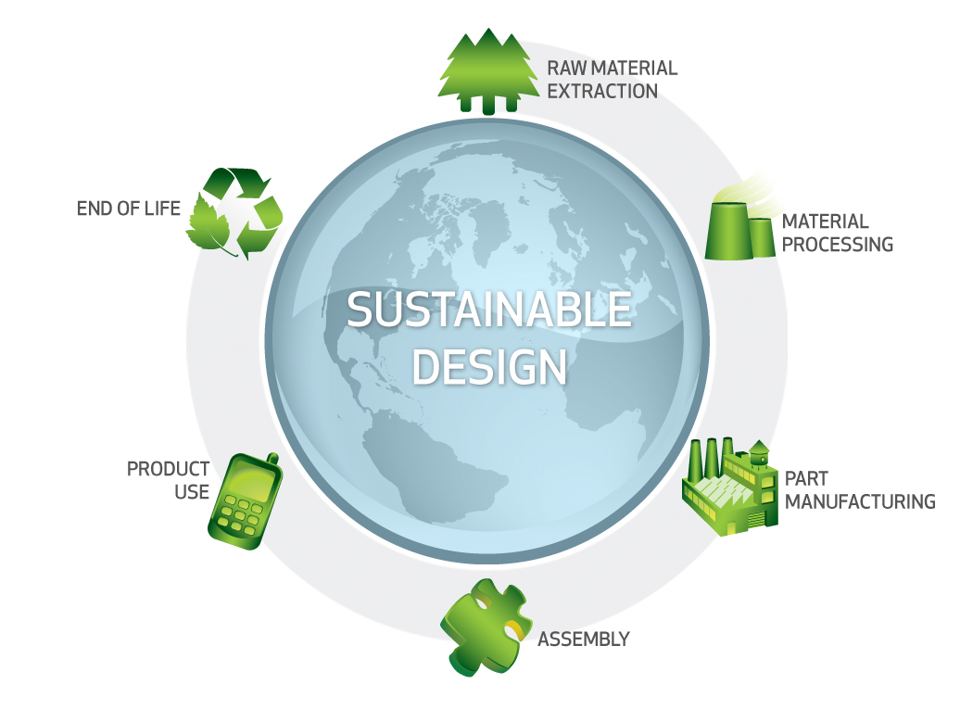

Sustainability Report
Glossary

Air Acidification - Sulfur dioxide, nitrous oxides other acidic emissions to air cause an increase in the acidity of rainwater, which in turn acidifies lakes and soil. These acids can make the land and water toxic for plants and aquatic life. Acid rain can also slowly dissolve manmade building materials such as concrete. This impact is typically measured in units of either kg sulfur dioxide equivalent (SO₂), or moles H+ equivalent.

Carbon Footprint - Carbon-dioxide and other gasses which result from the burning of fossil fuels accumulate in the atmosphere which in turn increases the earth’s average temperature. Carbon footprint acts as a proxy for the larger impact factor referred to as Global Warming Potential (GWP). Global warming is blamed for problems like loss of glaciers, extinction of species, and more extreme weather, among others.

Total Energy Consumed - A measure of the non-renewable energy sources associated with the part’s lifecycle in units of megajoules (MJ). This impact includes not only the electricity or fuels used during the product’s lifecycle, but also the upstream energy required to obtain and process these fuels, and the embodied energy of materials which would be released if burned. Total Energy Consumed is expressed as the net calorific value of energy demand from non-renewable resources (e.g. petroleum, natural gas, etc.). Efficiencies in energy conversion (e.g. power, heat, steam, etc.) are taken into account.

Water Eutrophication - When an over abundance of nutrients are added to a water ecosystem, eutrophication occurs. Nitrogen and phosphorous from waste water and agricultural fertilizers causes an overabundance of algae to bloom, which then depletes the water of oxygen and results in the death of both plant and animal life. This impact is typically measured in either kg phosphate equivalent (PO₄) or kg nitrogen (N) equivalent.

Life Cycle Assessment (LCA) - This is a method to quantitatively assess the environmental impact of a product throughout its entire lifecycle, from the procurement of the raw materials, through the production, distribution, use, disposal and recycling of that product.

Material Financial Impact - This is the financial impact associated with the material only. The mass of the model is multiplied by the financial impact unit
(units of currency/units of mass) to calculate the financial impact (in units of currency).

Learn more about Life Cycle Assessment

