Andy Wen
Sept.11th.2011
Summary of “Painting makes the difference” by Indra

Paint baking is a process of coating automobile metallic bodies with number of layers of paint, primer and top coat at elevated temperature and time. Usually, paint baking in automobile manufacturing involves 3 coat (primer surface, base coat, top coat) - 3 bake or 2 coat (primer surface, top coat) - 2 bake. Although the processes differ from manufacturer to manufacturer, paint-bake cycle in automobile manufacturing typically involves 7 stages: pre-cleaning, multistage phosphate pretreatment, electro-deposition coating, PVC underbody coating and sealing application, filler primer application and base and/or top coat application, and wax application (see Graph 1.1).
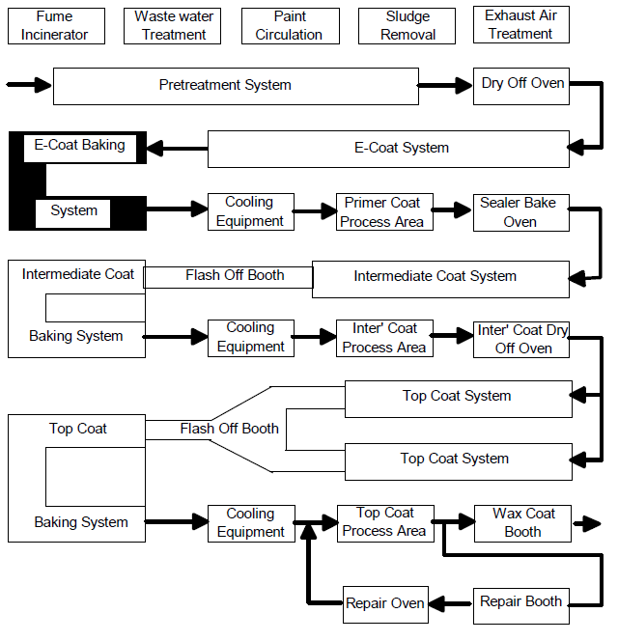
Graph 1.1: Process Flow Chart in a Typical Paint Shop

- Pre-cleaning
At this stage, dust, dirt and contaminants from previous processes on the body-in-white are removed to promote proper reactions and prolong the lifespan of degreasing baths of phosphate pretreatment stages. Pre-cleaning can be carried out by manual pre-cleaning with high pressure devices, brush cleaning with chemicals, or a combination of both methods.
- Multistage Phosphate Pretreatment
Phosphate pre-treatment is intended in good paint adhesion and metal surface protection against corrosion on all surfaces of the automobile bodies. The application of zinc phosphate is performed in number of stages. Before phosphating, all surfaces of the bodies are well rinsed and degreased to avoid contamination. The desired quality of phosphate coating texture, crystal size, morphology, and coating weight are controlled and manipulated by proper surface conditioning. The values of concentration in various solutions, temperature and duration of the treatment for respective zones are crucial to a phosphating operation. Between the stages, the bodies are sent to various rinsing zones to prevent the contamination of the solutions and rinsing tanks. Finally, a rinsing zone of fresh demineralized water is connected at the end of the pre-treatment line for metal passivation and neutralization. The general flow of the pre-treatment system is shown in Table 1.1:
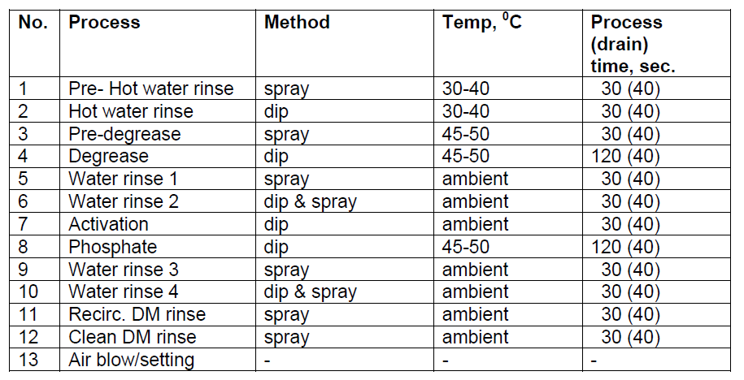
Table 1.1: Stages of Pretreatment System and Parameters

- Electro-deposition Coating:
Electro-deposition works similarly as eletrowinning processes. The metallic automobile parts are immersed into a paint bath that is prepared at a temperature of 25-27°C (pH-value of 5.6-6.6 and solid contents 16-20%) with deposition voltages between 350-500V. Consider the metallic parts as a negative electrode (Cathodic electro-deposition system). Because of the electrical forces generated between the electrodes, charged particles from the paint emulsion move towards the Cathode and deposited onto the body surfaces, forming an unfired but shaped “green” film. After coating reaches all surfaces of the automobile parts by several repeating deposition processes, the bodies are sent to a rinse zone to remove any paint particles that are still not electrically deposited. Finally, the electro-deposition coated parts are baked and cured at 165-180°C in an oven to set the paint and form a uniform, durable coat. The typical process sequence of electro-deposition system is as follows:
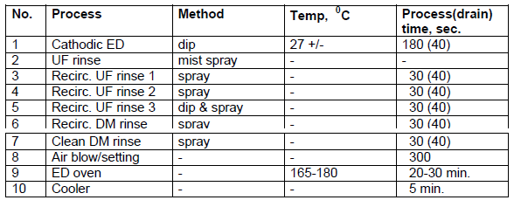
Table 1.2: Typical Process Sequence of Electro-deposition System

- PVC Underbody coating and Sealing Application:
This application is aimed to weld joints and areas that are liable to corrosion. The objectives are to increase impact and corrosion resistance. Implemented by programmed robots, sealants are applied and placed to gaps, cracks and seams within seconds and with an accuracy of less than 1 millimetre. Then, the parts are baked at approximately 160°C.

- Filler Primer Application and Base and/or Top Coat Application:
In the filler primer operation, the automobile bodies are coated with a filler primer layer that joins the electro-coat to the base and/or top coat. The purpose is to remove any contaminants from previous processes and smooth out any surface roughness in order for base and/or top coat to be applied properly. After the film is formed on all surfaces of the metallic parts, the bodies are moved to an oven at about 170°C for 30 minutes.
Top coat operation determines the visual appearance of the automobile vehicles. Depending on the manufacturer’s plan, the bodies can be either sent through a topcoat booth or a basecoat booth, followed by a topcoat booth. After the base and/or top coat applications, the automobile bodies are sent to an oven at around 160°C for 30 minutes.
- Wax Application:
This final application of the paint-bake cycle is used to protect the bodies from etching and scratch by applying a protective film of wax. The operation can be done by either manual spray method or automatic flooding method.
In manual spray method, the box sections and cavities are sprayed with a solvent that contains preservative wax with spray nozzles. In automatic flooding method, the bodies are first preheated to 50-80°C, and then hot wax with solvent free at about 120°C from a flooding tank is poured via automatic nozzles into box sections of the bodies.

**Reference
“Painting makes the difference.” Indra’s drishtikona (Viewpoint) 4 Aug. 2007. 11 Sept. 2011
<http://www.drishtikona.com/books/automobile-manufacturing/ch7.pdf>

