Shape Memory Materials
Shape memory materials are a special class of materials that are able to “memorize” a permanent shape, which can be temporarily altered and can then return to its original form upon heating (refer to fig.1). This property is derived from the ability of the material to store the elastic strain from temporary deformation, allowing it to retain a different shape. The stored elastic strain can then be released by the material upon heating which allows it to return to its original shape. This makes shape memory materials particularly interesting for use as an engineering material as it has the ability to exist in in 2 different states at different specified conditions.
Figure 1 – Shape memory materials have the ability to memorize shape.[1]

Due to the temperature sensitivity of shape memory materials, they have various applications ranging from the small scale applications (such as stents in the medical industry) to the large scale applications (such as various components in the aerospace industry). The use of shape memory materials in adaptive architecture does fall in this range of applications from a design point of view. In our project one of the goals is to incorporate temperature regulation in a building by using self-regulating blinds. The use of shape memory materials would be controlled by solar radiation, which would control the amount of radiation penetrating a building hence creating self-regulation. However further investigation would be required to determine the practicality of using shape memory materials in this kind of an application.

How do shape memory materials work?
There are several types of shape memory materials available for use, however for this project the main focus is around shape memory alloys and more specifically nitinol (this will be explained later on in the section). Nitinol is composed largely of Nickel and Titanium and depending on the application the amount of Nickel and Titanium varies; generally the amount of nickel is around 55% with the balance being composed of titanium and minute amounts of other elements such as carbon, oxygen and hydrogen[2].
As mentioned above shape memory materials have the ability to store elastic strain from temporary deformation, which can be released upon on heating. For shape memory alloys (SMAs) this is achieved through phase changes in the material, namely phase changes between the martensitic phase and the austenitic phase. In order for a phase change to occur, the SMA has to be heated or cooled past a threshold temperature known as the activation temperature (refer to fig. 2).

Figure 2 – Diagrams illustrating phase changes in SMAs.[3]

Initially the material needs to be set to a required shape; this is achieved by shaping the desired form of the material and then placing it at high temperatures for moderate periods of time. In order to shape nitinol, it needs to be formed and placed in a furnace at around 500°C for around 5 minutes [4]. This may also vary depending on other factors such as if high current sources were being used to heat the material for shape setting[5].
Once the shape has been set it is allowed to cool. This allows for the microstructure to adjust to the new shape being set. Once cool the martensitic phase exists stably. The cycle of deforming and reforming the material from the stable martensitic phase can then be explained by referring to fig. 2.
Once in the stable martensitic phase mechanical forces can be applied to the shape causing the material to temporarily deform, resulting in a deformed martensitic structure. Once heat is applied to the material and the temperature is sufficiently high (i.e. the temperature is greater than or equal to the required temperature to initiate the growth of the austenitic phase) the phase transforms and the crystal structure changes as well such that the elastic strain stored in the material is released allowing the material to revert its original shape. When heating is terminated and cooling initiated (below the temperature required to stop the growth of the martensitic phase) the martensitic phase begins to grow, however the material retains the shape of what it was in the austenitic phase. It is the solid state diffusion less growth of the martensitic phase from the original austenitic phase that allows for a shape memory alloy to be deformed and reformed through several cycles [6], in essence giving it the ability to memorize shapes.

Implementing shape memory materials in our design
As mentioned in earlier one of the goals of this project is to create a self-regulating blind and one of the ways to implement this is the use of SMAs, due to their temperature sensitivity.
Figure 3 – Proposed idea of blind actuation [7].

In our design the proposed concept is a small amount of shape memory alloy that will be used as a hinge, in a “box” like structure. The idea behind the blind is that a series of these boxes will be connected and the self-regulating part of the blind will be that the boxes can collapse. The collapsing of the blinds is controlled by the SMAs (refer to fig. 3). When the sun is shining and the air temperature is quite high the SMAs would change shape, causing the series of boxes to expand blocking sunlight from entering a building. Once cool the blinds can then be collapsed. The movement of the blinds based solely on solar radiation is what fulfills the criteria of self-regulation.
As mentioned in the previous section SMAs have the ability to store elastic strain from temporary deformation, which can be released upon heating; this involves a phase change from deformed martensite to austenite. In doing so the force that was stored in the material to deform it initially is then exerted by the material when the phase change occurs; this allows the material to return to its original shape. This is a vital property that can be exploited to enable the blind to be self-regulating. The force exerted during a phase change is what will allow the blind to stay expanded so that when the air temperature is high the solar radiation is blocked from entering the building (refer to fig 4.).
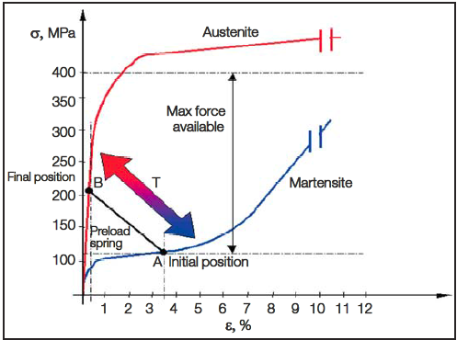
Figure 4 – How SMAs in our design will function[8]

The stress-strain curves for the austenitic and martensitic phases are shown in fig. 4. In the austenite phase the force required to cause a deformation is much greater than in the martensitic phase. Once cooled to the martensitic phase the force required to deform the material to the initial shape is comparatively much less.
This means that when the blind expands to block sunlight, it will do so for as long as the temperature is above that required to maintain a stable austenite phase; and due to the stability of the austenite phase sunlight will be blocked as a great deal of force is required to deform the material. Once the temperature is cool enough for the martensite phase to exist stably the blinds can be collapsed much more easily as the force required would be far less to deform martensite.
Challenge associated with recovery of SMA to original shape – {What TED talks about} – {Not sure if I should introduce it here}
Other considerations when using shape memory alloys in our design
For our design the use of nitinol was chosen as material of choice for self-regulating blinds. While there are several types of shape memory materials available for use the use of nitinol was based on certain properties that are explained in this section of the report.
One of the criteria for the SMA in the blind design is the ability for it to be used cycled over several times. Nitinol has the ability to remain stable when used through several cycles. For the temperature range that we require (confirm this with Ted) the most applicable SMAs are in the nitinol or the copper based SMA. Comparatively, while the copper based SMA does have a cost based advantage, they have been found to be more brittle and less stable[9].
For an SMA such as nitinol, there is an important aspect of the material to consider known as hysteresis. The change in phase from austenite to martensite and the reverse of that process do not occur at the same temperature. The cycle is characterized by the start and end of the formation of the martensitic phase (respectively M_{S} and M_{f}) and the start and end of the formation of the austenitic phase (respectively A_{S} and A_{f})[10].
Figure 5 – Diagram depicting hysteresis loop in SMA[11]. The decrease in the amount of martensite is balanced out by the increase in the amount of the austenite. A complete phase change would entail a complete change form martensite to austenite.

For an SMA the hysteresis loop is critical as it dictates the temperature range at which the SMA can be operated. Typically a hysteresis range for nitinol (as it is predominantly nickel and titanium) is around 25°C to 40°C, with a temperature range of between 0°C and a 100°C[12]. The temperature range where a transformation can occur can also change depending on the application.
For this project nitinol was chosen as the hysteresis range can be tweaked to ensure that the a phase change occurs in a certain range. A small hysteresis range is needed to ensure that the blind can actuate so that. This is accomplished by the addition of elements such as copper in the SMA as well as adjusting the ratio of nickel and titanium[13]. However as mentioned before the use of copper does cause some brittling to occur hence any changes to the microstructure have to be carefully studied to ensure the material is still compatible with the overall design of the blind.
Also the use of nitinol was chosen on the basis for the fact that it had a high strength to actuation ratio. In simpler terms it meant that the nitinol has a high strength to be able to withstand larger forces. This especially important as the blind needs to be able to support its own weight when expanded. Ideally when the blind is expanded it should change phase to the austenite phase as this is the strongest phase of the nitinol (refer to fig 6).
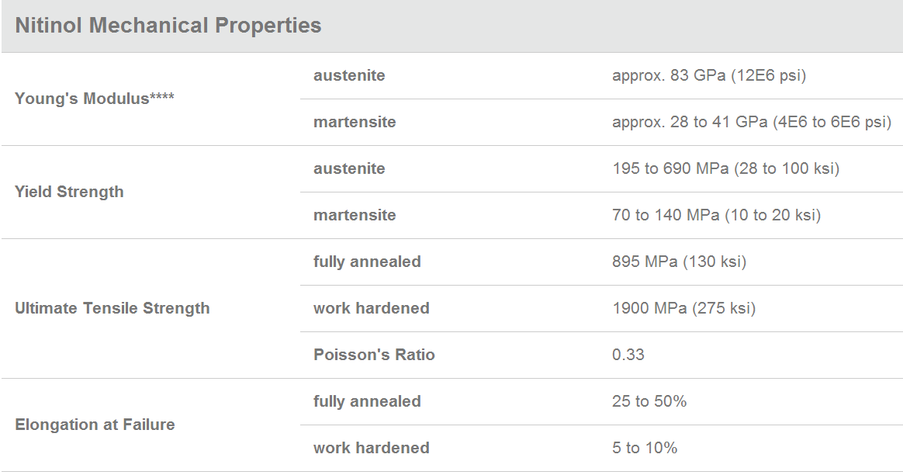
Figure 6 – Mechanical properties of Nitinol [14]

Aside from the actuation force to weight ratio there other mechanical properties which make it suitable for our design such as a high elongation to failure as well a high ultimate tensile strength. Combined these properties do provide evidence to show that nitinol is able to handle the mechanical forces. However the figures are for nitinol (Ni-Ti), if there are changes such as the addition of copper these would alter these values.
Considerations for final report
Aside from the reasons explained choosing to use nitinol, some of the other design considerations that have to be accounted for are those such as:
- Failure mechanisms such as fatigue or creep – The blinds need to have a long service life and due to the mechanism by which they operate they must not fail after short period of time via fatigue or creep.
- Corrosion resistance: The SMA in the blinds need to have fairly good corrosion resistance as they are going to be exposed to the weather elements such as moisture and heat. In order for the blinds to be safe (i.e. not corrode and fail), they need to have good corrosion resistance.
- The design of the blinds is such that they are a series of collapsing squares. The design of SMA will need to be considered. For example will the load bearing sections of the blinds require larger SMA hinges or is it possible to choose a material which can satisfy the weight requirements such that a standard SMA hinge can be used throughout the blind?

References
- Images obtained from: Grand Illusions. (2012). 'Hot' Wire - or Nitinol Wire [Web]. Retrieved from http://www.youtube.com/watch?v=Iz9Ht0ekU8I
- Fort Wayne Metals. (2013). Nitinol wire. Retrieved from http://www.fwmetals.com/nitinol-wire.php
- [Need to get source from Ted – Image was obtained from midterm presentation]
- Johnson Matthey Medical Components. (2013). Making Memory Shape Springs Retrieved from http://jmmedical.com/resources/261/Making-Shape-Memory-Springs.html
- Case, L., Kreiner, Z., Redmond , J., & Trease, B. (2004). Shape memory alloy; shape training tutorial. Retrieved from http://www-personal.umich.edu/~btrease/share/SMA-Shape-Training-Tutorial.pdf
- (2012). Retrieved from http://smart.tamu.edu/overview/smaintro/detailed/detailed.html
- From Chad’s presentation – not sure how to cite
- [Need to get source from Ted – Image was obtained from midterm presentation]
- Stoeckel. (1995). The shape memory effect ‐ phenomenon, alloys and applications . Retrieved from http://www.nitinol.com/media/reference-library/038.pdf
- Stoeckel. (1995). The shape memory effect ‐ phenomenon, alloys and applications . Retrieved from http://www.nitinol.com/media/reference-library/038.pdf
- Stoeckel. (1995). The shape memory effect ‐ phenomenon, alloys and applications . Retrieved from http://www.nitinol.com/media/reference-library/038.pdf
- Stoeckel. (1995). The shape memory effect ‐ phenomenon, alloys and applications . Retrieved from http://www.nitinol.com/media/reference-library/038.pdf
- Stoeckel. (1995). The shape memory effect ‐ phenomenon, alloys and applications . Retrieved from http://www.nitinol.com/media/reference-library/038.pdf
- Johnson Matthey Medical Components.(2013). Nitinol Technical Properties. Retrieved from http://jmmedical.com/resources/221/Nitinol-Technical-Properties.html

