Exploring Learning Resources
Time and Place at UBC: Our Histories and Relations

Students coming to UBC may have different understandings of the history of this place. Time and Place at UBC is a resource that reveals different layers of history by representing key events in Canada and BC’s history in parallel with significant moments in UBC’s institutional history and the university’s changing relationship with Indigenous students and communities. Not only does this help to make visible ongoing Indigenous presence at UBC, but it also helps us visualize and locate ourselves in relationship to these different histories and communities.

You will spend about 30 min individually exploring some aspects of this resource, focusing an activity that highlights some key events and your own relationship to them as a member of the UBC community. In the workshop you will have the opportunity to discuss and share what you have learned reflecting on ways that this resource and the issues it surfaces can be brought into your course design and teaching.

Individual activity (To be completed prior to the workshop):
PREVIEW: ( 10 minutes)
- Spend a few minutes previewing the activity “Our Time and Place at UBC”
- Go to http://timeandplace.ubc.ca/, and read “What is the Timeline?” and “Before you begin
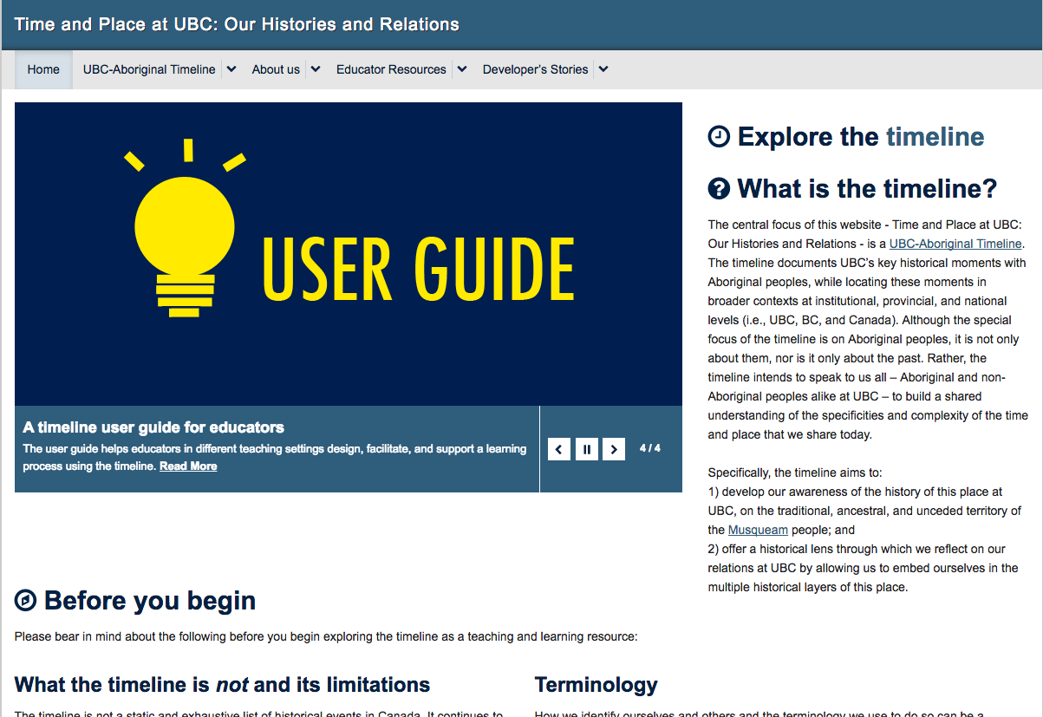

WATCH: (10 minutes)
- Watch Elder Larry Grant’s welcome and Dr. Linc Kesler’s explanation of “Why We Acknowledge Musqueam Territory” videos on the UBC Aboriginal Portal: http://aboriginal.ubc.ca/community-youth/musqueam-and-ubc/

READ AND REFLECT: (10 minutes)
- Read over the event pairings and reflection questions on the “Our Time and Place at UBC” resource (pdf).

Group activity (To be done in the workshop):

DISCUSS AND EXPLORE
- Choose a few of the event pairings and use the reflection questions to discuss in your small group.
  - What did you learn from this resource?
  - How might you adapt these materials for use in your own course, discipline or project? How might these materials be useful to others designing courses or learning resources?
- Discuss the videos and how they might complement learning when using a resource like Time and Place, or in framing your course or other content you would like to introduce.
- If time permits, explore the timeline and other learning resources on the Time and Place website with your group.
  - What timeline events or learning activities might you find useful for exploring in your own courses?
  - The developers of this site are currently working with the Musqueam First Nation to add a row of Musqueam historical events and educator resources to this website. What would you like to learn from this additional timeline row or associated learning materials? How would you imagine applying those materials to your own courses and projects?

RECORD
Notes from your discussion to report back

