In order to select design options that are suitable for the use of shape memory material in adaptive blinds, two main criterions need to be satisfied. First, the shape memory material needs to provide adequate actuation force. Second, it needs to deform back to the original shape before actuation for successful repeatability of the process.
Two classes of shape memory materials exist, shape memory polymers (SMP) and shape memory alloys (SMA). The main advantage of SMP over SMA is its much cheaper cost. SMP costs less than $10 per pound while SMA costs approximately $250 per pound (Liu, Qin, & Mather, 2007). However, the actuation force of SMP is in the range of 1-3MPa, which is roughly 100 times less than SMA with a range of 150-300MPa (Liu, Qin, & Mather, 2007). Therefore, it may be difficult for SMP to produce adequate force to actuate the adaptive blinds.
The maximum weight of each adaptive blind will be approximately 100g, which is within the capability of commercially available SMA (Dynalloy, Inc, 2012).
The specific shape memory alloy of interest is Ni-Ti alloy (Nitinol) due to its commercial availability and desirable transition temperatures between -100°C and 100°C (Stoeckel, 1995). Copper based SMA is available as well but will not be pursued since it is more brittle and less stable compared to Ni-Ti alloys (Stoeckel, 1995).
The energy source to activate actuation of the SMA can come from resistive heating of the SMA or resistive heating of an element that is in contact with the SMA (Paik, 2010). However, the use of only sunlight to heat the SMA will also be explored since it offers the possibility of zero energy consumption compared to resistive heating. The feasibility of using the sun for heating will be assessed by calculating the temperature rise in the SMA when exposed to sunlight in Austin, Texas and determining if it is higher than the activation temperature. Resistive heating of the SMA itself can be a more reliable way to reach the activation temperature, but the energy requirement is high for Nitinol due to its relatively low electrical resistivity of 90x10⁻⁹ Ω m compared to a more resistive metal like Ni–Cr which has an electrical resistivity of 1500x10⁻⁹ Ω m (Paik, 2010). Therefore, with Paik’s method of using Ni–Cr coil as a heating element in contact with Nitinol, energy efficiency of the actuator can be improved (Paik, 2010).
Once it activates and cools down, returning the SMA to its original shape requires a reset force from springs, opposing SMA actuators, or simply with gravity. As shown by Stoeckel in Figure 1a, the weight of the object that the SMA is actuating can be enough to exert the required reset force (Stoeckel, 1995). As well, Figure 1b shows how a spring can be used to store some of the energy exerted by the SMA during actuation to reset the SMA. Figure 1c shows how SMA actuators can also be used to reset other actuators when one is activated while the other one is not. Figure 2 shows how each reset principal can be applied to the blind design with the SMA actuators in red and blue corresponding respectively to activated and non-activated states. Since the force from springs and gravity will always keep resetting the blind to an open state unless the SMA actuators are activated, a constant power source would be required to keep the blind closed. In our design, shape resetting with opposing SMA actuators only require power while opening or closing the blind and thus have lower electrical energy use over gravity or springs. However, using multiple SMA actuators will result in increased cost.
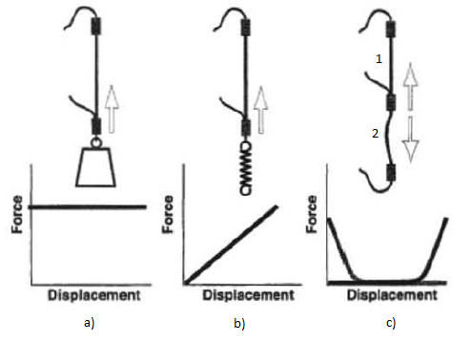
Figure 1 - Three Types of Reset Forces for SMA
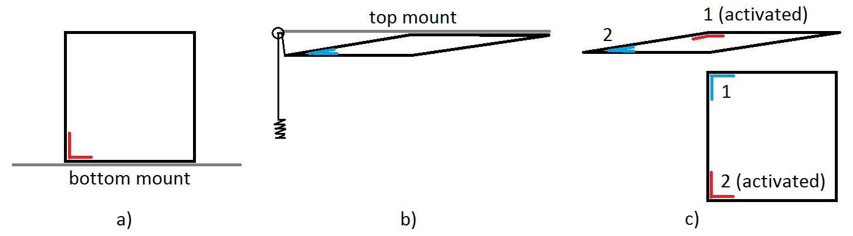
Figure 2 - Three Types of Reset Forces Applied to Blind Design
Ideally, a design that utilizes sunlight as the sole energy source for actuation of Nitinol is used since it can achieve autonomous operation without using other sources of energy. If this design is not feasible, then an alternative design using resistive heating can be used in conjunction with a light sensing controller. This option is more likely to work, but involves more components.

Bibliography
Dynalloy, Inc. (2012). FLEXINOL® Actuator Wire Technical and Design Data . Retrieved October 13, 2013, from Dynalloy: http://www.dynalloy.com/TechDataWire.php
Liu, C., Qin, H., & Mather, P. T. (2007). Review of progress in shape-memory polymers. Journal of Materials Chemistry, 1543-1558.
Paik, J. K. (2010). A novel low-profile shape memory alloy. SMART MATERIALS AND STRUCTURES, 1-9.
Stoeckel, D. (1995). Shape Memory Alloys for Power Systems EPRI. The Shape Memory Effect ‐ Phenomenon, Alloys and Applications (pp. 1-13). Fremont, CA: Nitinol Devices & Components, Inc.

