Assignment 2: Community Analysis and Report
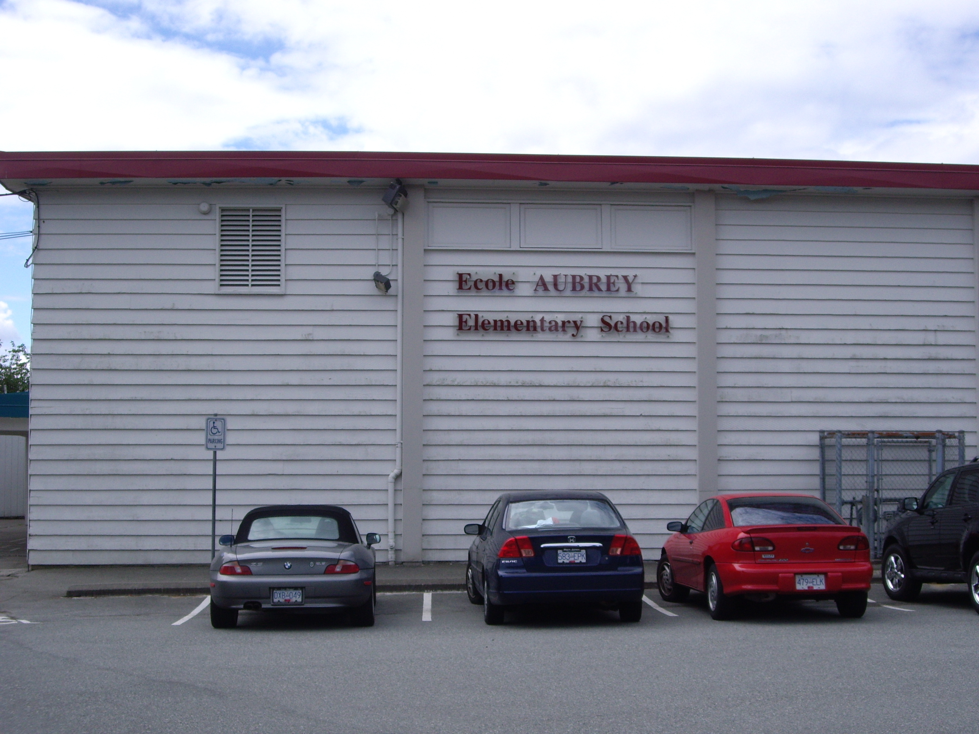
I. Where is École Aubrey?
École Aubrey Elementary School is one of 41 elementary schools located in the Burnaby School District (district # 41). Aubrey School is located within the early French Immersion catchment zone that extends from Boundary Road to Sperling Avenue. Aubrey’s English catchment boundary extends from Springer Avenue to Sperling Avenue. Aubrey School is one of eight elementary schools in the Burnaby School District that offers early French Immersion as an option. It is a dual-track school, meaning that there are French and English classes co-existing within the same school. École Aubrey is located at 1075 Stratford Avenue, just off of Curtis Road. Buses are readily available (1 block away) and the Holdom skytrain station is approximately 10 minutes by foot down the road towards Lougheed Highway. Kensington Arena and Burnaby North Secondary School are within moments from Aubrey School.
Details about the School Community:
Student enrolment at École Aubrey just reached 400 this year in June, although that could increase or decrease in the coming school year. While the school is mainly surrounded by single family homes, many students commute via the bus or automobile as the French Immersion catchment zone is extensive (Boundary Road to Sperling). I have even known some students to commute as far away as Port Coquitlam and New Westminster.
The School Trustee liaison for the school is Baljinder Narang. The school’s principal was Claudio Bortolussi this year; however, the community will be receiving a new principal in the coming school year (Shelley Parks). The school’s mission statement states: “At Aubrey School, students are encouraged to work toward their full potential in an environment that fosters dignity, respect and a pursuit of excellence.”
The school has a thoughtful and well developed code of conduct. For further details, access http://aubrey.sd41.bc.ca/codeConduct.htm.
The school fosters a sense of community with its motto: T.E.A.M which stands for “Together, Everyone Accomplishes More”. Aubrey’s school growth plan is focused on three main areas: reading comprehension, student self-assessment and healthy living. The school’s growth plan is published at http://aubrey.sd41.bc.ca/documents/growthPlan.pdf..

Aubrey has 22 teaching staff members (including a music teacher, resource team, teacher-librarian and head teacher). There are 17 divisions of students: 11 French classes and 6 English classes. The student body is multi-cultural and diverse in its socio-economical status.

On the FSA tests (Foundation Skills Assessment) for 2011, Aubrey School scored a rating of 5.8 out of a possible 10. In terms of performance for the 2009-2010 year, it ranked at number 449 out of 875 schools. In previous years, Aubrey has ranked higher at 262 out of 751 schools. The specific results for 2010 can be found at:
http://britishcolumbia.compareschoolrankings.org/elementary/Aubrey_Elementary/Burnaby/Report_Card.aspx#

Aubrey School offers a wide-range of extra-curricular opportunities to keep students involved. These include athletic programs (volleyball, basketball, cross-country and track and field), clubs (leadership), music programs (band and choir) and annual student competitions.

Overall, it is an exceptional place to learn.

DETAILS ABOUT THE SCHOOL DISTRICT:
Burnaby School District has 41 elementary schools (including seven community schools) and eight secondary schools. French Immersion is one of the numerous specialized programs offered by the district. Burnaby also has hockey schools, schools focused on the arts and on-line and international programs. The number of employees has reached in excess of 4000 to serve the more than 25,000 students (Kindergarten through Grade 12) within the school district. The average age of a male teacher in the district is 42 and the average age of a female is 43. The majority of the population of teachers fell into the age ranges of 35-39 and 40-44. The average age of an administrator in the district is 51 for females and 46 for males. The majority of the population of administrators falls into the age ranges of 45-49 and 50-54. The average number of years of experience for an administrator in the Burnaby District is 20 years while the average number of years of experience for a teacher is close to 12.

Looking at more specific data on the district, it was interesting to see that in the 2010/2011 year, there were 25,655 students in Burnaby district. Of those students, 12,553 were female and 13,102 were male. Additionally, 863 were of Aboriginal descent and 4,825 were enrolled in ESL programs. Finally, 1,905 were enrolled in French Immersion (making up only 7.4% of the population of students) and 654 were reported as non-residents.
When considering students with special needs, 152 were reported as having a visual impairment or as being deaf or hard of hearing. Additionally, 480 were reported as having a designated learning disability or “Q” designation. Additionally, there were 564 students reported this year with a behaviour designation and 337 were designated as gifted. Finally, there were 608 other students accounted for under “other special needs”.

II. The Burnaby Community:

a). Geography:
Burnaby is an extensive city that spans 98.6 square kilometres. It is located between Vancouver, bordering it on the west, and Coquitlam and New Westminster on the east. Included within the region are various geographical features that make it a unique and rather green urban environment considering its mounting population - lakes, farms, beaches, streams and mountains make Burnaby an impressive urban centre. The mayor, Derek Corrigan, states that almost one quarter of the land continues to be dedicated as park and green space” (http://www.burnaby.ca/cityhall/mayor.html).
B). History:
The municipality received its charter of incorporation on September, 1892 and was soon after named Burnaby after Robert Burnaby who explored the area prior around what is now Burnaby Lake in 1859. In 1992, when Burnaby celebrated its 100th anniversary of establishment, it was changed from the “Corporation of the District of Burnaby” to the City of Burnaby.
C). Population:
Burnaby is the third largest city by population in British Columbia, surpassed only by Surrey and Vancouver. In the last twenty years, Burnaby has shifted from being rural and suburban to becoming very urbanized. It offers a range of transit, housing and employment opportunities and features many shopping and recreational facilities. The total population in the 2006 consensus was estimated at 202,799: a rise of 4.6% (from 194,954) in 2001. Within that population, 29,845 or 14.7% is estimated to be between the ages of 0-14 and 28,815 or 14.2 % are estimated to be between the ages of 15-24. (Source: Statistics Canada, 2006).
D). SOCIO-ECONOMIC DATA:
While it has been named “The Best Run City in Canada” by MacLean’s Magazine, the socio-economic conditions within Burnaby are widespread and diverse much like the area. In many schools there is a distinct dichotomy within the student population: welfare and wealth. There are pockets in Burnaby with very high socio-economic conditions, i.e. the area in and around Seaforth School and even Aubrey school, but this is coupled by many community schools including Edmonds and Second Street which are dealing with very low income families and often students who are refugees. At Aubrey School, the average parent annual income was reported to be $60,800 and yet the school also has parents who are accessing the welfare system and food banks. While there are beautiful multi-million dollar homes in the vicinity, there are also some low-income housing units along Hastings Street and near Lougheed Highway, both of which are within the Burnaby French Immersion catchment.  One annual fundraiser in Burnaby reminds us of these challenges; it is called “Empty Bowls”. The proceeds go to the very active Burnaby Children’s Fund. As well, the proceeds from our school’s recycling program go to the Burnaby Children’s Fund and our School often hosts charities to support local schools in need such as Edmonds Community School. According to the Andrew Fleming in a recent article in the Burnaby Now, “children account for almost 30 per cent of the food bank usage and “The child poverty rate in British Columbia is still the highest in the country for the sixth year in a row.” (Burnaby Now, Andrew Fleming January 8th, 2011)  Read more: http://www.burnabynow.com/life/forget+food+bank/4079349/story.html#ixzz1RkJC7ptD  Aubrey School hosts an annual Christmas Food Bank drive at the school to support the local food banks.  Issues of concern in Burnaby continue to be affordable housing, hunger and in some school transient populations. The data below shows the rise in numbers of people who are living in high rises, apartments and townhouses in comparison to houses in Burnaby. Few families, even dual income, can afford to buy a house in Burnaby in 2011. | 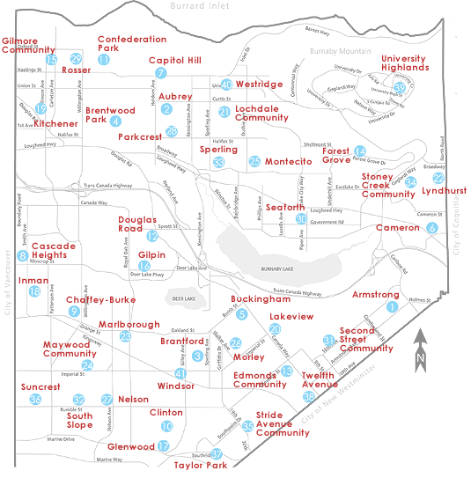

 | 1991 | % | 1996 | % | 2001 | % | 2006 | %
Single and Two Family | 32,760 | 52.2% | 34,180 | 49.5% | 35,580 | 48.1% | 35,095 | 45.0%
Townhouse | 3,895 | 6.2% | 5,387 | 7.8% | 6,170 | 8.3% | 7,250 | 9.3%
Low Rise Apartments | 16,535 | 26.4% | 18,210 | 26.4% | 19,490 | 26.3% | 21,065 | 27.0%
High Rise | 9,540 | 15.2% | 11,278 | 16.3% | 12,755 | 17.3% | 14,610 | 18.7%
Total | 62,730 | 100.0% | 69,055 | 100.0% | 74,000 | 100.0% | 78,020 | 100.0%
Source: Statistics Canada
E). AMENITIES:
Burnaby boasts diverse cultural and environmental amenities. It features beautiful regional parks, mountains and lakes which provide various recreational opportunities including biking, hiking, skiing, boating and fishing. There are several festivals that take place each year, including the Hats Off Street Festival in the Heights region of Burnaby in June, the Greek Festival in July and the Santa Claus Parade in December. Burnaby also has a great deal of cultural activities present. It has several museums such as the Burnaby Village Museum, the SFU Museum of Archaeology and Ethnology and the National Nikkei Museum. Burnaby’s famous Swanguard Stadium located at the corner of Kingsway and Boundary Road in Central park is home to the Vancouver Whitecaps. The Burnaby Express hockey team which competes in the “Junior A” hockey in BC has its home arena in Burnaby at the Bill Copeland Sports Centre on Kensington Ave. Burnaby has several theatres including the Michael J. Fox theatre, named after Hollywood star Michael J. Fox, a native of Burnaby. Also located in Burnaby is the Shadbolt Centre for the Arts, providing local entertainment such as operas, musicals and plays. Located in Burnaby is the largest shopping mall in all of British Columbia; it features over 450 shops and a movie megaplex theatre. Burnaby has two top level educational resources: SFU (Simon Fraser University) and BCIT (British Columbia Institute of Technology).
F). CULTURAL DIVERSITY:
Burnaby, like most of the Greater Vancouver Regional District, has a growing immigrant population. The diversity of ethnic-cultural groups that make up Burnaby’s population was highlighted in the following report, as part of the 2006 census: www.bcmulticulturalprofiles.gov.bc.ca/.../immigration/2006profiles/.../diversity.../Burnaby.PDF .
Extracted from the above document in the 2006 Census is this summary of the various populations for consideration within Burnaby School District. To accommodate ESL learners, Burnaby provides ESL service to learners in schools and Burnaby now features many privately operated English as a Second Language learning services throughout the city, many of which are located close to Metrotown area. As well, Burnaby School District hosts an Aboriginal Education Support Team which addresses the unique educational needs of aboriginal students within the district and provides a support teacher in each school. An aboriginal program occurs each month within each school community.
Total Population of Burnaby 202,799 100.0 %
Aboriginal Population 3,005 1.5
Visible Minority Population 111,295 54.9

O f T H E V I S I B L E M I N O R I T I T I E S T O T A L [111,295]

Chinese | 60,765 | 54.6 %
South Asian | 16,840 | 15.1 %
Filipino | 7,805 | 7.0 %
Korean | 7,680 | 6.9 %
Southeast Asian | 3,110 | 2.8 %
West Asian | 3,000 | 2.7 %
Japanese | 2,990 | 2.7 %
Latin American | 2,780 | 2.5 %
Multiple visible minority | 2,755 | 2.5 %
Black | 2,450 | 2.2 %
Arab | 695 | 0.6 %
Not included elsewhere | 415 | 0.4 %

It is important to note that these numbers are in no way meant to correspond to the number of ESL learners within the district. Many visible minorities do not require language assistance and many students of a different ethnic background outside of the visible minorities (ex. of European descent) may be receiving service. One year in Burnaby I had a few students from the Ukraine that were receiving ESL assistance. This data is included merely to speak the cultural diversity present within the district of Burnaby, in no way is the data commenting on ESL learning. According to the district website, Burnaby has over 4,000 students enrolled in ESL programs and a recent survey revealed that there are more than 85 different languages in addition to English that are spoken within the homes of Burnaby students. Multiculturalism is an enormous focus in Burnaby Schools.
Source: Statistics Canada (1991-2006).
III. Partners with the School
A). Partners within Aubrey School:
Within the school, teachers partner with other teachers, the resource team and the teacher-librarian when developing a project. For a project based on biodiversity, there would be a huge pool of resources within the parent population. I could foresee enlisting the assistance of our Aboriginal sponsor within our school to develop curriculum that targets to learning outcome (4.3): to demonstrate awareness of the Aboriginal concept of respect for the environment. As well, I would solicit specialists within the school community via the newsletter to attend the class and to speak on animal diversity (vets, biologists, conservation officers, botanists, et cetera). At the school, it would be interesting to explore the concepts of developing a local community garden (although this might contradict school policy) composting and perhaps planting a tree as a school for the environmental aspect to the IRP. Within the classes, students could hatch and then release salmon in a local stream, coordinate a school-wide Science Fair initiative based on biodiversity and invite guest speakers from the community to visit classrooms on the topic of biodiversity and habitats.
B). Partners within the School Community:
Burnaby Public Library: McGill  4595 Albert St.  Hours of operation:  Mon-Fri from 10 am to 9 pm Sat from 10-6 and Sun 1 – 5  http://www.bpl.bc.ca/locations-hours/mcgill  Within walking distance of the school, the Burnaby Public library makes a wonderful school partner! McGill library is located just off of Hastings and is an approximate 20 minute walk with the students from Aubrey School. Each year one of the librarians visits our school to discuss the Summer Reading program, beginning June 20th. The librarian visits our school and provides book talks to individual classes to discuss new collections. The McGill library also has story time events going on through the week and features a teen photo contest to encourage youth to come to their facility. Their website features some excellent websites linked to environmental awareness. When I searched their individual database under the term “biodiversity”, 51 items surfaced. However, when I narrowed the search limited to children, 6 surfaced. What impressed me about the resources available was that they are very current titles. No titles were available in French. I then broadened my search to simply “animaux” and was delighted to retrieve an impressive 44 books related to animals in their French collection. I could then narrow that to see titles as non-fiction, fiction and multimedia. I find their retrieval system to be very user-friendly and efficient. | Burnaby North School  751 Hammarskjold Drive  http://north.sd41.bc.ca/  Burnaby North Secondary School is kitty-corner to École Aubrey. This school has excellent mentorship programs and often hosts Science related events to showcase the students’ learning. Students from Aubrey often visit this school to peruse their Science Fair projects. This is an excellent opportunity for elementary students to learn and experience science outside of the classroom.
Simon Fraser University

http://www.sciencealive.ca/classroom/

Offers the exciting Science Alive programs available to the classroom for the months of May and June. The workshops feature interactive hands-on activities that are catered to the PLOS (prescribed learning outcomes of grades 2-7).
WRA Association (Wildlife Rescue Association)  5216 Glencarin Drive, Burnaby (near Burnaby Lake)  http://www.wildliferescue.ca/aboutcc.shtml  This wildlife rehabilitation centre offers tours and information programs in the habitat garden. The focus is on sustainability, respect for nature as we co-exist and issues facing the urban environment. Education programs include :  - Co-existing with Urban Wildlife  - Wildlife Habits and Habitats  - Nest and Wings and Things: Wildlife ID and Adaptations  - A Day in the Life of A Wildlife Rehabilitator | BCSPCA (Burnaby Shelter)  3202 Norland Avenue  http://www.spca.bc.ca/branches/burnaby/  The mission statement of the local B.C.S.P.C.A (British Columbia Society for the Prevention of Cruelty to Animals) is “to protect and enhance the quality of life for domestic, farm and wild animals in British Columbia”. The BCSPCA is able to accommodate presentations and shelter tours. While a little far for a walking visit, the volunteers at the BCSPCA in Burnaby will visit classrooms with appropriate pets (guinea pigs and rabbits) and discuss animal issues with the class. Their website has many excellent links and a section on teacher resources linked to their humane education department whose goal it is to teach children empathy and respect for animals: wild and domestic.
Burnaby Mountain Conservation Area
http://www.venturevancouver.com/burnaby-mountain-conservation-area-hiking-views
The Burnaby Mountain Conservation Area is located at the top of Burnaby Mountain below Simon Fraser University. It has beautiful, extensive trails and views of Indian Arm and the North Shore Mountains. It is home to a diverse and rich forest fauna and flora.
Deer Lake Park  http://www.trailpeak.com/trail-Deer-Lake-Park-near-Burnaby-BC-1231  With the beautiful Shadbolt Centre, Century Gardens, Burnaby Village Museum and Burnaby Art Gallery nearby, Deer Lake Park is a wonderful location to explore nature. The park hosts a variety of recreational activities including canoeing, hiking, kayaking and hiking. Boats are also available for rent. Students of neighbouring schools, including Aubrey, participate in dragon-boating racing on the lake. The animal and plant life present is astounding for being located in an urban centre. | Burnaby Lake Regional Nature Park  http://www.vancouvertrails.com/trails/burnaby-lake/  This nature park has many trails that span its extensive marshland and forest areas. Included in the park is an interpretive nature house which has educational displays and a viewing tower – perfect for viewing the birds and other wildlife present in the park. As well, there is the Burnaby Lake Equestrian Centre in close proximity. On the opposite side, close to the lake is the Wildlife Rescue Association (featured above).
.
- Other potential partners within the Lower Mainland:

To expand our community into the lower mainland region, many other partners can be found. These organizations include:
- VanDusen Botanical Gardens (for a hands on study of ecosystems and adaptations)
- Grouse Mountain (nature programs)
- Capilano River Hatchery (interpretive centre is open to the public year round at no charge)
- Burns Bog Conservation Society - Delta (fieldtrips/ tours of the ecosystems present)
- Galliano Conservancy Association (great tie in with Aboriginal studies)
- Surrey Nature Centre (tours and programs available for various age levels)
- Imax film (Born to be wild)– Vancouver
- Rainforest Reptile Refuge Society – Surrey (volunteers are available for a class visit or on-site visits, focus is on abused and abandoned exotic pets)
- Vancouver Aquarium – Stanley Park
- Boundary Bay regional Park – Delta (wildlife management area can arrange a tour of the area through the Greater Vancouver Regional District Office, they host talks on both the ocean life and bird species in the area)
- Maritime Museum – Vancouver (features programs on extreme environments and Artic climate change)

IV. THE SPECIFICS OF THE PROJECT

Who? The content I am addressing within Life Sciences is animal habitats, biomes and biodiversity. It will target two Grade 4/5 French Immersion classes at Aubrey School. I will be working with the classroom teachers, but will also need to collaborate with the Learning Resource team and the Aboriginal Support teacher who will be able to help link the materials to First Nations studies to address the learning outcome (4.3) (demonstrate awareness of the Aboriginal concept of respect for the environment). The classroom teachers are Mme Taylor and Mme West; both teachers will be new to Aubrey School for the 2011/2012 calendar year. I have worked with Mme Taylor before when she was previously at Aubrey and know her to be particularly interested in the environment and biodiversity. She has completed her Masters degree recently on an educational leave. Prior to her educational leave, Mme Taylor worked at Seaforth in the French immersion program and is familiar with the learning outcomes for Grade 4 level. The socio-economic climate at Seaforth is similar to that of Aubrey. Mme West is also coming from Seaforth this year and has worked with students at the Grade 4 level. A meeting to address the best way I can assist them in their exploration of the learning outcomes, providing them a forum to request specific materials, connecting them to partners within the school and community and assisting them in the researching aspect of the project will be ways that I can assist them in their goals.

What? For this project I have chosen to work with resources at the Grade 4 level in the area of Life Sciences. More specifically, my project is linked to habitats, biomes and communities. At this level, students learn to compare the structures and behaviours of local animals and plants in different habitats and communities; to analyze simple food chains; to demonstrate and awareness of the Aboriginal concept of respect for the environment; and to determine how personal choices and actions have environmental consequences. Drawing on electronic resources, resource materials in the library and partners within the community, I will make a variety of project ideas available to the teachers involved.

When? This project will be addressed in the 2011-2012 school year.

Why? The rationale for this project is to interface students with nature and the environment in a thoughtful, experiential and meaningful way.

How? Through potential fieldtrips, virtual learning activities, such as webquests, guest speakers and a variety of project-based learning opportunities, students will explore the learning outcomes stipulated in the IRP and ultimately will demonstrate the achievement indicators for each topic of discovery.

