Exploring Learning Resources
Indigenous Foundations

A common barrier to integrating Indigenous content in courses at all levels is negotiating variation in levels of prior knowledge, accuracy of information about Indigenous histories and contemporary realities, and anxieties around the use of language and terminology. These are some of the challenges that the website Indigenous Foundations tries to address.

Individual activity:

READ AND REFLECT: (15 mins)
- Preview the attached worksheet “FNSP 300: Identity and Terminology Worksheet”
- Go to http://indigenousfoundations.arts.ubc.ca/, click on the “Identity” section and spend one minute previewing the three articles: “Terminology,” “A discussion on Aboriginal identity,” and “A discussion on identity and terminology.”
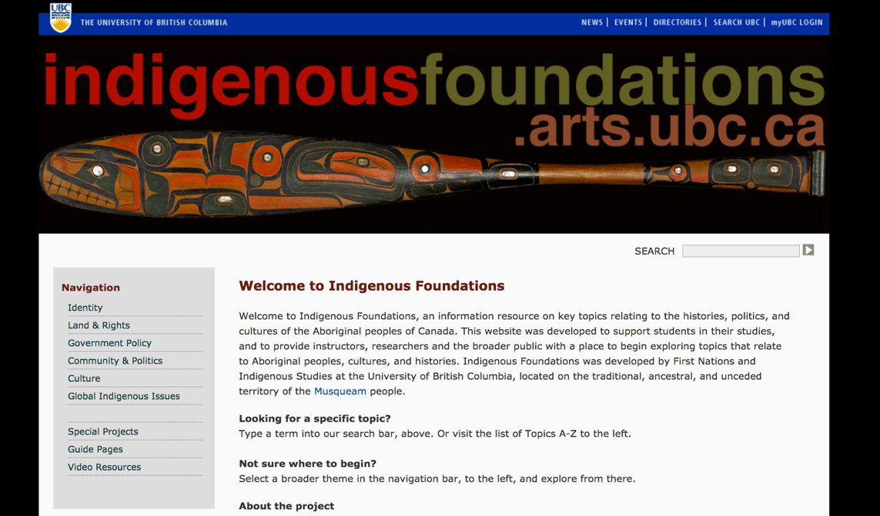
- Divide up the “Identity” articles among the group members so you are each reading a different one. If you finish before your other group members, look at the worksheet and begin to fill it out.

WATCH (5 mins)
- Watch “Ignorance or what?” – a short film by UBC alumna Maryel Sparks-Cardinal (http://aboriginal.ubc.ca/a-little-knowledge/)

Turn over for Group Activity >>
Group activity:

DISCUSS AND EXPLORE
- Discuss the resources, identifying some of your own experiences and challenges with background knowledge when teaching and/or learning Indigenous content.
- How might you adapt the materials from this activity for use in your own course, discipline, or project? How might these materials be useful to others designing courses or learning resources?
- If time permits, explore the navigation and other articles on Indigenous Foundations with your group. What topics might you find useful for exploring in your own courses?

RECORD
Notes from your discussion to report back

