Exploring Learning Resources
Power of a Name

“The Power of a Name” is a film series that examines the contested history of naming practices at UBC’s first year student residence, Totem Park, and features stories of relationships between UBC and Indigenous communities. It encourages members of the university community to think critically about their relationships to the unceded lands of the Musqueam people on which we are privileged to study, work, and live.

The area that Totem Park Residence occupies today used to be the site of an outdoor exhibit displaying different works by Bill Reid and Douglas Cranmer called “Totem Park.” The original six houses that became residences were named without community consultation, and the names Haida, Shuswap, Nootka, Dene, Salish, and Kwakiutl have been used since the 1960s without permission and without context. This has led to many disrespectful acts of misrepresentation and appropriation.

The Power of a Name films allow for the opportunity to break down stereotypes and misconceptions held by members of the UBC community and beyond. Furthermore, they also allow for Indigenous communities to represent themselves and to create their own narrative and share information of their own terms.

Individual activity: (To be completed before the workshop)

READ AND REFLECT: (10 min)
- Take a few minutes to read through the timeline presented on this page titled: UBC Centennial: The Hidden History http://centennial.aboriginal.ubc.ca
- Make note of any sections where you had an “ah-ha moment” or learned about a part of UBC history that you were unaware of.
WATCH (20 min)

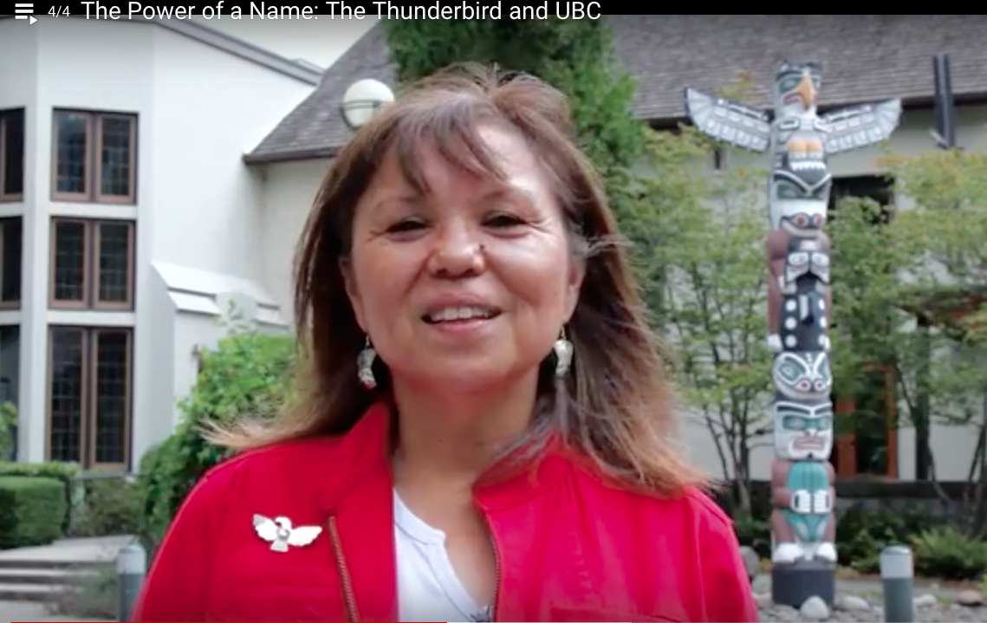
1) Take a few minutes to explore “The Power of a Name” website: powerofaname.ubc.ca
2) Go to the “FILMS” tab and select The Thunderbird and UBC film http://powerofaname.ubc.ca/2017/05/01/thethunderbird/

3) Note-down the prominent themes in the video. You will discuss these in the workshop.

Group Activity: (To be completed in the workshop)

DISCUSS AND APPLY
- Share your insights on the prominent themes presented in the video
- Reflecting on your “ah-ha” moments from reading the Centennial timeline: What were they and why might they exist (gaps in background knowledge)? How might you support further learning about them for yourself, your students and colleagues/project partners?
- How could you explore these resources in your own course/project? What else might you need to facilitate conversations around these themes?

RECORD
Notes from your discussion to report back

