Problem Specification
Glass is fast becoming a very common building material for a wide variety of reasons including cost, safety, and aesthetics. One of the problems, however, with use of architectural glass is its reflective and transmissive properties when it comes to sunlight. Glass use creates an issue of allowing or directing sunlight into places where it may not be desirable; either inside or outside the building. This project aims to address the need for a simple and elegant approach to obstructing sunlight autonomously – only when it is unwanted.
The project will involve designing a set of self-actuating shades or blinds that will reduce the cost of cooling a home by reducing the heat radiated through sunlight. These blinds are expected to function in a hypothetical home in Austin, Texas during the months when air conditioning systems would be required. The blinds will provide a simple and elegant way of blocking sunlight only when the sun is at a certain brightness while automatically retracting when the day cools down. That is to say, the blinds must autonomously open and close at suitable times during the day; responding to the changing levels of solar radiation reaching the windows. The system will be an alternative to traditional fixed or computer-operated shades that hang outside windows to reduce cooling costs.
There are several issues we aim to solve with this project. Fixed shades have a disadvantage of blocking light and obscuring sightlines permanently. Our design must have periods where there is little or no obstruction of the window. Cooler times in the evening and in the winter would not require the blinds to be closed. Sightlines could be maintained and light would be allowed through to warm the room on cooler days.
Computer controlled blinds can open and close at suitable times but have the disadvantage of being complex and expensive. These blinds are feasible for large buildings where blinds for multiple rooms could be installed together while being controlled and maintained centrally. Computer controlled blinds are less practical in homes where the cost and hassle of installation and maintenance do not make sense. Our blinds must be simpler to operate and easy to install. Ideally we would like a product that can be installed as simply as affixing a set of fixed shades while still providing the dynamic shading offered by a computer controlled system.
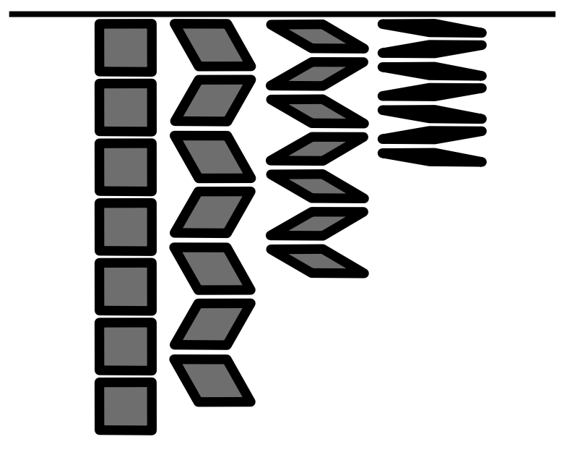
The goal of all these window shade installations is to improve the passive cooling ability of a building. The systems all slow the rate of heat transfer into a room via the windows. The shades will either be standalone or run alongside an active cooling system like air conditioning. Thus the system must have a significant impact on reducing the amount of air conditioning required for the room.
The shades must also be robust enough to function over multiple years without requiring significant maintenance. It should not degrade under UV light nor in high or low temperatures.
Finally, the blinds must have a particular aesthetic. The design settled upon at the start of the project was for a series of rhombuses which collapse to open the blinds. This shape aesthetic and mechanism must be followed for the purposes of this design project.

