MTRL 466 MEETING MINUTES

Project Name: | Process Modelling for Adhesive Bonding of Aluminum Automotive Sheet
Group: | 1
Current Meeting: | Friday October 4th, 2011
Minutes Prepared By: | Adam Ohashi
Attendees:
Dr. Chad Sinclair
GROUP 1: Jerry Chang, Michael Fu, Judy Makmillen, Adam Ohashi
Agenda:
- Gantt chart / timeline review:
  - Gantt chart for last 3 weeks completed/posted to Wiki

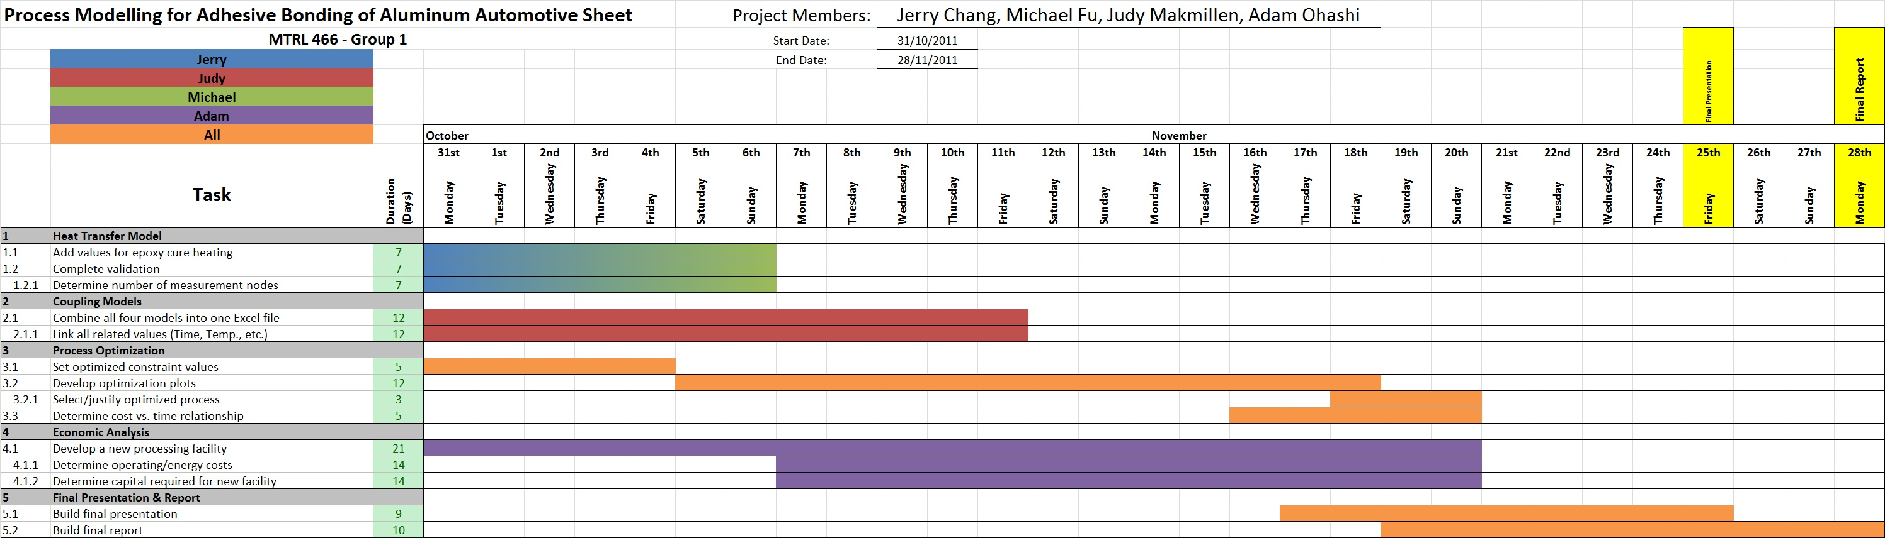
- Heat transfer model – Next Step:
  - Validation of model
    - Heating profile; semi-infinite slab, constant surface temperature
  - Heat values obtained from curing model integrated
  - Heating orientation? (1 side vs. both sides)

- Coupling models:
  - Judy managing the combining of all 4 models into one Excel workbook
    - Any issues with lack of sufficient memory?
      - Possibility of creating code to execute calculations
- Optimization:
  - Constraints:
    - Curing: approx. $α≤0.95$
    - Softening: approx. $\frac{∆σ_{5xxx}}{∆σ_{5xxx}^{o}}≤0.9$
    - Hardening: approx. $\frac{∆σ_{6xxx}^{peak}-∆σ_{6xxx}}{∆σ_{6xxx}^{peak}}≤0.9$
  - Waiting on coupled model to produce output values before determining optimal values of T, t, h
    - Smallest time that meets all process constraints

- Economic Analysis:
  - To start this weekend:
    - Determine costs associated with paint baking, energy/operating costs
    - Capital required for an annealing booth, paint station, etc.x
      - Can use contacts from local companies for pricing
    - Begin developing a new processing facility (large scale)
Minutes:
Meeting start time: 1:40pm
Meeting end time: 3:20pm

- Midterm report review - aspects to look out for:
  - Referencing
    - Consistency
    - Lack of proper references
  - Repetition of facts
  - Flow from paragraph to paragraph
    - Make sure sub-sections connect
    - Have introductions for each section
    - Segregate processing section from models
  - Be specific!
  - Revise constraints and free variables
    - Add thickness, heating conditions, sheet start temp., etc.
  - Revise these aspects and use in final report

- Heat transfer model:
  - Biot number = convection vs. conduction dominance
  - Newtonian heating conditions
  - Value for epoxy conductivity?
  - Validation done! (numerical vs. analytical)
  - Finite difference model
    - Checks boundary conditions (surface)
    - Half of cross-section = 12 nodes
      - 23 nodes in total
    - Small Δx = small Δt
      - small Δt = many time steps, requires more memory
      - Using Python, code our coupled models, have output to a text file
  - Can have different heating methods implemented in code/heat transfer model
    - Turbulent convection on one side, stagnant on other side with no direct heating
    - For now: start with symmetric heating, if time allows we can vary it
  - Furnace temperature, heating coefficient = constant or varying?

- Optimization
  - Arbitrary constraints for α, σ₆₁₁₁, σ₅₇₅₄
    - Find optimal values for these:
      - α ≥ …, 0.85, 0.9, 0.95, …
      - σ₆₁₁₁ ≥ …, 0.85, 0.9, 0.95, …
      - σ₅₇₅₄ ≤ …, 0.95, 0.9, 0.85, …
      - T_{epoxy} ≤ 200°C
      - Starting oven temp.?
        - Preheat to certain T
      - Painting takes 15 – 45 min
        - Require a proper time window
    - Have checkpoints in Python to stop execution @ points out of constrain range

- Economics
  - 3 steps (strengthening, curing, paint baking) vs. 1 step (all-in-one)
    - In parallel = need same production rate of cars
    - Require energy consumption/car
    - Capital cost, need more 3-in-1 booths to meet production rate
    - Estimate costs, for example: paint booths
      - Make sure characteristics of custom paint booths match what we want
    - Depreciation, recovery of capital
  - Use existing facility
    - When pricing, costs are done, what is the economic benefit of 3-in-1?
Action Items:
- Revise midterm report section for use in final report
- Heat transfer model:
  - Find epoxy conductivity
  - Decide on heating conditions
- Decide on optimization constraints based on model output
- Initialize process economics
  - Price custom paint booths
  - Find energy consumption/costs
  - Determine overall benefit of 3-in-1 process

- Next meeting: Wednesday, November 9th, 2011 @ 1:30pm

