Cough
CCFP Objectives
- In patients presenting with an acute cough:
  - Include serious causes (e.g. pneumothorax, pulmonary embolism [PE]) in the differential diagnosis.
- Consider life-threatening conditions: pneumothorax, PE, heart failure, exacerbation of asthma or COPD, pneumonia
- Approach to cough:
Divide patient population | Divide cough
Pediatric: less than 15 yr.  Adult: older than 15 yr.  Special populations: smoker, immunosuppression, chronic (lung) disease | Acute: less than 3 weeks  Subacute: 3-8 weeks  Chronic: more than 8 weeks, more than 4 weeks in children
For subacute cough: if history of infection treat as post-infectious until cough becomes chronic (i.e. lasts longer than 8 weeks), if no history of infection, treat as chronic
- In children with acute cough, consider croup, bronchiolitis, pertussis and treat
  - Diagnose a viral infection clinically, principally by taking an appropriate history.
- No one sign, symptom or test rules out bacterial infection or rules in viral
- However, if no red flag symptoms present, no CXR or further investigation is warranted until the cough persists into chronic phase.
History | Red Flag Symptom
Age  Details of cough: Duration, ?productive, impact on function, other symptoms (fever, congestion, muscle aches, SOB, chest pain)  Other medical conditions: asthma, COPD, Heart Disease, cancer, HIV, immune-suppressed  Recent surgery or hospitalization  Smoking status  Medications, recent use of antibiotics  Infectious contacts, vaccination status  Occupation (infectious contacts, irritants, allergens)  Travel | Sudden fever - Suggestive of influenza, pneumonia, SARS  Shortness of Breath, chest pain – r/o life threatening causes  Recent surgical procedure – increases likelihood of PE, aspiration, atypical infection  Other health problems – ?exacerbation of lung disease (COPD, asthma), risk of atypical infection (immune suppression, IVDU)  Smoker: get more infections, tend to persist longer  Contact with infected person (influenza, SARS)  Recent travel – increases likelihood of atypical infection
Physical Exam | Red Flag Signs
Vitals, weight  Listen for cough in office, judge frequency, severity  H&N  Cardiac – including volume status, signs of heart failure  Chest | Unusually ill, abnormal vitals  Shortness of breath, respiratory distress  High fever  Reduced air entry, signs of consolidation, restricted air entry  Other signs of DVT  Weight loss, weight gain (if fluid overload)
  - Do not treat viral infections with antibiotics. (Consider antiviral therapy if appropriate.)
- Acute bronchitis commonly lasts 7 to 10 days; up to 1 month in 25% of patients
- Controversial, but may consider Abx if cough lasts >14 d
- Abx do not increase/speed up resolution; but decreases “time feeling ill” by 0.5 days
- Most people just want the cough to stop: Cough management options
Non-pharma (possibly more effective) | Pharma (expert consensus only)
Decrease or quit smoking  Fluids (keep mucus thin)  Moist/humid air | Beta agonists (only if wheezing)  Codeine, Dextromethapham  1st gen antihistamines
- In pediatric patients with a persistent (or recurrent) cough, generate a broad differential diagnosis (e.g., gastroesophageal reflux disease [GERD], asthma, rhinitis, presence of a foreign body, pertussis)
- In children, divide chronic cough into specific (dx recognizable from description of cough and/or other findings on hx or exam) and non-specific
- Specific cough (Table 2)
Type of cough | Diagnosis
Barking or brassy cough  Honking  Paroxysmal (+/- inspiratory “whoop”)  Staccato | Croup, tracheomalacia, habit cough  Psychogenic  Pertussis and parapertussis  Chlamydia in infants
Sign/Symptom | Suggested etiology
Auscultatory findings (wheeze, crackles, differential breath sounds)  Cough characteristics (eg, cough with choking, cough quality, cough starting from birth)  Cardiac abnormalities (including murmurs)  Chest pain  Chest wall deformity  Daily moist or productive cough  Failure to thrive  Feeding difficulties (including choking/vomiting)  Atypical and typical respiratory infections  Neurodevelopmental abnormality  Recurrent pneumonia | Asthma, bronchitis, congenital lung disease, foreign body aspiration, airway abnormality  Congenital lung abnormalities  Any cardiac illness  Asthma, functional, pleuritis  Any chronic lung disease  Chronic bronchitis, suppurative lung disease  Compromised lung function, immunodeficiency, cystic fibrosis  Compromised lung function, primary aspiration  Immune deficiency  Primary or secondary aspiration  Immunodeficiency, congenital lung problem, airway abnormality
- See ACCP Algorithm at end of document.
- In patients with a persistent (e.g., for weeks) cough:
- Consider non‐pulmonary causes (e.g., GERD, congestive heart failure, rhinitis), as well as other serious causes (e.g. cancer, PE) in the differential diagnosis. (Do not assume that the child has viral bronchitis).
- Wide differential, often with multiple causes in the same person.
- Start with hx and p/e as for acute cough, plus CXR. Be wary for constitutional symptoms suggestive of cancer or TB infection.
- Three most common causes in adults: Post-nasal drip, asthma, GERD
- Investigate appropriately.
AAFP Algorithm
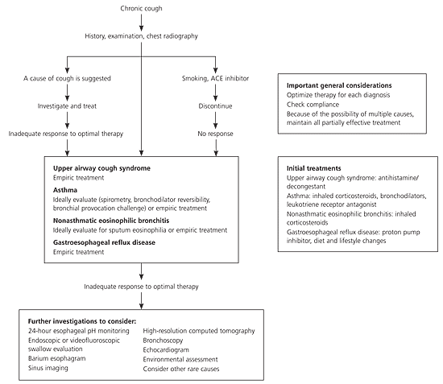
- Do not ascribe a persistent cough to an adverse drug effect (e.g. from an angiotensin‐converting enzyme inhibitor) without first considering other causes.
- If cough caused by ACEi, expect resolution within 2 weeks of stopping.
- In smokers with persistent cough, assess for chronic bronchitis (chronic obstructive pulmonary disease) and make a positive diagnosis when it is present. (Do not just diagnose a smoker’s cough.)
- See COPD topic

Relevant Guidelines and References:
- Worral, G. Acute cough in adults. CFP Jan 2011;57(1):48-51
- Coughlin, L. Cough: Diagnosis and Management. AFP 15 Feb 2007; 75(4):567-575
  - Summary of American College of Chest Physician Guidelines; has chronic cough algorithm
- Worral, G. Acute cough in children. CFP Mar 2011; 57(3): 315–318
- Irwin, R. et al. Diagnosis and Management of Cough: ACCP Evidence-Based Clinical Practice Guidelines. Chest. 1 Jan 2006; 129(1 suppl):1S-292S
  - Really dense; stick with the AFP Summary
- Chang, A and Glomb, W. Guidelines for Evaluating Chronic Cough in Pediatrics. Chest. Jan 2006; 129(1 suppl):260S-283S

- ACCP Guidelines. Table 2 show above.
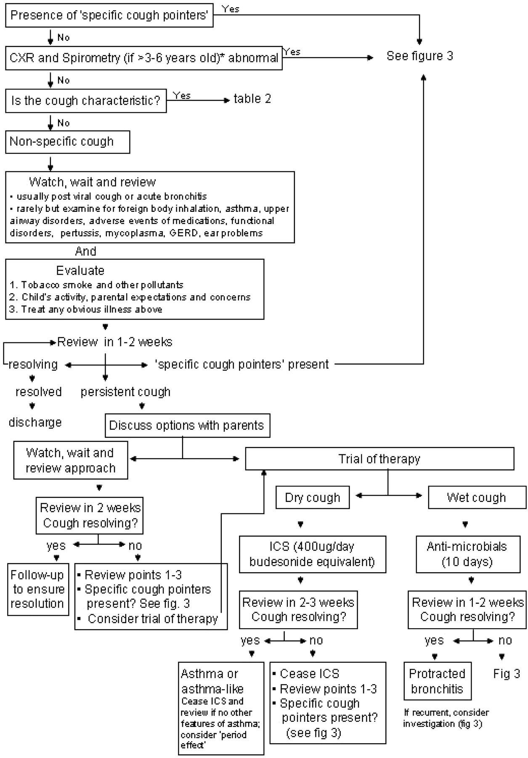 Figure 2
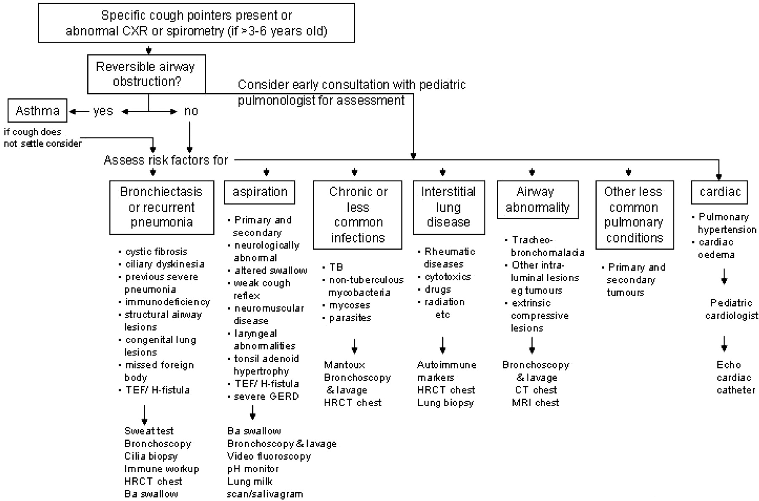 Figure 3

