Ricoh Printer Instructions
Hooray! We are the proud owners of 6 new Ricoh machines (print/scan/copy devices).

Locations:
Three are located on the 3rd floor: You can see one from the CLC desk, in front of the entrance to the Heritage Core. Two are located in the MAA library, in front of the Circulation desk.
The 3rd floor printers are colour machines.
Three are located on the 2nd floor, close to the desktop computers and Ike’s (where the Xerox were).
The 2nd floor printers are black and white only. Colour print jobs will not show up on these machines.

Instructions for Use:
Log in by swiping your card (press the PaperCut icon on the home screen to access the login screen). PaperCut is the program for Pay-For-Print. From here you can access device functions such as copying/scanning, as well as printing. Always make sure to log out before leaving! 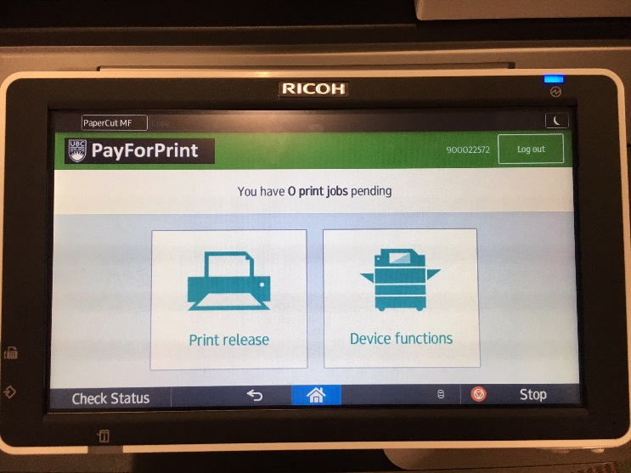
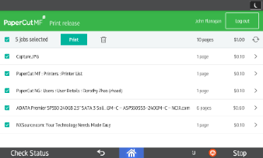 PaperCut print release screen. Patrons can choose which of their jobs to print by selecting the jobs on the left-hand side.
Copies: Note: the default for making copies is duplex (double-sided). By scrolling down on the ‘copy’ screen (top left of screen above on right of PaperCut), you can access options to change this to single-sided. Below is the PaperCut copy screen, where patrons can choose their settings (scroll down for more options).
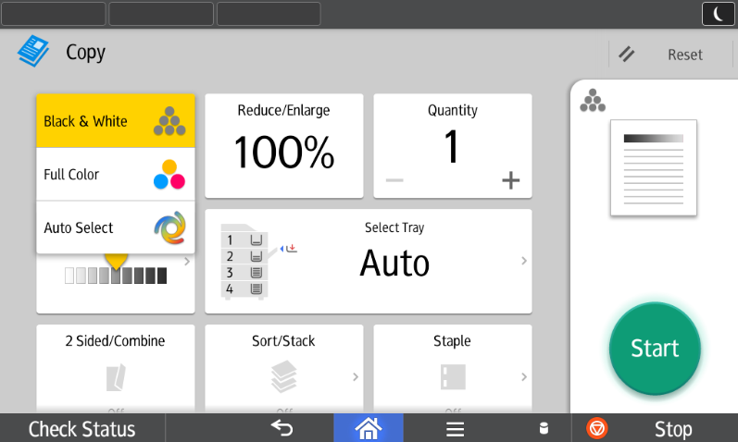
Printing from USB: A USB reader is located on the left hand side of the screen. From here, you can print documents including JPG, TIFF, Word .Doc, and PDF, but not Excel (patrons might be confused why their spreadsheet isn’t showing up).

How to load paper and toner:
Paper:
Tray 1 (8.5x11): Load the paper on the left-hand side (see below) and close the tray (it fits 3 reams of paper per side). The printer will move the paper to the right-hand side, where it will be fed into the machine. Take care not to exceed the limit of paper, indicated by the orange line.
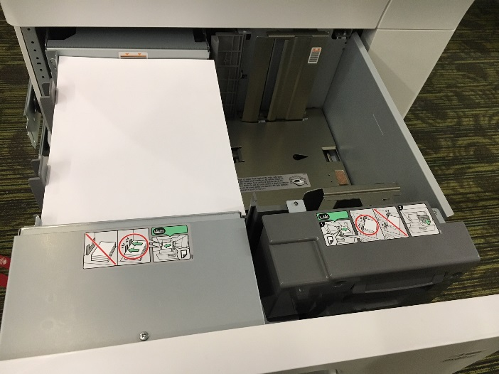
Toner:
Toner levels are indicated on the home page.
Level 2 printers: 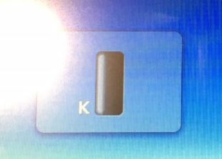
Level 3 printers: 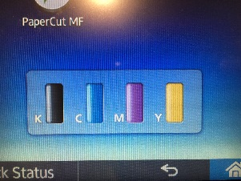
To change toner on new Level 2 printers, swivel the cartridge out to the right as seen below, then twist the toner capsule out and twist the new one in. Only do this when the machine indicates that the toner is empty. Level 3 printers in MAA are the same as our Ricoh beside the CLC desk.
Note that the black toner for the Level 2 machines has a larger cartridge (see below). The toner for the Level 3 machines does not work in the Level 2 machines.
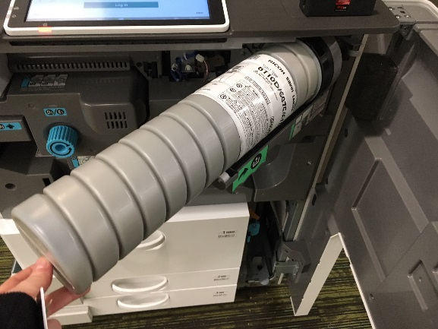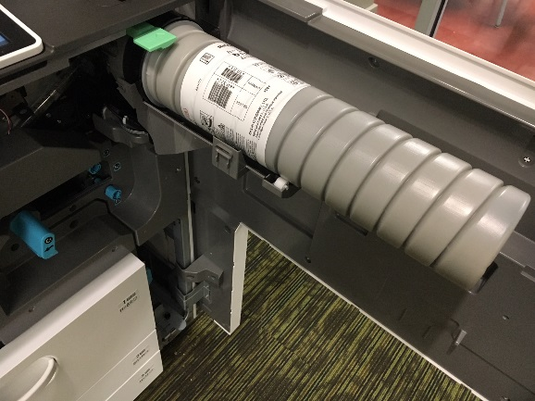
Troubleshooting:
The On/Off button is located on the upper left hand side of the printer.
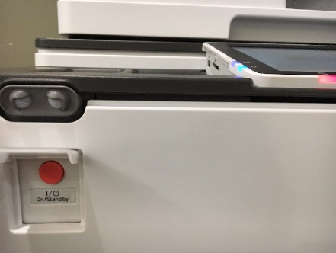
When an error occurs, a red light will flash on the bottom left side of the screen (see above). Press ‘Check Status’ (bottom left of screen, see below) for an explanation of what has gone wrong.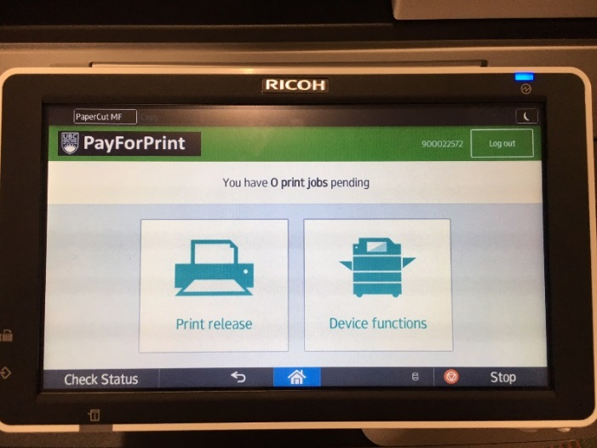
Here’s a look at the inside of the printer. To clear a paper jam, move in alphabetical order through each of these parts.
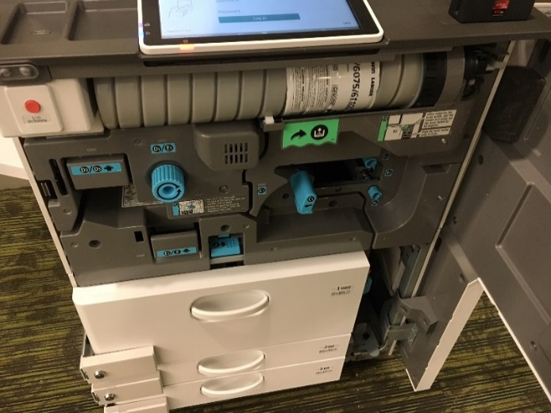
Paper Troubles? Sometimes on Level 2 the following message will appear:
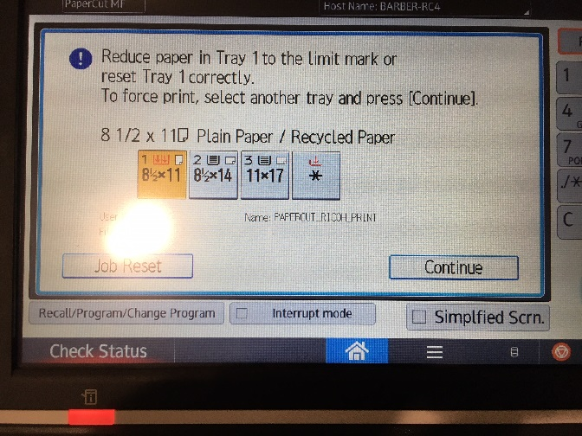
- Turn off the printer.
- Check that the paper is below the limit mark (orange line). If so: move all the paper from the right-hand side, back to the left-hand side where it was loaded.
- Close the tray and restart the printer.
- It should resolve this issue.
A4 Paper: if a patron tries to print A4-sized paper, an error message will indicate this. The patron can either press ‘Tray 1’ (which will try to resize the print job to 8.5x11), or cancel and resubmit their print job with the correct paper sizing.

The contact number and website link for further troubleshooting with the Ricoh machines are on the blog under ‘Tech Troubleshooting’.

