Instagram Tutorial for Web Team 2019 Mar
- Download “Canva” app for Instagram Posts and Stories designs
  - Use your own photo and words to create content
  - Do not have giveaway or contest for @ubclearn accounts
- Use Insight to track on each post’s likes, comments, send and labels
  - In the beginning of the term, record monthly profile visit and reaches
  - In the end of the term, record the increase or decrease of the monthly visits
- Use Instagram’s Profile Bio and Website to promote new blog post
- In setting, check “Insight” to see “Activity, Content and Audience”
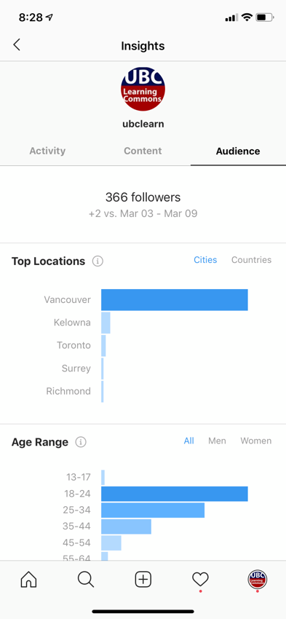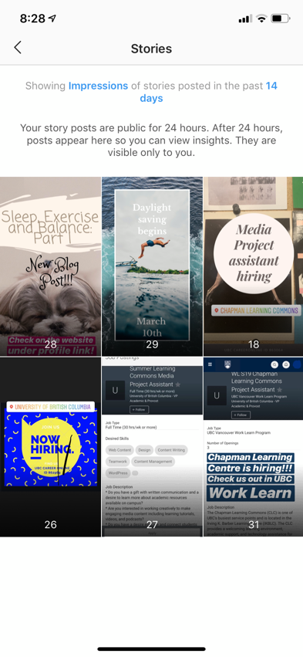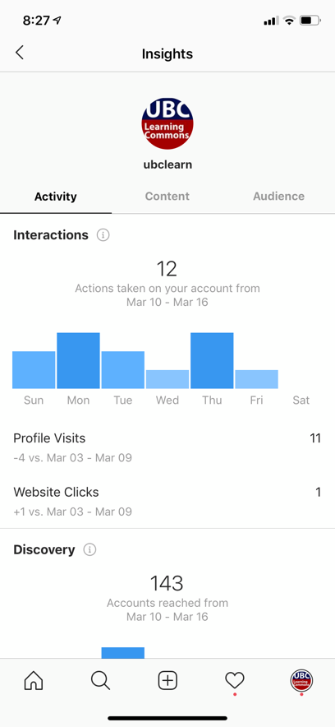

- Go to see video direction at
  - teamsharedrive > LBRY > IKBLC Program Services > Student Files > Chapman Learning Center > 1 Minute Video > Instagram Demonstrations

