Technical Review
Previous Applications of SMM
Shape memory materials are sometimes found in electrical appliances as safety switches, or in automobiles as thermal control valves. In situations where lower friction, noise, and number of parts are desired from actuators, shape memory materials can be a better option compared to pneumatic actuators or D.C. motors11. Shape memory materials have also been successfully used in the aerospace, medical, and electronic industry.
Similar to the present design study, shape memory materials have been demonstrated to be able to block sunlight or regulate air temperature inside a building. Kai Hansen used shape memory alloy in his conceptual mock-up “Adaptive Façade”. This concept used fritted panes that close automatically when the system detects sun light, with the use of light sensors, circuit boards, and electrical resistive heating. As well, shape memory alloys have been installed as thermal actuators for greenhouse windows that open and close the windows autonomously without electricity to regulate the greenhouse temperature. In using shape memory materials to regulate air temperature inside a building by actuating blinds that block sunlight, our design should be fully autonomous without the use of external systems, much like the greenhouse thermal actuators.

Introduce materials
The most common shape memory materials are shape memory alloys. Originally, the shape memory effect in metal alloys was first observed in an AuCd alloy in 1951¹¹. Currently, the shape memory alloys that are commonly used are nickel-titanium based (Nitinol) or copper based, with Nitinol being the more popular choice due to its superior shape memory properties12,. Although Nitinol alloys are superior to copper based shape memory alloys, they can cost more than 10 times as much. Even less common, but an emerging type of shape memory materials are shape memory polymers, which are made of polymers that show pronounced shape memory effect such as polyurethane. The extent of recoverable deformation for shape memory polymers is approximately two orders of magnitude higher than the extent of recoverable deformation for shape memory alloys¹⁸. The disadvantage is that the exerted force during shape recovery is also approximately two orders of magnitude lower due to the low stiffness of shape memory polymers¹⁸.

Assess and Select Design Options

Shape Memory Actuators
Three shape memory materials were investigated, shape memory polymers, copper based SMA, and Nitinol. They were chosen to represent a range of available shape memory materials.

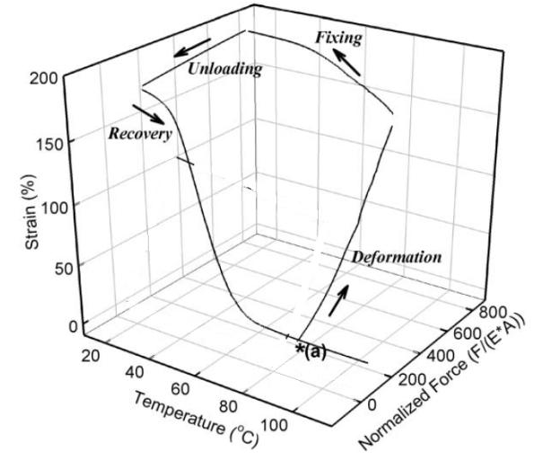

Figure 2 – From technical review section

Although shape memory polymers generate two orders of magnitude less force during recovery than copper based SMA or Nitinol, Appendix # shows that all three shape memory materials can provide the minimum required force to actuate a single unit of the blind. As well, shape memory polymers are at least 25 times less expensive than shape memory alloys and can recover deformation up to 800%, which is significantly more than copper based SMA (up to 6%) and Nitinol (up to 8%),. However, as shown in Figure 2, a shape memory polymer cannot recover its shape unless the load applied to cause deformation is removed. As will be discussed in the ‘Detailed Design’ section of this report, the blind in our design exerts a constant load on the SMM caused by gravity. Because the constant load from gravity would prevent a SMP from recovering its shape, SMP would not be able to provide actuation for the blind in our design. Figure 1 shows that SMA can deform under a constant load when heated or cooled due to the martensitic and austenitic phases having different stress-strain behavior relative to each other. This means that shape memory alloys have the potential to provide actuation for the blind in our design.
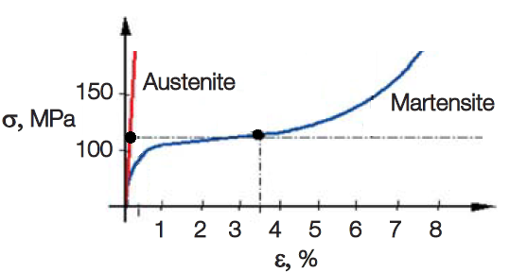
Figure 1 Stress-strain curve of austenitic and martensitic Nitinol at the region of recoverable deformation. Adapted from “Shape Memory Actuators for Automotive Applications,” by F. Butera, 2008, Advanced Materials & Processes, 37-39.
For our project, it is important to maximize the recoverable deformation of the shape memory materials while maintaining a stable critical transformation temperature. As mentioned previously, copper based SMA has lower recoverable deformation compared to Nitinol. Also, the martensitic phase in copper based SMA may stabilize due to aging at room temperature which gradually raises the critical transformation temperature. Additionally, copper based SMA has lower corrosion resistance than Nitinol, which is important since our blind design will be exposed to the external environment.
Because Nitinol can recover its shape while under the force of gravity in our design, has a stable activation temperature, and has higher recovery strain and corrosion resistance than copper based SMA, it is selected over SMP and copper based SMA as the shape memory material used for further analysis in our design.

Soboyejo, W. O. (2006). Advanced Structural Materials: Properties, Design Optimization, and Applications. Boca Raton, FL: CRC Press, (p. 152-153)
(Wakjira, 2001)
Hansen, K. (2012). Adaptive Facade Mock-up v2. Intelligent and Responsive Building Systems. Retrieved November 24, 2013, from http://robofacades.wordpress.com/gallery/adaptive-facade-mock-up-v2/
(Proft, 1989)
(C. Liu, 2007)
(Lederlé, 2002)
(K. Ishida, 2002)
(Behl, 2007)
(C. Liu, 2007)
(Schiller, 2002)
(Cazacu, 2008)
(Proft, 1989)

