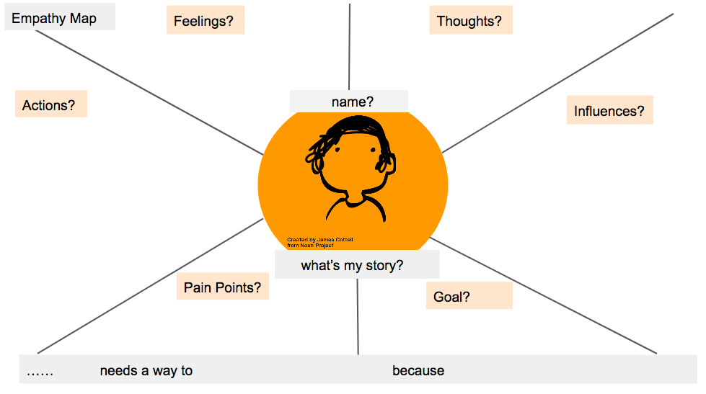

* What insights emerge as you look at your completed empathy map?
* What does your learner NEED (based on the insights that have emerged)?
* How would you complete the “point of view” statement above?

