Assignment 3: Teaching a Lesson
Due: June 15
NB: Lessons will be taught in class in Weeks 8 and 9 (see course schedule)

Points: /18 (30% of final grade)

This assignment is self-graded. Every student is guaranteed an A- (80%), minimum, regardless of the grade you give yourselves when working with the rubrics. Why? I want to remove as much as possible any pressure around grading yourselves and to encourage experimentation and authentic engagement with the rubrics. Please see the instructions provided below, under the heading “Self Assessment/Rubric” for how to go about assigning yourself a grade.
NB: Note that the guarantee of an 80% minimum is predicated on the assumption that students will demonstrate bona fide engagement with the assignment and meet the assignment learning objectives.

Purpose:
To use your teaching knowledge and skills to teach a lesson to a live audience and afterwards to reflect on the experience. To experience using a grading rubric.

Learning Objectives:
Through completion of this assignment, you will...
- teach a lesson to a live audience
- design and follow a lesson plan
- apply knowledge and skills learned so far in the course, including
  - maximizing student engagement
  - using a variety of teaching techniques
  - applying learning theory to an actual lesson
- develop teaching materials
- apply formative and/or summative assessment techniques
- time a lesson to fit the time available
- pace lesson elements to suit the topic and audience
- reflect on your own performance and identify areas of strength and areas for further development
- use a rubric to assign a grade/level to your work
- complete all parts of this assignment in order to meet the requirements for the A- minimum grade

NB: You will not be graded on your teaching, only on your lesson preparation, teaching materials, and your reflection on your teaching. Why? Again, to reduce pressure and encourage experimentation and risk taking. We learn through doing, and through making mistakes. My aim is for you to feel free to experiment and make mistakes.

Task:
Choosing from the topic list below, teach a 30 minute lesson (which will be video-recorded) to a selection of your classmates. If there is time in your teaching group, and you’d like to do a 45 minute lesson, that will be fine. (In groups of 7 people, you should sign up for the first class of teaching if you want to do a 45 minute lesson.)

Mandatory:
NB: As you watch your classmates teach, you will be responsible for giving constructive feedback to each person who teaches: Tell them one thing they did well and offer one suggestion. Give your feedback to the teacher of the lesson. When writing up Assignment 3, you will comment on this feedback from your own students in your self evaluation. Note that this is mandatory! Your peers are counting on you to give them feedback that will help them a) with this assignment and b) with developing their teaching, so please be sure to give each teacher your thoughtful feedback. It will be anonymously collected.

You will hand in:
- The video of your lesson
  - I prefer a link to an unlisted Youtube video or a UBC media space upload, or similar, if possible. Downloading huge video files can be problematic. Please make sure you give me permission to view your video.
- ONE document that contains all of the following:
  - Your lesson plan (details as per Assignment 2)
    - Please include any changes that you’ve made to your A2 lesson plan in a different colour, so I can easily see where the changes are. Red and green are both colours that work for me (I do not have any form of colour blindness), just FYI.
    - Please include an updated explanatory notes section, explaining the differences between your A2 lesson plan and the one you’re handing in for A3. Please also write it in the above different colour or you can label it “Updated explanatory notes” or both.
      - Note that I realize many of you will be making changes “because the instructor suggested it” in the A2 feedback. This is fine, but what I want to see in the explanatory notes is your understanding of why those changes are beneficial. If you can’t explain this, you should check with me to make sure you understand my feedback and why I’m suggesting it. Or, you shouldn’t make those changes. Either way, you should have a logical explanation for making or not making them.
      - If I make a suggestion in my feedback and you decide not to implement it, please address that also. I spend a lot of time making these suggestions and writing my feedback to you, so I’d like to know your thinking in not taking my advice. You are free not to take it, but please let me know why.
      - Also, there may be other changes that you make, completely unrelated to my feedback, and this is where you’ll explain those to me.
Please make it easy for me to see the changes/additions!*
  - Copies of your teaching materials
  - Copies of your students’ feedback forms
  - The background information you shared with your students, if not already included in your lesson plan above (document available in Week 9)
  - Your reflection on your teaching (500-1000 words, double spaced), parts 1 and 2 (see more detailed instructions further down on this point)
    - Reflection part 1: Comment on how your lesson went, what you learned, what you would like to work on, etc. BEFORE looking at the video of your lesson
    - Reflection part 2: Watch the video of your lesson and make any further comments that you wish to add to what was said in part 1
  - Your self assessment: Parts A, B and C (see below for the details)
    - Please copy and paste Parts A, B and C into your single document, rather than appending them separately.

NB: Please do not submit a dozen different files containing all this information. Put it all in one document. If you forget, and submit things in different files, I will email you asking you to consolidate everything into one file. Don’t worry if your document is huge. I’m expecting that.

*The easiest for me when I’m grading, is when the student uses the document from A2, with my feedback still included, and then responds in a different colour in that document, making updates in the new colour, but leaving my original comments.

Potential topics (same list as from A2):

- Narrowing your topic
- Brainstorming for keywords
- Search strings
- Using the library catalogue
- Using a database
- Using the federated search
- Peer reviewed sources
- Evaluating information
- Citing/ethical use of information
- Searching in Google
- How to use ebooks (or audiobooks)
- How to use a particular device (eg. phone) for accessing library resources
- Critical Information Literacy approach to one of these topics
- How to use an archives finding aid
- Or, a topic of your choosing (please consult with instructor)

What should go into the reflection on your teaching?:

Part 1: This section is designed to help you improve your teaching and your self-awareness while teaching. The act of self reflection is part of a Reflective Teaching Practice and allows us to stay relevant and effective as we move through our teaching career. Focus on:
- What went well or as expected
- What didn’t go well or didn’t go as expected
- Thoughts on why things didn’t go as expected
- How did you handle the situation if things went differently than planned? Were you happy with the way you handled it and if not, what would you do differently next time?
- What would you do in the future to improve this lesson if you had to do it again?
- What are the main things you learned from the experience?

More detail: Reflective elements for your consideration (this is a sampling – feel free to add to it):
  - Covered everything in lesson plan? If not, why not? What did you learn? What would you change next time?
  - Finished early/ran out of material? Why? What did you learn? What would you change next time?
  - How were your materials? How do you know? Strengths? Areas for improvement?
  - What was particularly challenging about this topic/audience/context, etc.?
  - What differences do you think would exist between this class (ie. a group of your peers) and a “real” class in your chosen context?
  - What did you learn?
  - How was your teaching style? Did it work well for the lesson/students in question? Was it what you expected your style to be?
  - What will you do to improve your teaching?
  - What are you already doing well?
  - Did the students reach the learning outcomes? How do you know?
  - Did your evaluation of their understanding/skill development tell you what you needed to know? If not, how would you change it next time?
  - Where would you put your teaching (from this experience) on a continuum from 1 to 10, with 1 being “learned very little” and 10 being “learned a lot”. Why?
  - Was the feedback from your students helpful? What can you take from it into the future?
  - etc.
Feel free to include anything you want to comment on. I am looking for evidence of objective self-evaluation, with an eye to improving your teaching, preparation and materials for the future. This is the job of the teacher – constant self-evaluation and reflection to move towards improvement. When reflecting, it’s also important to recognize areas of strength, which is why I say “objective” self-evaluation. It’s not helpful only to be critical.

Part 2: After watching the video of yourself teaching, what would you add to the above? This section can be long or short, depending on what you have to say.

Parts 1 and 2 together should be no more than 1000 words and no fewer than 500 words.

NB: Don’t change your lesson plan or explanatory notes! Remember that the lesson plan and the explanatory notes are both reflective of your planning and thinking before teaching. Please do not go back into those sections of the assignment and update them after teaching the lesson, and getting your students’ feedback and reflecting on how it went. The idea is to show me what you were thinking beforehand and the lesson plan and explanatory notes should be preserved in their pre-teaching state. The lesson plan and explanatory notes should not contain any language along the lines of “In the end I didn’t do this” or “I changed this section on the fly as it looked like I was running out of time”, etc. If you want to share how it went, or how you’d change things after teaching the lesson, put that into your reflection. Please ask me if this is not clear.

Self Assessment/Rubric:

This assignment is self-graded. As mentioned, each student is guaranteed an A- (80%) for this assignment, minimum, assuming bona fide engagement with the assignment. Please use the rubrics below to assign a grade to your work. I will provide feedback after reading through all your submitted documentation.

This self grading exercise will take place in three parts:
- Part A: Assigning a level from the rubric and no points or grade
- Part B: Assigning a letter grade, according to the grading system at UBC
- Part C: Reflecting on this experience

Part A:
Instructions:
- Please use the Part A Self Assessment Rubric (on Canvas) when doing Part A
  - Note that there are two Part A rubrics. I’m going to let you choose which one you like better. The first rubric is what you see pictured and explained below. The other is a “single point” rubric, the instructions for which are included in the rubric document (on Canvas). Please have a read of it and let me know if you have any questions about either rubric or how to use them.
- When using the first rubric (not the single point rubric), read the description of what is expected for each level of achievement and decide which level fits for your work in that category.
  - Colour the cell that is appropriate so it stands out visually. See example below, where I have chosen the “Meeting expectations” level:
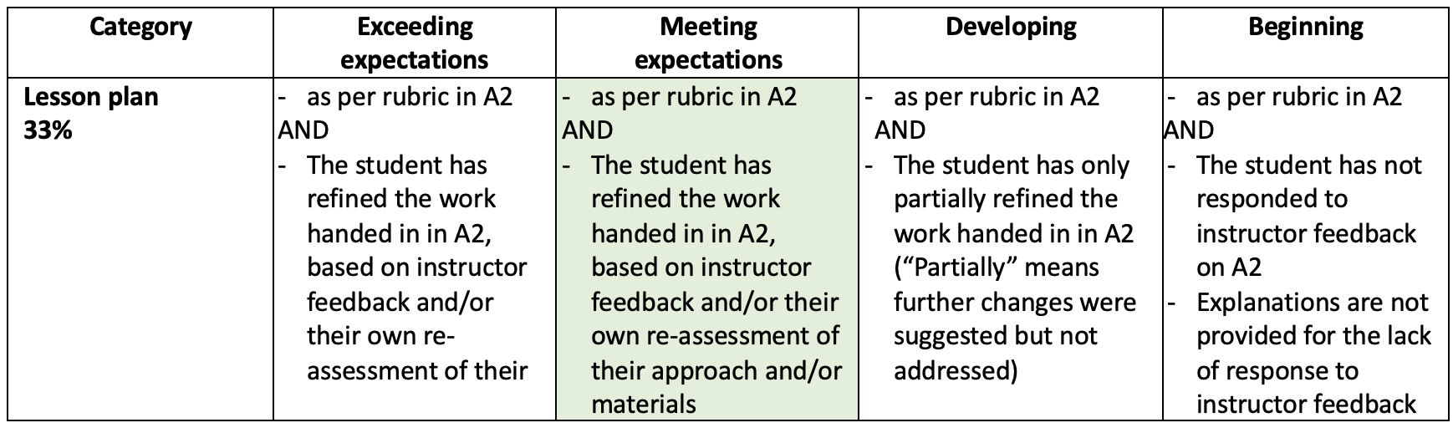
- When you reach the end of the rubric, look back up at the different categories and give yourself a holistic, overall level, based on the pattern of cell choices you see, and the relative importance placed on each category by the percentages on the left.
  - Eg. Above, we see that the Lesson plan component of this assignment is weighted at 33% so it is quite important in terms of student achievement/mastery.
  - Whichever level you choose for the Lesson plan category will carry more weight towards the final overall level than another category that might have only a 12% weighting, for example.
- Please justify your overall level in a paragraph at the end of the rubric. You may also wish to include comments with each category, justifying your choices by category.

The final outcome of this part of the self assessment will be one of the levels – Exceeding expectations, Meeting expectations, Developing, or Beginning – being assigned to your A3.

I strongly recommend that you complete Part A’s rubric before you even look at the rubric for Part B, as the grades associated with the levels in Part B may influence your choices here. I want you to have an authentic experience using this rubric, which includes no pressure from assigning grades.

NB: By Meeting or Exceeding “expectations” the rubric is referring to course expectations and/or assignment expectations. If you’re meeting those expectations, you are doing what is expected at a competent level. If you’re exceeding those expectations, your work could be described as going “beyond” or being in some way superlative. How do we know what those expectations are? Look at the course and/or assignment learning outcomes, and also MLIS program standards and outcomes.

Note: If you are unclear about the rubric or how to use it, please ask for clarification before completing this assignment.

Part B:
Instructions:
- Please use the Part B Self Assessment Rubric document from Canvas for this part of the assessment.
- If you used the first rubric, referenced above (not the single point rubric) for Part A, it’s a similar process but this time, you will be assigning points and a grade.
- Go through the rubric and choose a level to represent the work you have done for each category. Please use a colour to indicate which level you have chosen – use a different colour from Part A.
- Notice that the percentages on the left have been replaced by a maximum point allocation for each category. The weighting is the same, but now you will be assigning points for each category that will translate into a letter grade.
  - Now that it is clear where the levels fall in terms of letter grades, please resist the urge to go back and change any of the choices in Part A. This is part of the experience I want you to have. I want you to see if your choices change when there is a letter grade attached. This is an experiment, and I’m looking for authentic participation. There is no penalty for changing your assessment from Part A to Part B. If that does happen to you, it will provide good fodder for reflection in Part C.
  - Please also note that if I think you’ve given yourself too low a grade in Part B, I will boost it to what I think it should be. This is less of a concern now that you are all guaranteed an A- minimum, but please know that if I think your work deserves an A or A+ and you haven’t given yourself that, I will assign that grade. I want to remove all the pressure that could come with giving yourselves a grade, and I want you to have as authentic an interaction with the rubric as possible, trusting that you will end up with the grade you’ve earned. If you grade yourself higher than what I would have, I will be looking at your justification, which should be very clear about why you deserve the grade you’ve assigned. If I don’t see a clear justification, or clear evidence to support the grade, I may adjust your grade downwards. However, I prefer to go with your grade wherever possible, and in my experience, this works well for most people.
- Look at the maximum score for the category (eg. 6 for Lesson plan – the first category), and decide where on the scale from zero to the maximum (eg.0-6) you believe your work falls for this category. I have provided the breakdown to help you, for each level of achievement in each category. You can choose within that range once you’ve decided which level is appropriate. For example:

 | Exceeding expectations  5.1-6 | Meeting expectations  4.56-5.09 | Developing  3.84-4.55 | Beginning  0-3.83

- Here, you can see that this category’s maximum is 6 points. If you feel, after reading the descriptions, that your work falls into the “Exceeding” category, you then must assign points between 5.1 and 6. How will you do that? Look at the description provided for that level (Exceeding in this case) and decide if your work perfectly fits the description or if it falls a little lower than perfection. (And remember that no one is perfect .)
  - Note that it’s generally not helpful to start at 100% and deduct marks. This will typically result in grade inflation. Keeping in mind that this is graduate school and, as mentioned above, none of us is perfect, it’s a more helpful practice to start at a B+ or A- and add marks for areas where you have excelled. This will result in a more accurate grade, and it will also give you a very clear idea of how to justify your grade.
  - Also, note that you are grading yourself in a vacuum, which is difficult. If you were in my place, you’d see the entire class and have more context. Do your best. I’m aware of this potential challenge and I keep it in mind when looking at your work.

- Once you’ve assigned points for each category, add them up to see the final score. Please indicate the percentage and letter grade that goes with this score.

- Justify the grade you have given yourself in a paragraph at the end of the rubric. If you wish to include comments for each category, that is also fine. Please see this link for a guide to the percentages that correspond to letter grades at UBC: https://students.ubc.ca/enrolment/courses/grades

What do the letter grades mean in terms of “quality”? Here is a rough guide:

A+, A, A- indicates excellent performance.
B+, B, B- indicates good performance.
C+, C, C- indicates satisfactory performance.
D+, D, D- indicates less than satisfactory performance.
F indicates unsatisfactory performance (no credit: always include last date of attendance).
(From: https://inside.lanecc.edu/copps/documents/grades-definitions)

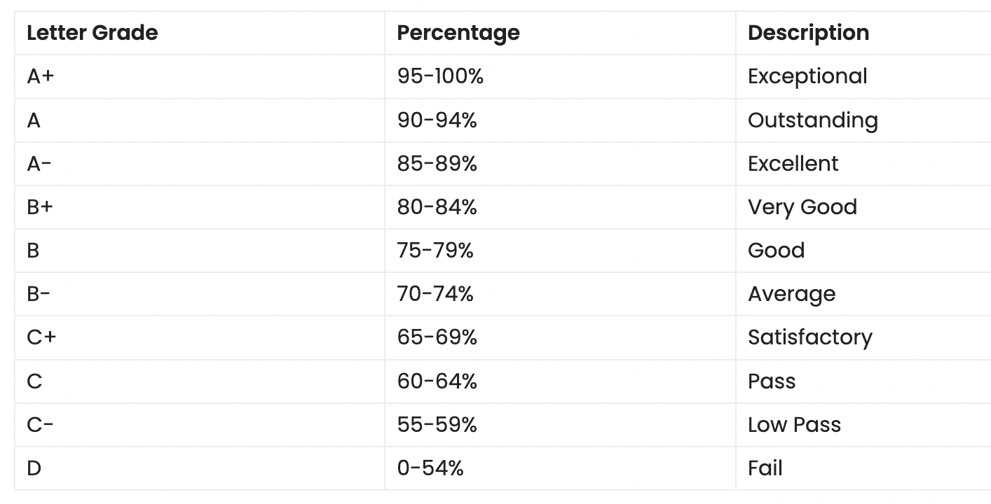
And here is another explanation that may assist (https://studying-in-canada.org/canada-grading-system/):

Both of the above examples use highly subjective language. This is where the rubric comes in, providing more evidence-based and quantitative ways of determining points/grades.

Part C: Reflection
Instructions:
In part C, I want you to tell me how this experience was for you. How did you feel when you were using Part A’s rubric, compared with that for Part B? How did the different rubrics influence your decisions? How do you think each rubric would contribute to the student experience if you were an instructor using one or the other? Anything you want to comment on here is appropriate, so please feel free to share anything that arises for you.

Why am I asking you to do this?
I have several reasons:
- Firstly, because grading student work is one of the most difficult things you will do once you start teaching (assuming you have to grade student work – you may not). I want you to get a sense of how it works and how to make it more objective. If a student challenges a grade that you have assigned, understanding how a rubric works and how to justify your grading choices using the rubric will be crucial.
- Secondly, assigning a grade to your own work is a highly reflective activity, which is in keeping with the spirit of this assignment (and course).
- Thirdly, I want you to experience the difference between a grade-based system and a non-grade-based system. They are subtly different, but have potentially profound impacts on the instructor, the student and the learning environment.

As always, please ask if you have any questions.

Updated May 5, 2026

