21 DVT
Introduction
Risk factors= acronym THROMBOSIS
Trauma,hypercoag.,OCP,malignancy,birth control,obesity,surgery,immobility,sickness.
Most important sequale is venous insufficiency pulmonary embolism in 50%of proximal thrombosis
Etiology=Virchow’s triad
Endothelial injury, stasis&hypercoagulability
Hypercoag may be inherited or idiopathic & acquired like age(60),trauma,surgery,neoplasm ,hyperhomocystinemia(TT folic acid 5mg daily),antiphospholipid antibodies(APLA),blood dyscriasis,hormones&immobilization

Clinical picture :

Homan’s sign is calf pain on dorsifection of the foot (classic sign but not specific or sensitive)
Tenderness of affected leg and palpable cord like structure are also classic symptoms
Unilateral leg edema is the most sensitive indicator of DVT

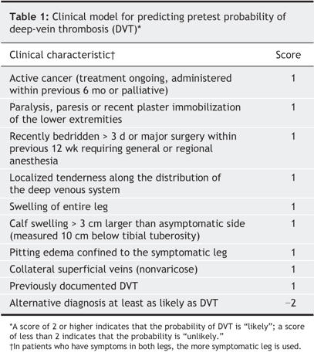
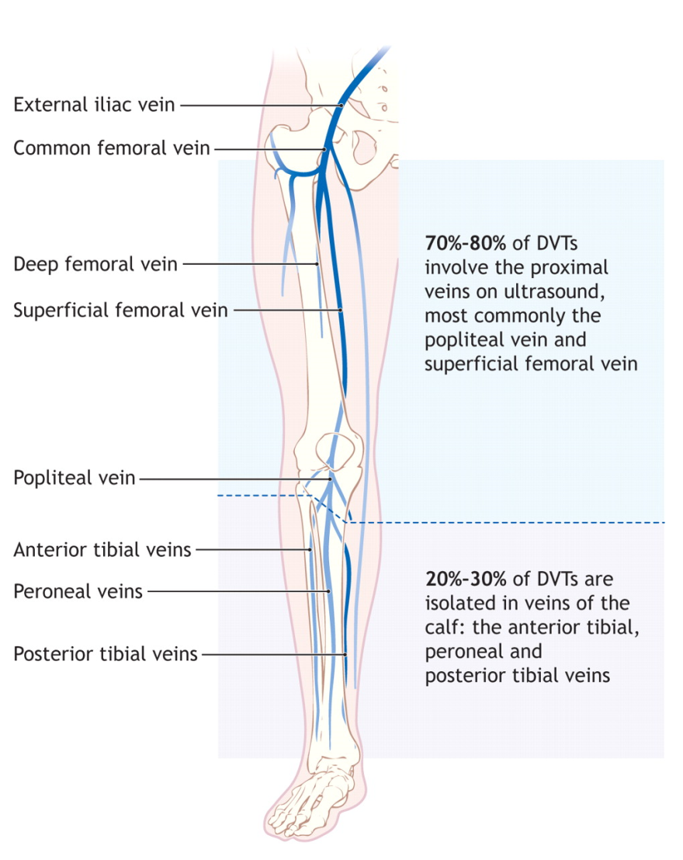
Wells Criteria

Differential Diagnosis
Ruptured Backer’s cyst
Cellulitis
Ruptured Achilles tendon
Lymphedema
Superficial phlebitis
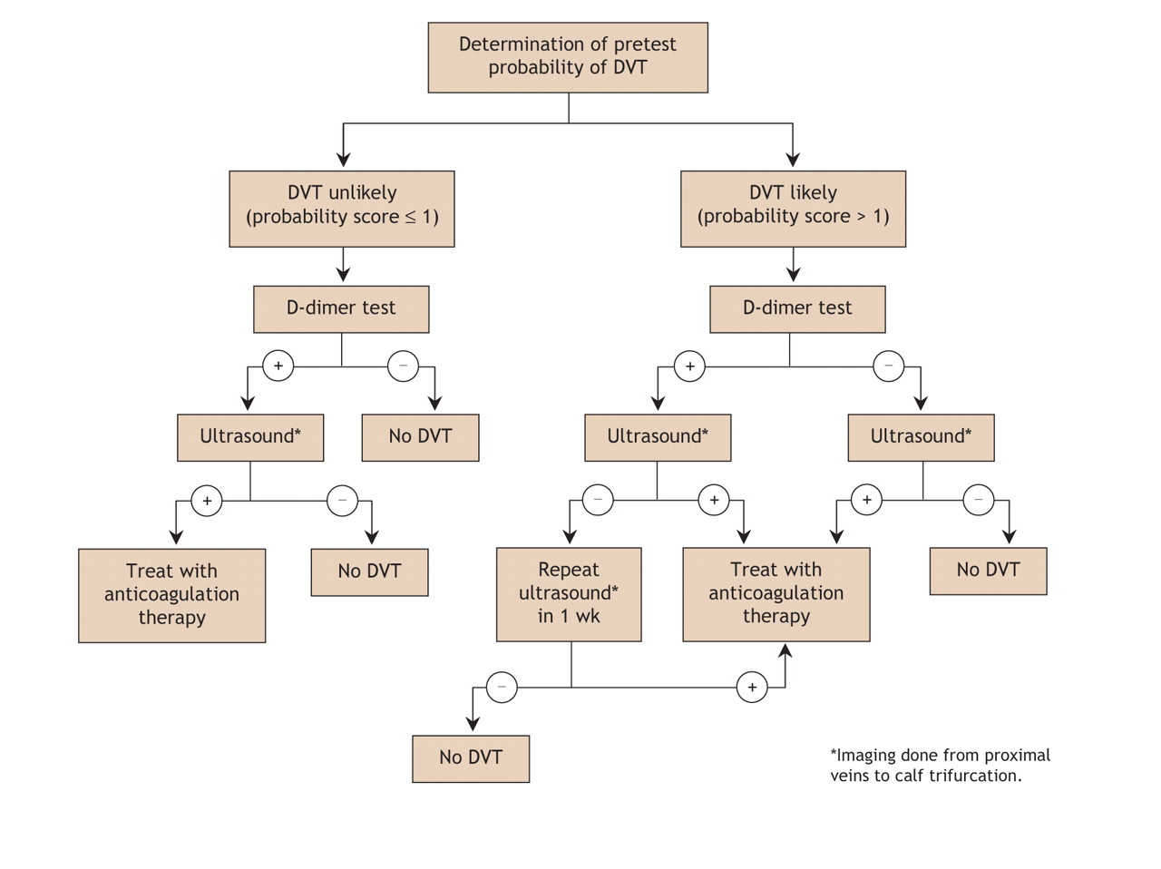
Algorithm for the Initial Work-up of Suspected DVT
D-dimer (fibrin degradation product) is usually increased in thromboembolic disease
Sensitivity of about 80% for DVT but Specificity of 30% [i.e. not the greatest test]
Real utility is its negative predicative value of over 90% [useful only if the test is negative]
Many studies show that low pre-test probability by Wells criteria and negative d-dimer rules out DVT
There is about 1% false negative rate with negative US and negative D-dimer
Doppler (95% sensitive for proximal DVT, 75% for distal calf DVT)
Distinction between proximal and distal DVT is important because calf only DVT rarely leads to PE
Prevention of pulmonary embolism is the reason for treating patients with DVT

1-Initial treatment;
A-Unfractionated heparin =bolus 7500-10.000 IU followed by infusion of 1000-1500 IU\H
Or weight based monogram .reversible by protamine .need to monitor aPT(level=2xnormal)
B-LMWH;subcutaous.as effective as heparin ,no monitor ,lower risk of HIT,renal clearance& need adjustment,
HIT patients=need hirudin, fondaparinux
If life threatening thrombosis we can use thrombolytic drugs like TPA, streptokinase
Long term treatment.
Warfarin with target INR
LMWH in cancer patients
* DVT1st episode=duration 3 months
*1st episode with ongoing risk like cancer, APLA consider indefinite period of treatment.
*1st episode with single inherit risk 6-9 months or indefinite
*Recurrent DVT=indefinite period.
*IVC filters if anticoagulant contraindications, with recurrent PE, pulmonary HTN, or pt require urgent surgery.
*Pregnancy=use LMWH then warfarin 4-6 weeks postpartum. Total duration 3-6 M.

Initiation of warfarin
-10 mg dose= shorter time to get target INR than start with 5mg without increase of side effects.
Overlap 4-5 days of heparin &warfarin required
Heparin antagonist vitamin K should be discontinued once harm stopped otherwise increase VTE.
Prophylaxis=BID 5000 IU if low risk, TID if high risk
*Risk of bleeding from heparin 7%
*Absolute contraindications of heparin
Include blood dyscriasis, recent ocular, intracranial surg., recent ICH, active bleeding
*DVT initial u\s should be followed by another u\s in a week to for extension to proximal veins

