Sept.11th.2011
Paint baking is a process of coatings in automotive assemblies that involves the application and cure of electrodeposited primer, sprayed primer/surfacer, and sprayed enamel coatings. Although the operations differ from manufacturer to manufacturer, a typical paint-bake cycle includes 7 stages: pre-cleaning, multistage phosphate pretreatment, electro-deposition coating, PVC underbody coating and sealing application, sprayed primer application and base and/or top coat application, and wax application (see Figure 1.1).
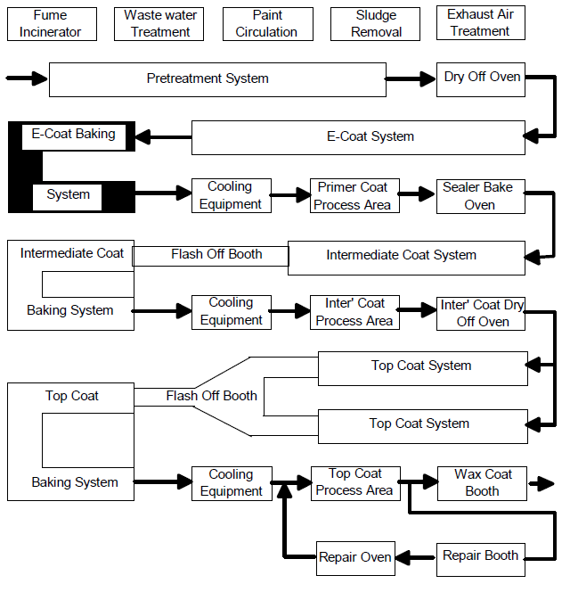
Graph 1.1: Process Flow Chart in a Typical Paint Shop
Each stage is explained below:
- Pre-cleaning
At this stage, dust, dirt and contaminants from previous processes on the body-in-white are removed to promote proper reactions and prolong the lifespan of degreasing baths at the phosphate pretreatment stage. Pre-cleaning can be performed manually with either high pressure devices, brush cleaning with chemicals, or a combination of both methods.
- Multistage Phosphate Pretreatment maintain
Phosphate pre-treatment provides better paint adhesion to protect metal surface against corrosion on the surfaces of the automobile bodies. The application of zinc phosphate is performed in number of stages. Before phosphating, all surfaces of the bodies are well rinsed and degreased to avoid contamination. The desired quality of phosphate coating texture, crystal size, morphology, and coating weight are maintained by proper surface conditioning. The values of concentration in various solutions, temperature and duration of the treatment for respective zones are crucial to a phosphating operation. Between the stages, the bodies are sent to various rinsing zones to prevent the contamination of the solutions and rinsing tanks. Finally, a rinsing zone of fresh demineralized water is connected at the end of the pre-treatment line for metal passivation and neutralization. The general flow of the pre-treatment system is shown in Table 1.1:
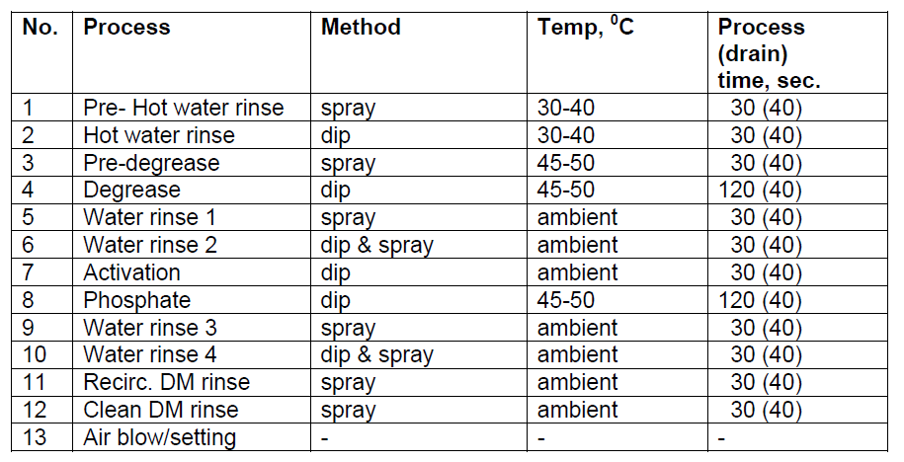
Table 1.1: Stages of Pretreatment System and Parameters

- Electro-deposition Coating:
Electro-deposition works similarly as eletrowinning processes. The metallic automobile parts are immersed into a paint bath that is prepared at a temperature of 25-27°C (pH-value of 5.6-6.6 and solid contents 16-20%) with deposition voltages between 350-500V. Consider the system as a cathodic electro- deposition. The automatic assemblies act as a negative electrode. Due to the electrical forces generated between the electrodes, charged particles from the paint emulsion gather towards the cathode and deposited onto the body surfaces, forming an unfired but shaped “green” film. After coating reaches all surfaces of the automobile parts by several repeating deposition processes, the bodies are sent to a rinse zone to remove any paint particles that are still not electrically deposited. Finally, the electro-deposition coated parts are baked and cured at 165-180°C for 20-30 minutes in an oven to set the paint and form a uniform, durable coat. The typical process sequence of electro-deposition system is as follows:
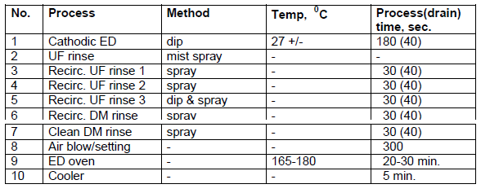
Table 1.2: Typical Process Sequence of Electro-deposition System

- PVC Underbody coating and Sealing Application:
This application is aimed to increase impact and corrosion resistance of the automotive assemblies. At this stage of the paint-bake cycle, joints and areas that can be easily corroded are welded. Gaps, cracks and seams are sealed with placement of 1 millimetre accuracy within seconds by programmed robots. At the end, the parts are sent to an oven at temperature of 160°C.

- Filler Primer Application and Base and/or Top Coat Application:
In the sprayed primer operation, the automobile bodies are coated with a filler primer layer that joins the electro-coat to the enamel. After the film is formed on all surfaces of the metallic parts, the bodies are moved to an oven at about 170°C for 30 minutes. Then, to the primer coated assemblies are sent to a “flash-off” shop to remove any contaminants from previous processes and smooth out any surface roughness in order for the enamel coating to be applied properly.
The enamel coating operation determines the visual appearance of the automobile vehicles. It is often made up of a colour base coat and a clear protective cover layer. Depending on the manufacturer’s plan, the bodies can be either sent through a topcoat booth or a basecoat booth followed by a clear coat booth. After the enamel applications, the automobile bodies are baked at around 160°C for 30 minutes.
- Wax Application:
This final application of the paint-bake cycle is used to protect the bodies from etching and scratch by applying a protective film of wax. The operation can be done by either manual spray method or automatic flooding method.
In manual spray method, the box section openings of the automotive bodies are sprayed with a solvent that contains preservative wax by spray nozzles. In automatic flooding method, the bodies are first preheated to 50-80°C. Then, a flooding tank of solvent-free hot wax at about 120°C is poured via automatic nozzles into box sections and cavities until completely filled.

**Reference
“Painting makes the difference.” Indra’s drishtikona (Viewpoint) 4 Aug. 2007. 11 Sept. 2011
<http://www.drishtikona.com/books/automobile-manufacturing/ch7.pdf>

