Leon Zhang, Vantage student
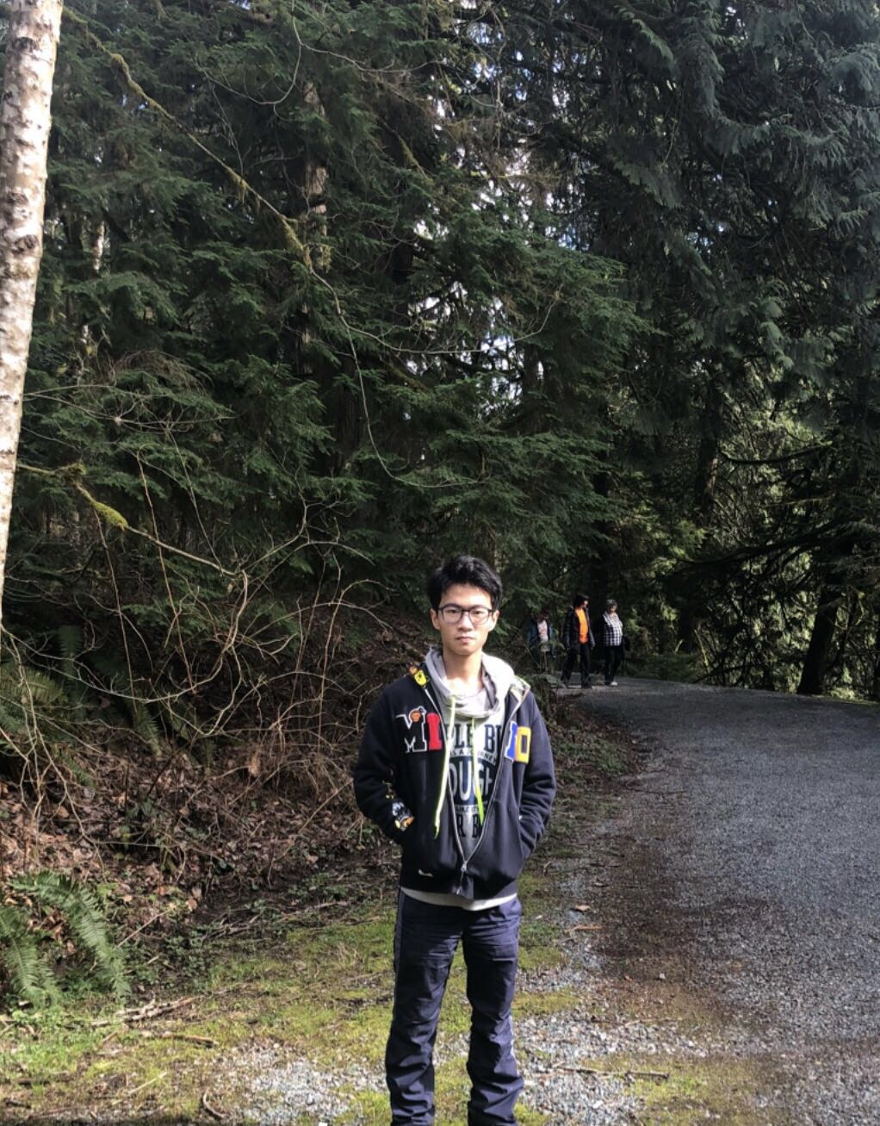
zhangyaolun000@gmail.com

Leon, international student of vantage college, based in Vancouver, vantage college is a college which designed for oversea student to get into second year of UBC degree. Leon has been studying in Vantage college for eight months.
Leon has a record of graduating in B.C. high school as well as achieving the standard requirement of volunteering for 24 hours through his time during high school. From which being a active volunteer in helping elderly.
Leon shows interest in learning and studying in sustainable environment and its solution to current problems in BC transportation system. He tires to help to solve the current problem in BC by doing qualitative research.

