Exploring Learning Resources
Indigenous Foundations

A common barrier to integrating Indigenous content in courses at all levels is negotiating variation in levels of prior knowledge, accuracy of information about Indigenous histories and contemporary realities, and anxieties around the use of language and terminology. These are some of the challenges that the website Indigenous Foundations tries to address.

Individual activity (To be completed prior to the workshop):

WATCH (5 min)
- Watch “Ignorance or what?” – a short film by UBC alumna Maryel Sparks-Cardinal (http://aboriginal.ubc.ca/a-little-knowledge/)

READ AND REFLECT: (15 min)

- Preview the “Identity and Terminology Worksheet” (pdf)
- Go to http://indigenousfoundations.arts.ubc.ca/, click on the “Identity” section and spend one minute previewing one of the three articles: “Terminology,” “A discussion on Aboriginal identity,” and “A discussion on identity and terminology.”
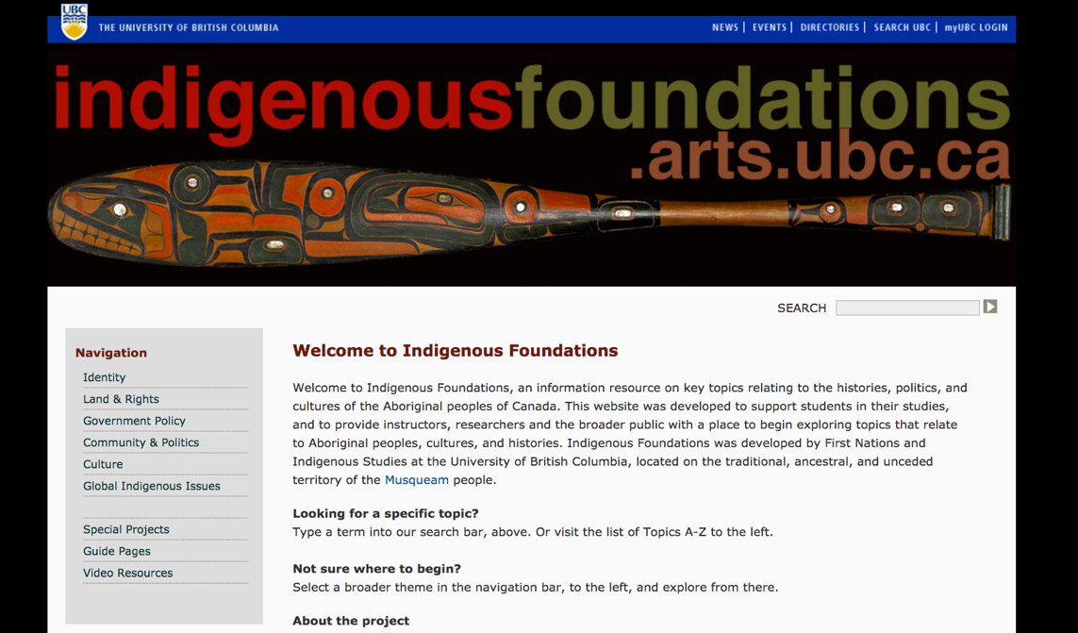
Apply: (15 min)
- Based on the information in the “Identity” article you selected- Look at the Identity and Terminology worksheet and begin to fill it out. If you get stuck that is ok we can revisit this in the workshop.

Group activity (To be done in the workshop):

DISCUSS AND EXPLORE
- Discuss the resources you engaged with as pre-work (video, worksheet and article) identifying some of your own experiences and challenges with background knowledge when teaching and/or learning Indigenous content.
- How might you adapt the materials from this activity for use in your own course, discipline, or project? How might these materials be useful to others designing courses or learning resources?
- If time permits, explore the navigation and other articles on Indigenous Foundations with your group. What topics might you find useful for exploring in your own courses?

RECORD
Notes from your discussion to report back

