Assignment #1: Land Acknowledgment

Instructions: Choose either A OR B to demonstrate what you have learned about Land Acknowledgments
Option A: Draft your personal Land Acknowledgment as a short paragraph (~100-150 words). Remember to include a reconciliation commitment/goal and a visual (picture).

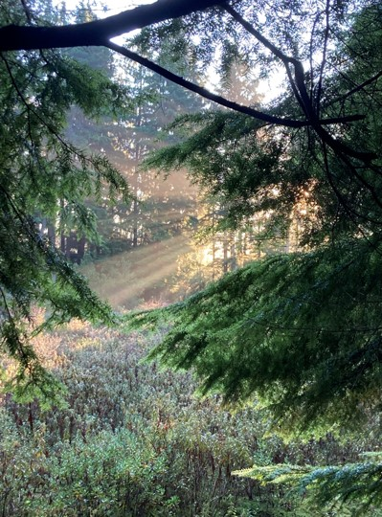
Option B: Draft your personal Land Acknowledgment as a short video (~ 1 minute). Remember to include a reconciliation commitment/goal.

Useful Nouns:
Land | Territory | Connection(s) | (De)colonization
History | Caretakers | Reconciliation | Elders

Common Adjectives:
Indigenous | Sacred | Beautiful | Uninvited
Traditional | Ancestral | Unceded | Stolen
* Remember it is important to choose adjectives that are respectful and accurate

Suggested Verbs:
To acknowledge | To study | To reside | To honour
…is located (on) | To live | To commit (to) | To recognize

xʷməm̓qʷe:m at sunrise

