Eco-Audit blurb for life cycle analysis.
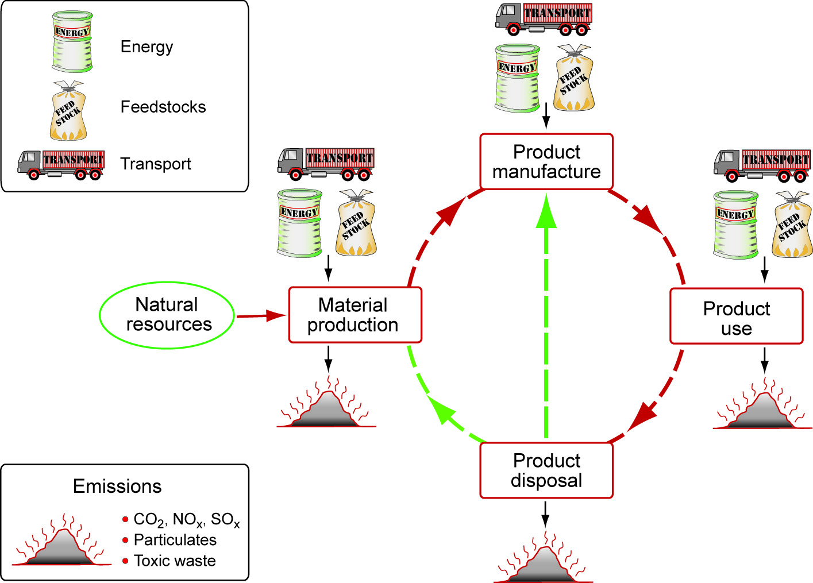
A life-cycle assessment documents resources consumed and emissions excreted during each phase of life for a particular item. These phases include material production, product manufacture, product use and product disposal. For the life cycle assessment (LSA) portion of our project we will be using the eco-audit component available in the CES software. As the purpose of this assessment is to compare how each of the actuating materials performs in terms of environmental impact, to start off we will use a simplified version of the standard eco-audit tool. This will allow us to make an initial decision of which actuator is a higher performer environmentally, for which we can later create a full assessment on the actuator of choice.
For the purposes of our initial selection, the simplified life cycle analysis will not take into account attributes that will be the same between the prototypes with the respective actuators, such as transportation and anything related to frame components. Rather it will focus on resources needed and emissions excreted for the manufacture, use and disposal of the actuators themselves.
Data to complete this assessment will be complied through manufacturer’s specification and research of the actuators and their environmental impacts.

