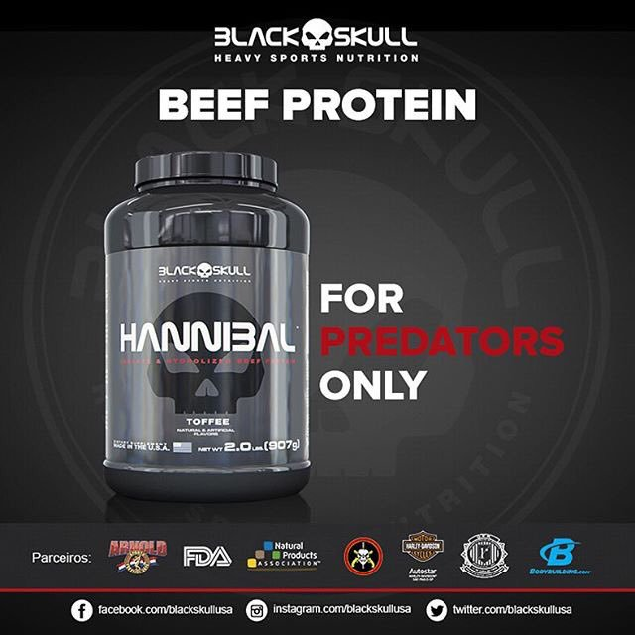

First, let's discuss the original ad:
I specifically went searching for an image that illuminates the mass slaughter of the Amazon rainforest. I wanted something that would demonstrate Bolsonaro's exploitation of the Indigenous peoples, the lands, and their wildlife, all to make way for beef agriculture. Then I stumbled across this.
My prime focus was on environmentalism, looking to bring consumer attention to the misinformation leading them to believe that meats are a healthy food choice. I wanted to let it be known just how much CO2 is released into the atmosphere with every tree being chopped down to make way for cattle farming.
But this image mirrors so many more societal issues that just environmentalism. We could look at the side of male toxicity. Both in regards to the product (selling protein), and then looking at the meaning and name behind the product.
Black skull: relates to death, violence, grief, turmoil.
Hannibal: is a historically significant Carthaginian military leader. The name portrays dominance, war, fighting, violence, death.
The tagline “For Predators only” is obviously intended to reach a male audience. But advertising/promoting this testosterone-driven mentality is both unhealthy and dangerous. They are implying that it is good to be the predator, AKA to hurt or kill another creature. This product is intended for consumers that are exercising to increase body weight/strength, but the product fails to promote a healthy body image, mental health, or fight the stigma that males need to be strong/violent to be considered “men” in society. This ad also promotes violence and a distorted societal image of what it means to be male.
On the environmental side, this product suggests killing other beings for the benefit of protein. As beef protein consumption is a major contributor to climate change, it is important to break down the product's advertisement and educate the public on how detrimental a beef-free diet is to sustainability.
The consumer product may be well-intended for strength and muscle building. But as the layers are torn off, bit-by-bit this product becomes more destructive.
We are in Grave Danger
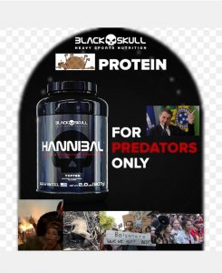

On first look, I reconstructed the image to look like the tombstone of a grave. I thought this would be fitting to represent the death brought forth by major beef industries in South America- particularly in Brazil. I want people to practice being conscious consumers and learn about the web of lies promoted by some of these corporations.
Beside the slogan "For Predators Only" is the fitting portrait of Brazil's current president, Jair Bolsonaro. Before being elected, Bolsonaro promoted a far-right, conservative government that would completely dispose of all intentions to protect the Amazon- including its animals, plants and Indigenous communities living there. Bolsonaro is known for his racist, homophobic, and sexist ideas. He is known to attack marginalized groups in order to gain power and money.
This past summer, forest fires increased by 80% in comparison to 2018 and previous years. Over 70,000 fires ravaged the Amazon rainforest that produces 20% of the world's oxygen.
Bolsonaro loosened environmental laws and encouraged mining and logging companies to deforest the Amazon, to make room for their corporations. Researchers have proved that the Amazon basin stores almost 127 billion metric tons of carbon. As the Amazon is destroyed, more carbon is emitted into the atmosphere and risks accelerating climate change to the point of no return. And the main reason behind the deforestation? To make way for agricultural industries to use the deforested land for farming. Primarily beef farming, and secondarily farming of soy beans- to feed the cattle.
This predator's actions have spiraled to create so many environmental and social issues. The photos I incorporated in the bottom of the grave represent:
1- the Indigenous
2- the native wildlife
3- the general public
4- my generation and younger that will have to deal with the consequences
I aspire to invoke change in people’s thought processes. Every single thing we consume has a chain reaction. We have the ability to change this narrative. Consuming one serving of beef can contribute to: thousands of liters of water being wasted, several square kilometers of deforested land, methane and carbon being emitted into the atmosphere, causing wild species to go extinct, destroying native culture and lives.
I hope that my culture jamming project may influence change in thought and behaviour! It is time we take control of our consumer behaviours to fight major corporations and their attack on our climate.

Works Cited:
https://www.nationalgeographic.com/environment/2019/08/amazon-fires-cause-deforestation-graphic-map/
https://mg.co.za/article/2019-09-05-00-as-bolsonaro-incinerates-the-amazon-urgent-action-is-needed-for-climate-justice
https://www.climatechangenews.com/2018/10/08/bolsonaro-made-grim-threats-amazon-people/
https://www.rainforesttrust.org/climate-change-series-part-1-rainforests-absorb-store-large-quantities-carbon-dioxide/

