Electronic Thesis & Dissertation (ETD) User Guide for cIRcle

Your ETD Submission Checklist:
□ Register for cIRcle Login
□ Contact the Faculty of Graduate Studies
□ Steps 1-10 – Submit your ETD to cIRcle

IMPORTANT!
Have you submitted your completed thesis forms to the Faculty of Graduate Studies?
If not, go to the Final Dissertation & Thesis Submission webpage on their website.

If you have already submitted your completed thesis forms to the Faculty of Graduate
Studies, you can proceed with the next steps.

Register
1a. Go to circle.ubc.ca
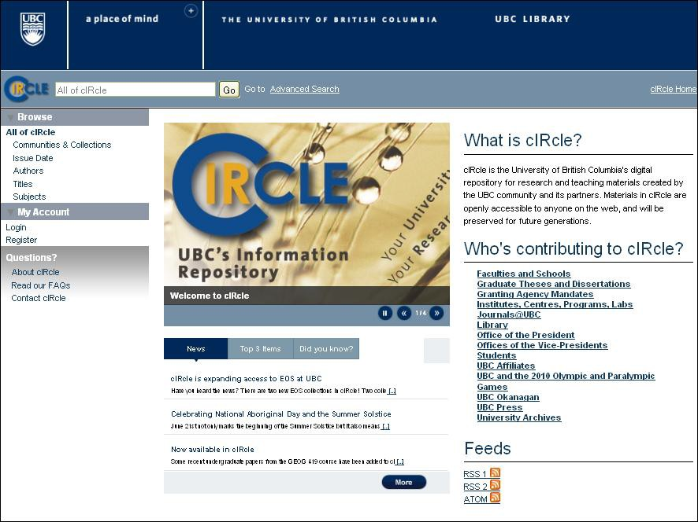1b. Click on “Register”

Step 1b.

Register (continued)
1c. Enter your email address
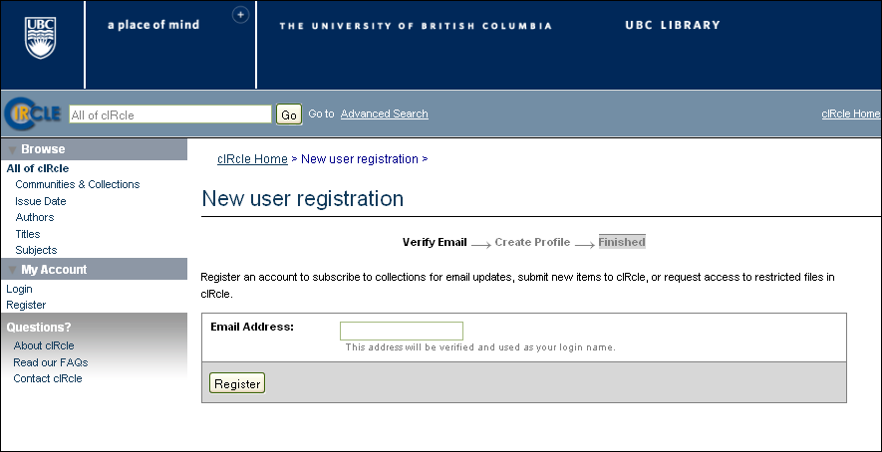1d. Go to your email account immediately to continue cIRcle account registration process. If you delay too long , you may receive an 'Invalid token' error message. If this occurs, please start the login registration process again from the beginning.

Step 1c.

Contact
Once you have registered for your cIRcle login and set your password, email the
Faculty of Graduate Studies (FOGs) at graduate.thesis@ubc.ca with your name and email address in the body of the email. Your email address needs to be the same email address that you entered in cIRcle.

TIP! If the Faculty of Graduate Studies has received your forms, your cIRcle account will be activated and you will receive an email confirming that you can now submit your thesis. If so, you can now submit your thesis electronically to cIRcle by following Steps 1-10 provided in this guide.

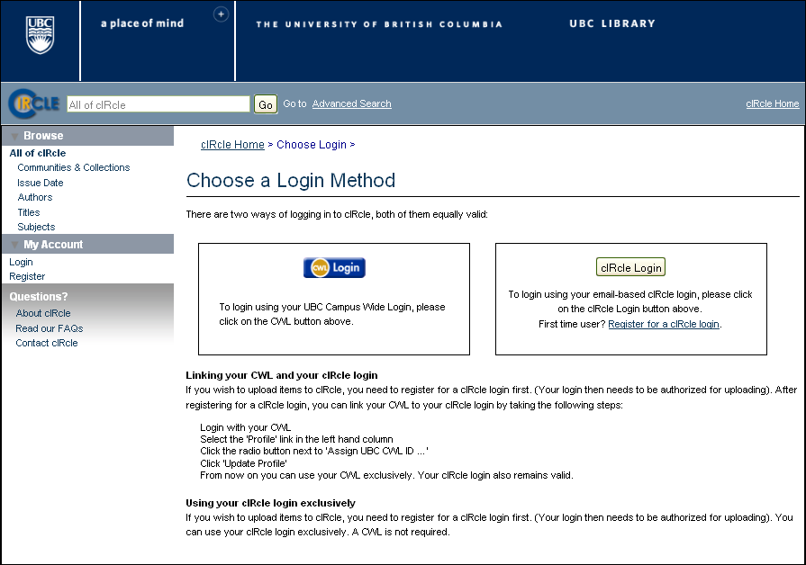Choose a Login Method:
1. On the cIRcle homepage at circle.ubc.ca, click on “Login” under “My
Account” in the left sidebar.
2. Next, click on the “cIRcle Login” button in the box.

TIP! Use your cIRcle Login account. Do not use your CWL login account.

TIP!

Step 1. Login to your account:
1. On the cIRcle homepage at circle.ubc.ca, click on “Login” under “My
Account” in the left sidebar.

TIP! At several stages in the upload process, you will be given the option to “Save
and Exit” if you wish to complete the submission at another time.

Step 1.

Step 2a. Start a new submission:
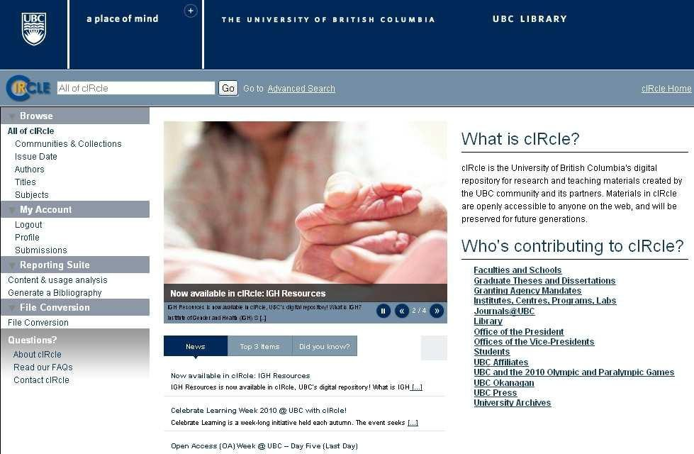Under "My Account" in the left sidebar, click on "Submissions".

Step 2a.

Step 2b. Start a new submission:
Next, click on "Start a New Submission".

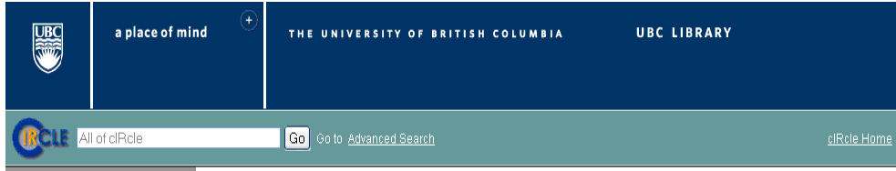

Allof ciRcle
Communities & Collections
Issue Cate Authors Titles
Subjects

ciRcle Home > Submissions >

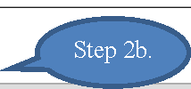Submissions & workflow tasks

Unfinished submissions

My Account These are incomplete item submissions.You may also stmt another·submsi sion .

Logout

Tttel

Collection

Submitter

Profile
Submisions
Reporting Suite
Content & usage analysis
Generate a Bibliography
File Conversion
File Conversion

About cRi cle Read our FAQs Contact ciRcel
0 Testv Test UBC and the 2010 Olympic and Paralympic Games: Coursework
0 Untitleel UBC and the 2010 Olympic and Paralympic Games:Research
UBC and the 2010 Olympic and Paralympic Games: Coursework

[ Remove selected submissions J
email:Tara Stephens email:Tara Stephens email:Tara Stephens

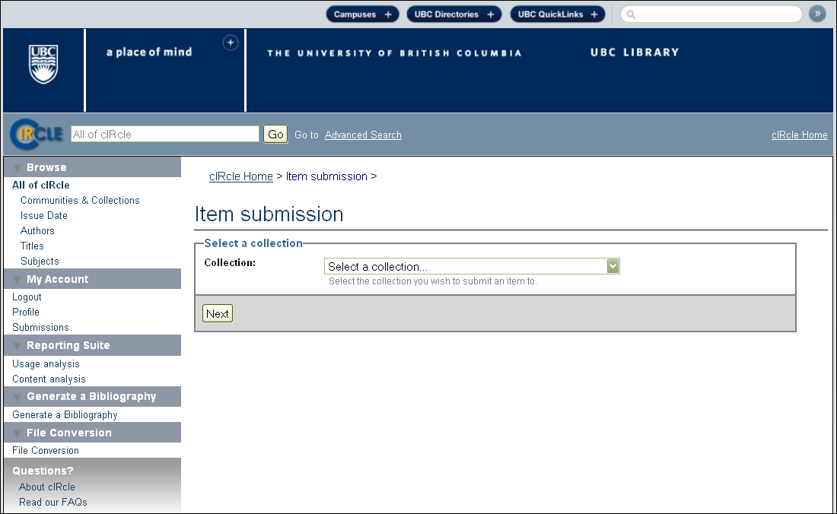Step 3. Select a collection:
3. Under "Item Submission", click on “Select a collection” from the drop-down
menu and select “Electronic Theses and Dissertations (ETDs) 2008+”. Click on
“Next” to continue.

Step 3.

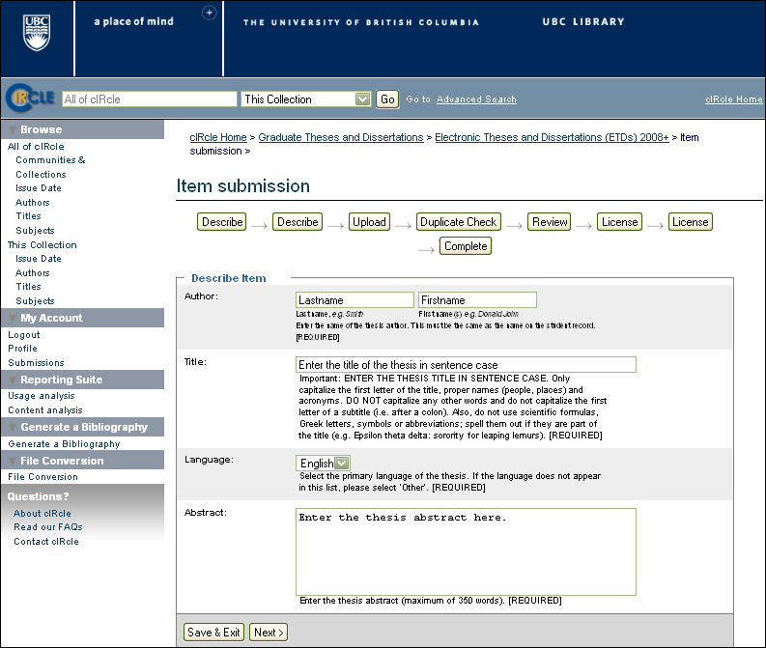Step 4a. Describe the item:
Fill in all of the required fields. Required fields will display in red if you do not
fill them in and you will be prompted to complete this step before continuing the submission process. You may also fill in the optional fields if desired. When you have finished, click on “Next” to continue.

TIP! If there are special characters such as diacritics, symbols, etc. in your title
or abstract, you can enter them in cIRcle by following the instructions in Entering Special Characters on the Faculty of Graduate Studies website at: http://www.grad.ubc.ca/current-students/final-dissertation-thesis- submission/circle-instructions.

Step 4a.

Step 4b. Describe the item:
Select the correct information from the drop-down menus for the required fields.
When you have fmished, click on "Next" to continue.

TJPI Your "Graduation Date" is the season in which you will formally be granted your degree and invited to convocation ceremonies. It will be either spring or fall.

Communities & Collections Issue Date
AuthofS
Titles
Subjects
This Collection Issue Date AuthofS
Titles
ciRcle Home > Graduate Theses and Dissertations > Electronic Theses and Dissertations CETDsl2008+ >Item submission >

Item submission

IDescribe I _,IDescribeI _,IUploadI _,IDuplicate Check I _,IReview I _,ILicense I _,ILicenseI

-->

Oestribe ttem

Subjects
Degree:
1 ... Select Degree ...
Select the degree level. (REQUIRED]

Program: I···Select Program··· I
Select the program. [REQUIRED]
Campus: 1 ... Select Campus ... J
Select the campus. (REQUIRED]

Graduation Date:

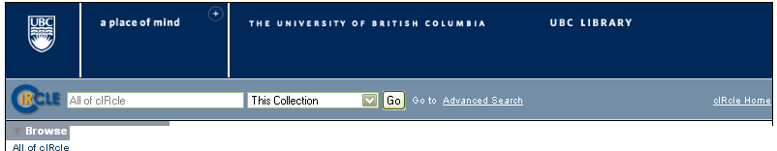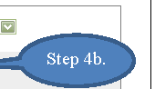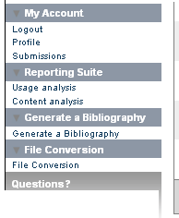

About ciRcle
Read our FAQs
Contact ciRcle
Copyright Date: 1 ... Select CoPJ'right Date ... J
Select the year of copyright from the title page of the thesis. (REQUIRED]

I< Previous IISave & Exit IINext> I

Step 5. Upload your thesis file:
Before uploading your thesis file, make sure that you have saved the file name
using all lower case and in the format shown directly below:

* ubc_gradyear_gradseason_lastname_firstname.pdf
* E.g.: ubc_2010_spring_houdini_harry.pdf

Next, click on the "Browse" button and locate the file on your computer. Then, click on "Upload". Verify that you have uploaded the correct file. When you have finished, click on “Next” to continue.

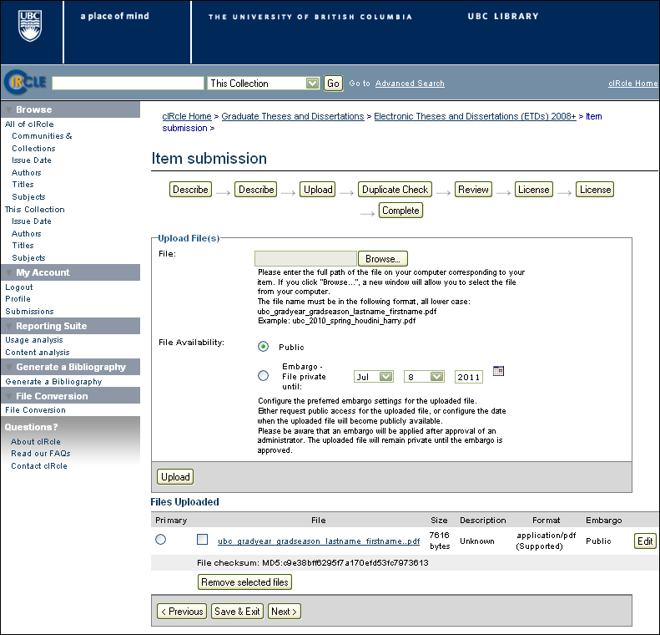TIP! If you uploaded the wrong file, select the file you want to remove under “Files Uploaded” then click on “Remove selected files”. Repeat Step 5 to upload your correct file.

Step 5.

TIP!

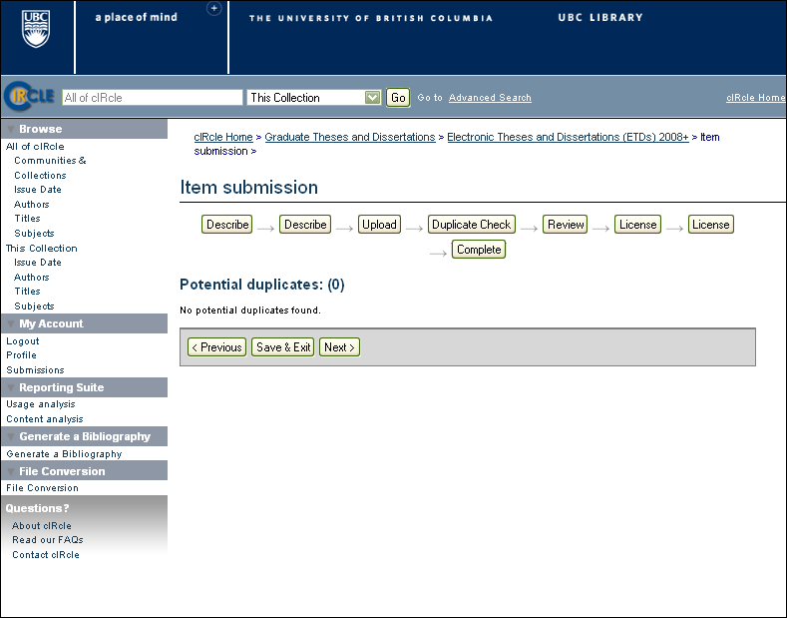Step 6. Potential Duplicates:
The system automatically checks for duplicate items in the database. The statement on the screen should read, “No potential duplicates found.” Click on “Next” to continue.

TIP! This quality assurance check makes sure that there are no duplicate submissions already archived in cIRcle. If the statement indicates the presence of a duplicate, email the cIRcle Office at ubc-circle@interchange.ubc.ca for assistance.

Step 6.

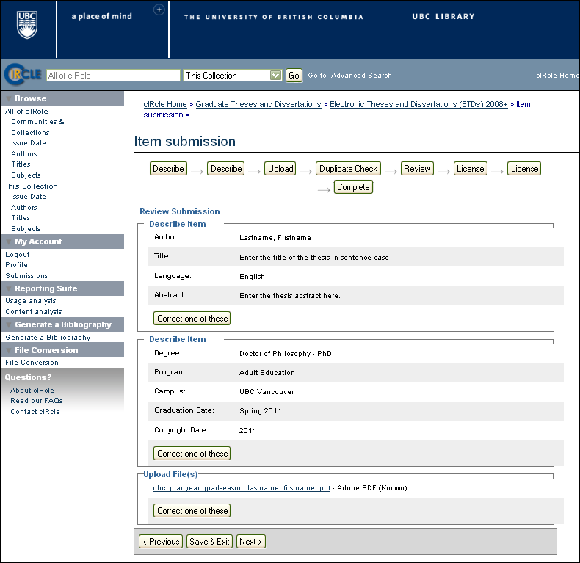Step 7. Review Submission:
Under each of the “Describe Item” sections, verify that the information entered
into all of the metadata fields is correct. Click on “Next” if there are no changes.

TIP! If you need to change the metadata in one of the fields, click on “Correct one of these”. This will allow you to return to the relevant section to make changes. Be sure to click on “Next” after making any correction(s) to ensure the changes have been saved. To navigate through the Item submission sequence, simply use the tabs labelled, “Describe”, “Upload”, “Duplicate Check”, etc. that appear at the top of the Item submission page.

Step 7.

TIP!

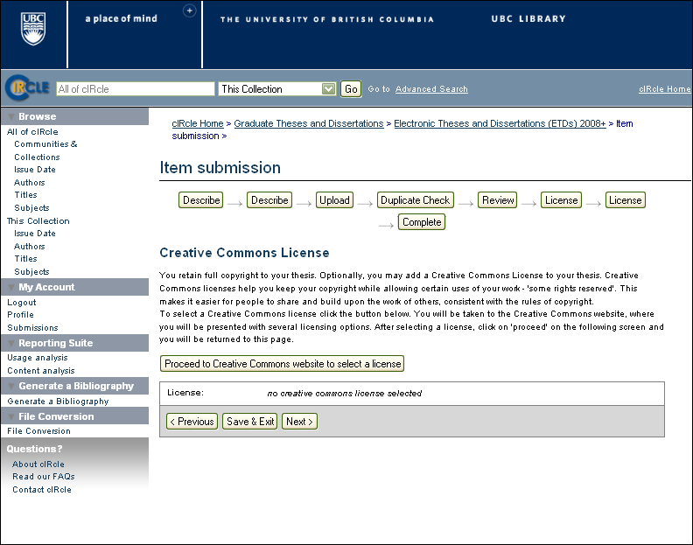Step 8a. Add a Creative Commons License (Optional):
To select a Creative Commons License, click on the “Proceed to Creative Commons website to select a license” button and follow the instructions. If you do not want to add a Creative Commons License, then click on “Next” to proceed to Step 9 in the submission process.

TIP! Creative Commons Licenses govern what people who access your work may then do with it. If you proceed to the Creative Commons website, you may see one or both of the following messages:

Message 1: “Security Warning: Although the page is encrypted, the information you have entered is to be sent over an unencrypted connection and could easily be read by a third party. Are you sure you want to continue sending this information?”

--Click on “Continue” to go to the Creative Commons License website.

Message 2: “This web page is being redirected to a new location. Would you like
to resend the form data you have typed to the location?”

--Click on “OK” to proceed.

Step 8a.

Step 8b. Complete your Creative Commons License:
On the Creative Commons License website, choose the type of license you prefer and click on “Select a License”.

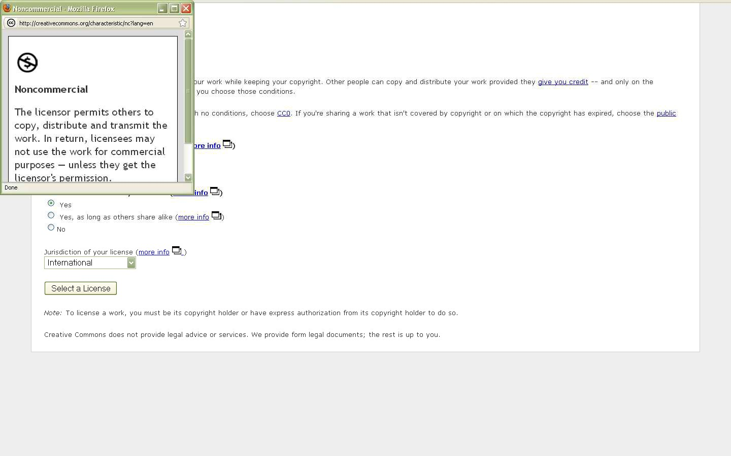TIP! To help you decide which license to use, click on the “More Info” link for each license type to learn more about conditions of use.

TIP!

Step 8b.

Step 8c. Complete your Creative Commons License:
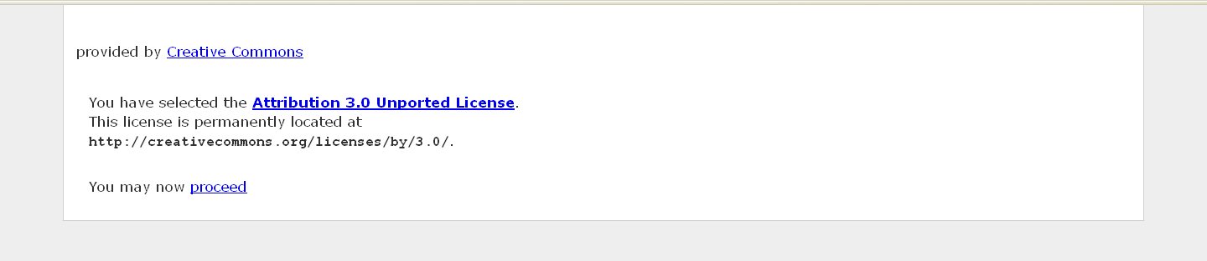After selecting your Creative Commons License, click on the “You may now proceed” link at the bottom of the screen. This will automatically return you to your unfinished submission in cIRcle.

Step 8c.

Step 9. Preview your Creative Commons License in cIRcle:
Under the “Creative Commons License” section, you will now see the Creative Commons License you just created with its associated hyperlink next to the “License” field in cIRcle. If you do not wish to make any changes, click on “Next” to proceed to the last phase of the submission process.

TIP! To delete the Creative Commons License, click on the “Remove this
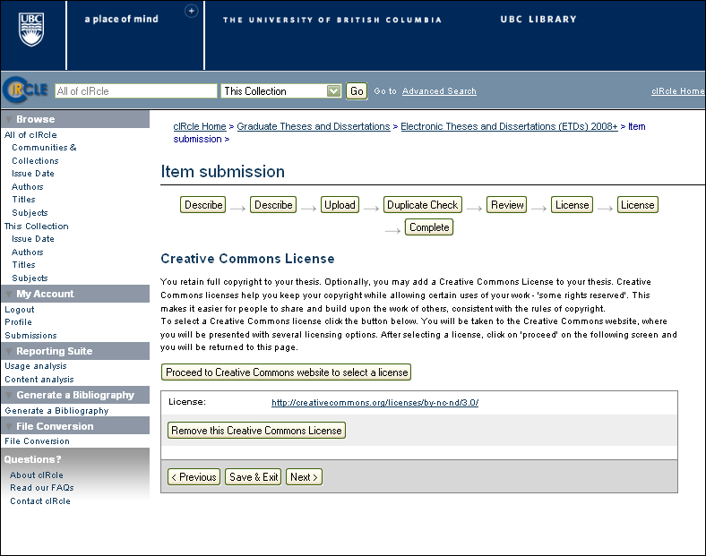Creative Commons License” button.

Step 9.

TIP!

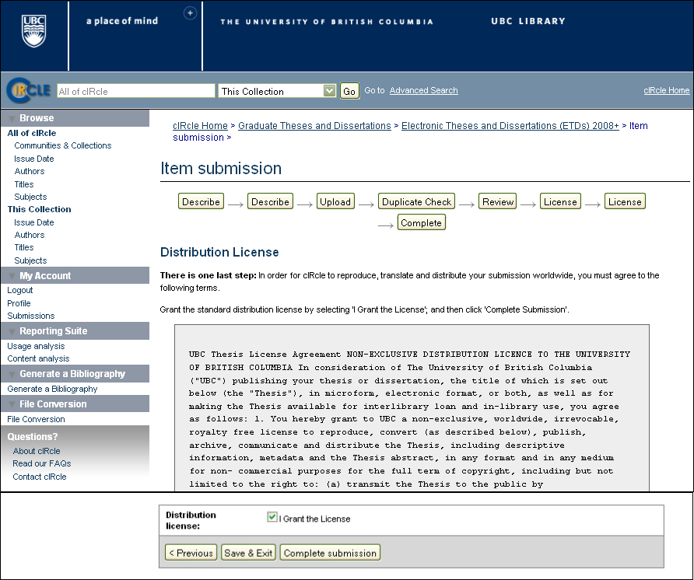Step 10. Complete the UBC Thesis Non-Exclusive Distribution License:
This is the final step in the submission process. The distribution license permits cIRcle to make your work available via the Web but you, as the author/creator, retain the copyright. Once you have read the license agreement, click on the box beside the statement, “I Grant the License”. Then, click on the “Complete submission” button.

Once you have made your submission, the final screen will indicate that the submission was successful.

Step 10.

Congratulations! You have now completed your cIRcle submission!

IMPORTANT!
It may take up to two business days for your thesis to be reviewed. When the Faculty
of Graduate Studies has reviewed and approved your thesis, you will receive an email notification. Your thesis has not been approved until you receive this email.

Last revised July 12, 2011

