Aluminum Alloy Common to automobiles:
Kaufman, J. Gilbert Introduction to aluminum alloys and tempers, November 2000, page 11-13 pages 95-96, pages 97-99, page 102 ,Pages 116

Main benefit of using Aluminum for automobiles: better gasoline mileage and its good specific strength
The following alloys are commonly used in automobiles:
- 5182 or 5754 sheet for car frame
- 6111 for body sheet panels
- 5083 and 5754 for inner body panels
- 7029 and 7129 for bumpers
- 3003 for Air conditioner tubes, heat exchangers
- 5257,5657 and 5757 for auto trim
- 2036, 6016 and 6111 for the hood and deck lids
5xxx series alloys – magnesium based: usually strain hardenable but not heat treatable
6xxx series alloys – magnesium and silicon as alloy content

6xxx – Aluminum-magnesium-silicon alloy reasons for choosing the 6xxx series alloys:
- Heat treatable (It could be strengthened by solid solution and precipitation strengthening)
- High strength (ultimate tensile strength = 125-400 MPa)
- Corrosion resistance (important for body sheets because it is common for car bodies to undergo environmental degradation)
- Easy to extrude (which makes the part easier to process)

** Commonly used for applications where stiffness is important (this could be important for resisting dents). However, the main reason for choosing 6xxx aluminum-magnesium-silicon alloy is due to its ability to be easily extruded.

5xxx- aluminum-magnesium alloy reasons for choosing the 5xxx series alloys:
- Good Strain hardenable (to increase hardness and strength by plastic deformation or working a metal below its recrystallization temperature)
- Excellent Corrosion resistance
- Good strength (ultimate tensile strength = 125-350 MPa)
- Good toughness ( could not find quantity)
- Could be welded with ease (many variety of welding techniques could be used and could be welded up to a thickness of 20 centimeter)
- Mechanical properties could be increased with more magnesium content
Note: 5xxx aluminum alloy series with more than 3 % magnesium content is susceptible to stress corrosion cracking (SCC) when continuously exposed to temperatures above 100°C
7xxx- aluminum-zinc alloy reasons for choosing the 7xxx series:
- Heat treatable
- High strength and toughness (Ultimate tensile Strength = 220-660 MPa)

From the literature review, it seems that the 5xxx and 6xxx aluminum alloy series are the most common aluminum alloys to the automobile industry. Therefore, it will be worth investigating further.
Compositions of aluminum alloys:
xxxx series alloy – example
First digit: major alloying class (1xxx = mostly pure aluminum etc.)
Second digit: defines variation in the original basic alloy (variation typically ~ 0.15% -0.50%)
- – original composition
- – first variation
- – second variation
Third and fourth: defines a specific alloy within a series

Typical Compositions of different 5xxx aluminum-magnesium alloy:
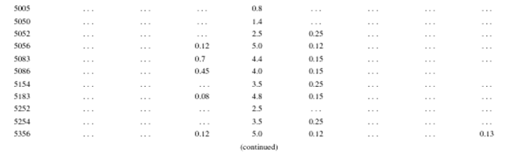
Typical compositions of different 6xxx aluminum-magnesium-silicon alloy:
