Antibiotics
In patients requiring antibiotic therapy, make rational choices (i.e., first-line therapies, knowledge of local resistance patterns, patient’s medical and drug history, patient’s context).
Otitis media
- Etiology – viral, Strep pneumonia, H. Influenza, M.catarrhalis
  - If perforation or tubes consider staph aureus, Pseudomonas aeruginosa or virridans strep
- Consider watchful waiting or delayed antibiotics
- Antibiotics SHOULD be given if <6 months, > 39 fever, immunodeficient, craniofacial abnormalities, heart or lung disease, history of otitis media complications and Down’s syndrome
- Amoxicillin first line treatment 75-90 mg/kg/day po divided q12h.
  - Clarithromycin alternate for Betalactam allergy
Chronic Rhinosinusitis
- Bacterial more likely if symptoms lasting longer than 10 days or symptoms worsening more than 5 days
- Etiology - >90% start as viral then Strep pneumonia, H. Influenza, M catarrhalis. If chronic – Staph aureus, Grp A strep, enterobacteriacea, anaerobes
- 70% will resolve spontaneously – resever antibiotics for severe symptoms or moderate symptoms that don’t improve in 7-10 days or get worse
- Amoxicillin first line treatment. Amox-clav for chronic sinusitis
  - TMP/SMX or doxycycline for betalactam allergy
Soft tissue infections
Impetigo
- Staph aureus, Grp A Strep
- Give systemic antibiotics if multiple, extensive or recurrent lesions, fever, constitutional symptoms, lymphadenopathy, immunocompromised, valvular heart disease
- Mild symptoms - topical Mupirocin 2% or Fusidic acid 2%
- Systemic antibiotics – Cloxacillin or Cephalexin
  - For betalactam allergy – erythromycin or clindamycin
Folliculitic or Furuncles
- Usually self-limited not requiring antibiotic treatment. Treat with systemic antibiotics if on scalp
- If recurrences treat carrier state with mupirocin 2% topically to nares for 3-5 days
- Hot tub folliculitis may be due to Pseudomonas which is also usually self-limiting but if severe can be treated with Ciprofloxacin
Cellulitis
- Do thorough history to rule out bites, dermatitis, foreign body, tinea, vascular causes
- Mild – cloxacillin or cephalexin
- Severe non-facial – cefazolin or clindamycin
- Severe facial – Cefazolin or cetriaxone
- Alternate for Betalactam allergy is clindamycin
Pharyngitis
- >90% viral and do not require antibiotics. Antibiotic treatment can be delayed while waiting for swab
- Conjunctivitis, cough, hoarseness, rhinorrhea and diarrhea suggest viral etiology
- If bacterial – Group A strep, all other causes are rare
- Goals of antibacterial treatment are to prevent rheumatic fever, shorten course by 1 day and prevent transmission
- Amoxicillin first line
  - Erythromycin for betalactam allergy

Urinary Tract Infections –
- Acute cystitis
  - First line
    - SMP/TMX (be aware of local resistance patterns)
    - Nutrofurantoin – not if CrCl <40
- Recurrent cystitis < 1month
  - Do cultures
  - First line SMP/TMX or Nitrofurantoin
- In pregnancy
  - Do follow up cultures
  - First line
    - Amoxicillin
    - Nitrofurantoin <36 weeks
- Complicated UTI
  - Men, obstruction, chronic catheter structural abnormalities, spinal cord injuries
  - First line SMP/TMX or IV amp and gent
  - Consider culture and sensitivities
- Pyelonephritis
  - First line cipro for outpatient, IV amp and gent for inpatients
- Prostatitis
  - First line SMP/TMX or Cipro or IV amp and gent

Pneumonia –
- Most common mycoplasma pneumonia, chlamydophylia pneumonia and strep penumoniae
- First line Amoxicilin or macrolide (erythromycin, azithromycin or clarithromycin), second line Doxycycline.
- IF comorbidities (COPD, diabetes, malignancy, renal failure, heart failure, alcoholism etc.) but NO antibiotics or po steroids in past 3 months –
  - All above etiologies plus H. Influenzae, M. Catarrhalis
  - First line Azithromycin, clarithromycin or Doxycycline
- IF comorbidities AND antibiotics or po steroied in past 3 months –
  - Above etiologies plus M. Catarrhalis, legionella pneumophilia
  - Use
    - Amox or amox/clav PLUS macrolide or doxy
    - OR Respiratory fluroquinolone (levofloxacin, moxifloxacin)
- Nursing home residents
  - chlamydophylia pneumonia, strep penumoniae, H. Influenzae, staph aureus, gram negative rods, aspiration pneumonia
  - Use
    - Amox or amox/clav PLUS macrolide or doxy
    - OR Respiratory fluroquinolone (levofloxacin, moxifloxacin)
- In hospitalized patients – treatment within 4 hours can decrease mortality
- In patients with antibiotic usage in the past 3 months, select an antibiotic from a different class
- If pneumonia onset is >5 days from admission to hospital resistant organisms are more likely to be present
- If at risk for MRSA
  - Consider in athletes, military, inmates, very young, aboriginal, IVDU
  - Add SMP/TMX, clindamycin, vancomycin or linezolid
- Aspiration pneumonia
  - Oral anaerobes
  - Consider if loss of consciousness, seizures, alcohol or drug overdose
  - First line amox/clav or cefuroxime
    - Second line clindamycin OR metronidazole PLUS fluoroquinolone
- Pseudomonas pneumonia
  - Consider if in ICU, cystic fibrosis, HIV, structural lung disease, bronchiectasis
  - First line Ciprofloxacin OR levofloxacin PLUS one of imipenem, meropenem, cefrazidime, cefepime or pip-tazo

In patients with a clinical presentation suggestive of a viral infection, avoid prescribing antibiotics.

In a patient with a purported antibiotic allergy, rule out other causes (e.g., intolerance to side effects, non-allergic rash) before accepting the diagnosis.
- Approximately 85-90% of patients with reported penicillin allergies who undergo skin testing do not have positive skin tests and are able to tolerate penicillins
- Differentiate between types of reactions as Type 1 carries risk of anaphylaxis if patient re-exposed
- Do thorough history of reaction including time since last reaction (penicillin IgE Ab decrease over time)
- Referral to allergy specialist is recommended
- Delayed cutaneous reactions more common if concurrent viral infection esp EBV
- Patients with history of Stevens-Johnson syndrome, toxic epidermal necrolysis, hypersentivity syndrome or other exfoliative dermatoses should not be re-exposed under any circumstance
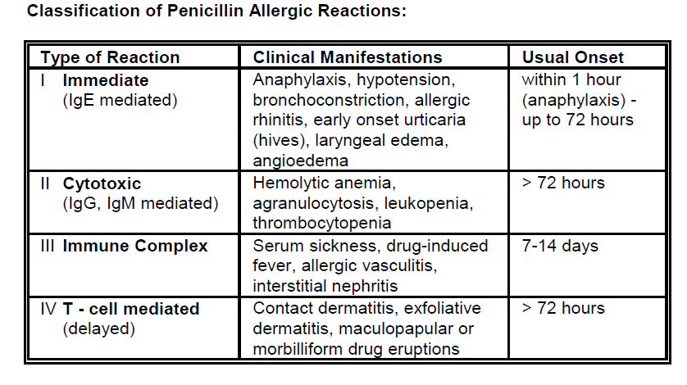

Screen clipping taken: 11/02/2012, 9:04 AM

Use a selective approach in ordering cultures before initiating antibiotic therapy
Usually do not order cultures in uncomplicated cellulitis, pneumonia, urinary tract infections, and abscesses.
For elderly patients – do not culture urine if not symptomatic
Do order cultures for assessing community resistance patterns, in patients with systemic symptoms, and in immunocompromised patients
In urgent situations (e.g., cases of meningitis, septic shock, febrile neutropenia), do not delay administration of antibiotic therapy (i.e., do not wait for confirmation of the diagnosis).
Suspected condition | Empiric treatment | Other considerations
Meningitis | <1 month  - Amp +cefotaxime  1-24 months  - Vanco + ceftriaxone or cefotaxime  2-50 years  - Vanco + ceftriaxone or cefotaxime  >50 year  - Vanco + ceftriaxone or cefotaxime + amp
Septic shock | Obtain cultures  Empiric therapy  - Vancomycin PLUS one of cefriaxone, cefotaxime, pip-tazo, imipenem, meropenem | Assess for risk of pseudomonal infection
Febrile neutropenia | Initiate anti-pseudomonal beta-lactam ie: cefepime, meropenem, pip-tazo  Add other antibiotics in patients with focal findings, complicated presentations or demonstrated antimicrobial resistance | Consider addition of an anti-fungal drug after 4-7 days in high risk patients

