Research Commons:

Citation Management Workshop Using Flow

Learning objectives

- Overviewing citation management tools
- Creating Flow account and installing Flow tools
- Adding references
- Organizing, categorizing and annotating references
- Citing references and generating bibliography using Flow with Word
- Sharing your references

Creating Flow account and installing Flow tools
Creating a free Flow account
- Go to: https://flow.proquest.com/signup/
- Enter your university email.
- Enter a password.
- An email will be sent to the email you have entered and you will be asked to click on a link for verification.
- You will be prompted to enter basic information.
Adding Save to Flow to your Browser
- After entering your information to create a Flow account, you will be asked to add the “Save to Flow” button into your bookmarks bar.
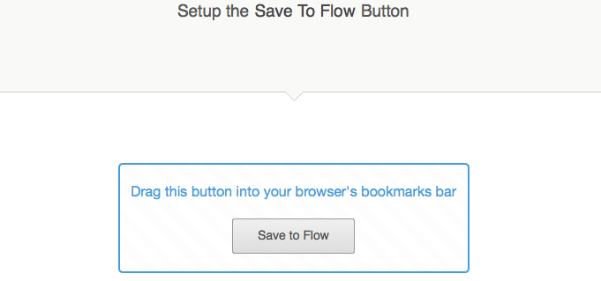

- The “Save to Flow” button captures information on a webpage and saves it to your Flow library.
- Simply drag and drop the button into your bookmarks bar.

Importing existing references

- You will also be given the option to import references from another citation management programs.
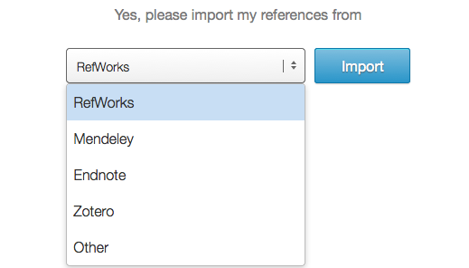
- Using the drop-down menu you may select from which program you would like to important your references.
- You may also choose to not to import references, and click “Let’s Go!”

- You will then be taken to your Flow library.

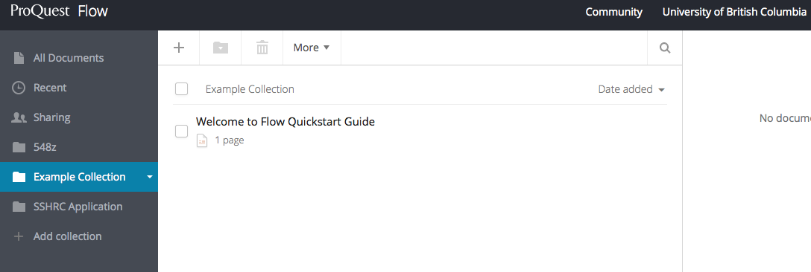

Adding references
There are a number of ways to add documents and references to Flow:

- Drag and drop: References can be added by dragging existing .pdf documents into the main library space. This will usually automatically gather information such as title, author, date, etc. However, sometimes it does not recognize the file, and data must be typed manually. Even if the data inputs automatically, it should always be checked for mistakes! This is especially so for volume and issue numbers.

Editing data is easily done by clicking the file to open it within Flow, and selecting the pen in the upper right corner to edit the document.

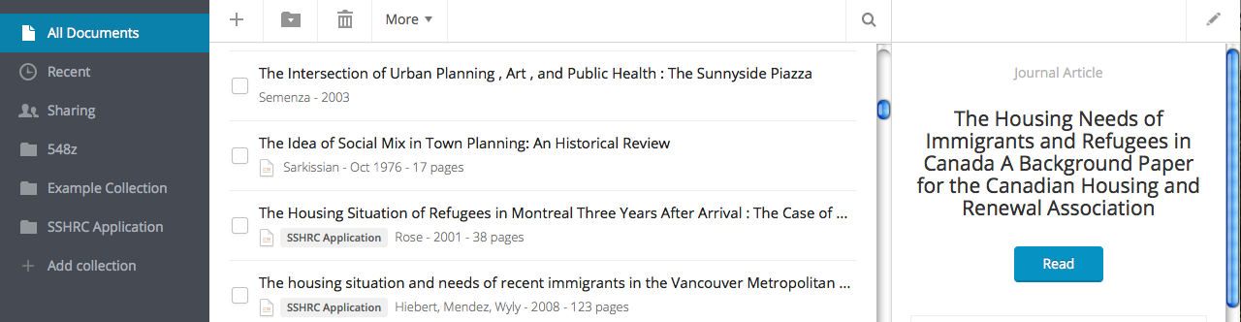

- Upload documents: Using the add reference button + , select “Upload document” to select files from your computer to add to your Flow library.
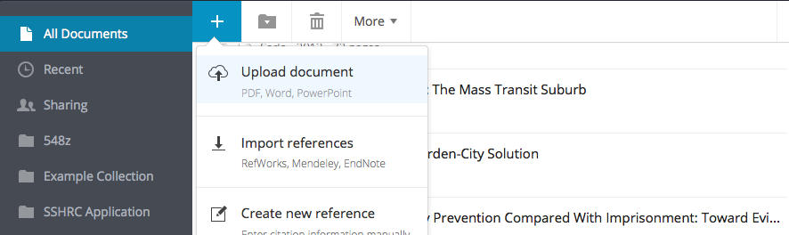

- Manual entry: Adding references manually is useful when references don’t import due to technical difficulties or you are using non-traditional sources like interviews, TV shows or radio programs.

Using the add reference button +, select “Create new reference” and enter the reference information in the side bar on the right-hand side. Select “Save” to add the reference to your library.
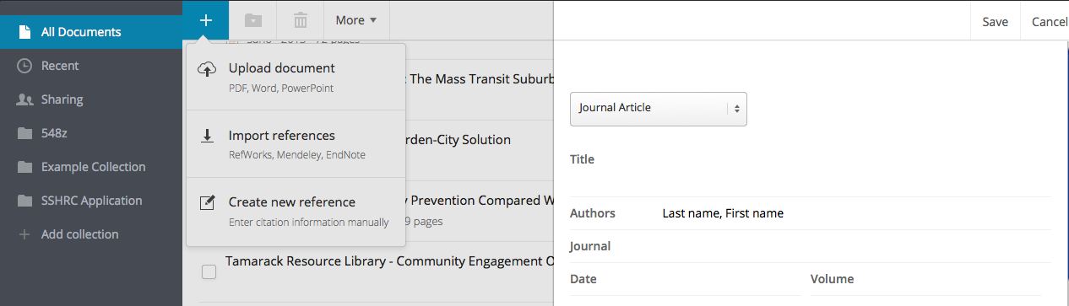

- Web importer: Whenever you’re on a web page that has an item you want, click the “Save to Flow” button to save the reference, .pdf or document to your library.

You can add references directly from the Internet in several ways:

From search results: After performing a search using Google Scholar or a journal database click the Save to Flow bookmark. A pop-up window will appear with a list of articles from the search result, and the desired articles can be selected to import to Flow.
Items with the option will also import the file to the library.

From an abstract: The same can be done from an abstract page.

From an article .pdf: If the article opens as a .pdf within the browser, Save to Flow will also import the file.

*Note: If the article is downloaded to your downloads folder and opens in a .pdf viewer, such as Adobe Acrobat, the Save to Flow button will not be present. In this case the file must be dragged and dropped in the Flow library.

From a non-academic web page: The Save to Flow button works much the same way for web pages, for example, online newspapers and blogs. When you Save to Flow, extraneous information like online advertisements will be removed.

Organizing and managing

1. Incoming documents: Incoming documents will be automatically placed in the ʻAll Documentsʼ and ʻRecentʼ collections in Flow.
2. New collections: To create a new collection select “Add collection” and enter a name.

3. Move collections: To move an item into an existing collection you can simply drag and drop into another collection.

4. Search: Using the search bar, Flow searches full text, metadata, notes and annotations.

Reading and annotating

- Reading: To view a document in Flow’s reader, click on the document in your library and select

- Highlight: In the reader, you have the option to highlight selected text.

- Notes: You also have the option to annotate selected text.

Citing and creating bibliographies
Flow has two ways for you to use documents and references in your papers:

- “Bibliography” button: You can create a bibliography from a collection or from all your documents and have it formatted in a specific style. Under “More”, select “Create bibliography”. Simply copy and paste the displayed references into your paper.

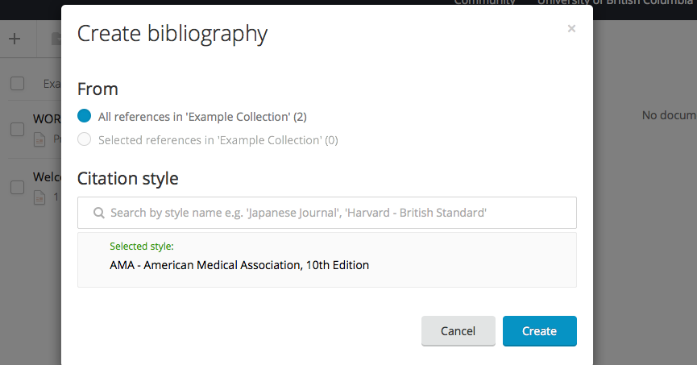

- Flow for Word:

* Please note that ProQuest for Word is only available to those with a paid subscription to Flow. It is not available to those using the free version of Flow with a UBC email.

Go to “Tools”, under the dropdown where your email address is listed and download “ProQuest for Word”. This is an extension to Microsoft Word that connects to your Flow library. Using this tool, you can automatically cite references and generate a bibliography.
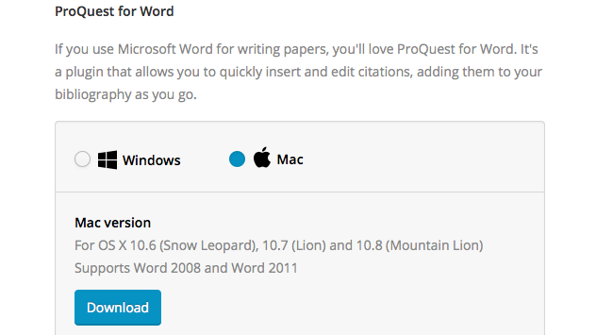

Below is the new tab on MS Word for Flow

From this tab you can “Insert citation” within a text and from Bibliography “Insert bibliography” at the end of a document. There is also an option to change the Citation Style.

Sharing and collaborating

With Flow, you can provide colleagues or project members with access to your collections.

- Open the collection you wish to share. Under “More” click “Share collection”.

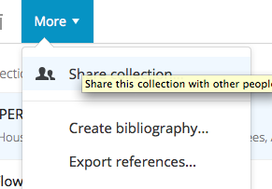

- You will then be able to invite people by entering their email addresses.
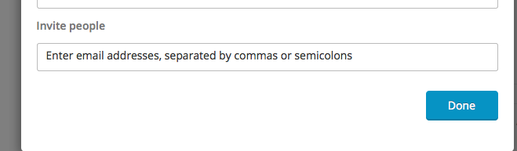

3. You determine the level of access for each collaborator and you can “unshare” the collection at any time.

