MTRL 466 MEETING MINUTES

Project Name: | Process Modelling for Adhesive Bonding of Aluminum Automotive Sheet
Group: | 1
Current Meeting: | Friday October 4th, 2011
Minutes Prepared By: | Adam Ohashi
Attendees:
Dr. Chad Sinclair
GROUP 1: Jerry Chang, Michael Fu, Judy Makmillen, Adam Ohashi
Agenda:
- Gantt chart / timeline review:
  - Gantt chart for last 3 weeks completed/posted to Wiki

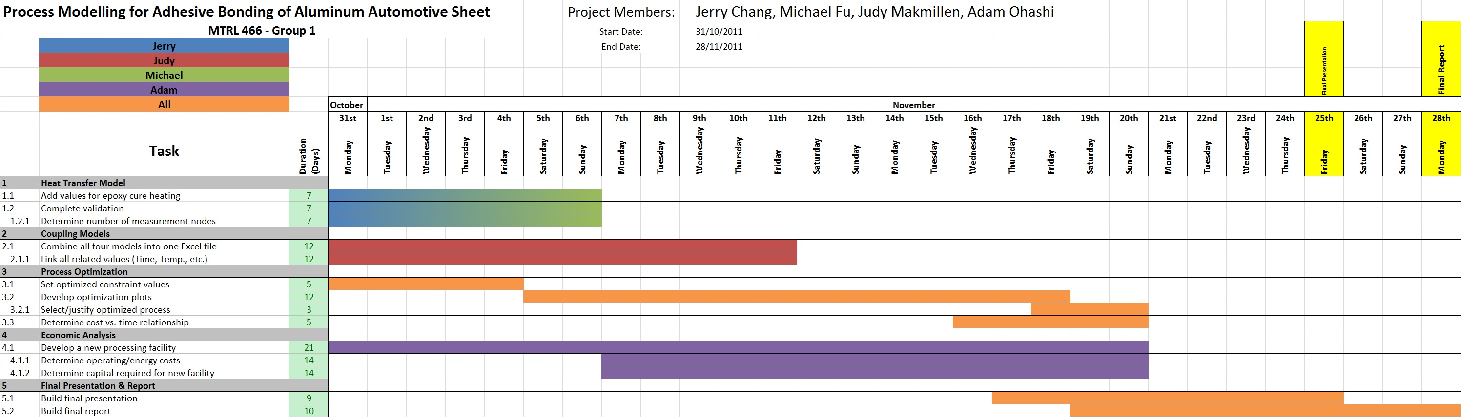
- Heat transfer model – Next Step:
  - Validation of model
    - Heating profile; semi-infinite slab, constant surface temperature
  - Heat values obtained from curing model integrated
  - Heating orientation? (1 side vs. both sides)

- Coupling models:
  - Judy managing the combining of all 4 models into one Excel workbook
    - Any issues with lack of sufficient memory?
      - Possibility of creating code to execute calculations
- Optimization:
  - Constraints:
    - Curing: approx. $α≤0.95$
    - Softening: approx. $\frac{∆σ_{5xxx}}{∆σ_{5xxx}^{o}}≤0.9$
    - Hardening: approx. $\frac{∆σ_{6xxx}^{peak}-∆σ_{6xxx}}{∆σ_{6xxx}^{peak}}≤0.9$
  - Waiting on coupled model to produce output values before determining optimal values of T, t, h
    - Smallest time that meets all process constraints

- Economic Analysis:
  - To start this weekend:
    - Determine costs associated with paint baking, energy/operating costs
    - Capital required for an annealing booth, paint station, etc.
      - Can use contacts from local companies for pricing
    - Begin developing a new processing facility (large scale)
Minutes:
Meeting start time:
Meeting end time:
Action Items:
- Next meeting:

