Land and Privilege Acknowledgment

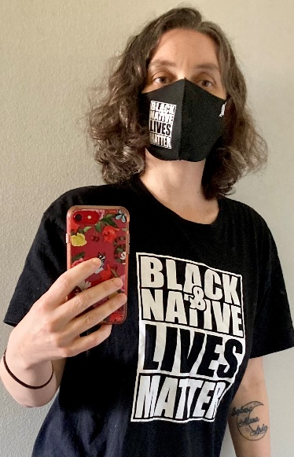

I would like to personally acknowledge that I was born and educated on the traditional lands of the Powhatan People. I also continue to live and work in real and virtual spaces as An Uninvited Guest thanks to the xʷməθkʷəy̓əm (Musqueam), sḵwx̱wú7mesh (Squamish), and sel̓íl̓witulh (Tsleil-Waututh) First Nations.

