PRACTICE TEMPLATE FOR USE IN RESEARCH COMMONS THESIS FORMATTING WORKSHOPS: NOT THE REAL THING

by
John Doe

B.A., The University of British Columbia, 2008

A THESIS SUBMITTED IN PARTIAL FULFILLMENT OF
THE REQUIREMENTS FOR THE DEGREE OF

MASTERS OF ARTS
in
THE FACULTY OF ARTS AND RECREATION

THE UNIVERSITY OF BRITISH COLUMBIA
Vancouver

January 2012

© John M. Doe, 2012

Abstract

This is the Abstract.

The abstract is a concise and accurate summary of the research contained in the thesis. It states the problem, the methods of investigation, and the general conclusions, and should not contain tables, graphs or illustrations. It must not exceed 350 words, and should contain relevant keywords that will make your thesis more likely to be found in an electronic search. Do not put a separate list of keywords. There must be a single abstract for the entire thesis.

Here are some other formatting notes that you may find helpful. Font size for text throughout your thesis should be 10-12 point if you are using Arial or Times New Roman. If you are using another font, make sure it’s not smaller than these fonts at these sizes. Your line spacing must be either 1.5 or double. Quotations of more than one line may be single spaced. Acknowledgements, footnotes, captions (for tables, figures and illustrations) and bibliography entries may also be single spaced, provided that individual entries are separated by a full space.

In terms of paragraphs, you may choose either to indent your paragraphs, or to leave an extra space between each paragraph (which is the method used in this template). You must use some form of paragraphing in your thesis.

In this template, the term ‘thesis’ is used rather than ‘dissertation’; however, this template may be used for either theses or dissertations.

Preface

This is the Preface. The Preface is only included if necessary under the conditions indicated below. If it is necessary, it will always appear immediately after the Abstract and before the Table of Contents. If you do not require a Preface for your thesis, you should delete these pages.

You must include a preface if any part of your research was partly or wholly published in articles, was part of a collaboration, or required the approval of one or more of UBC’s Research Ethics Boards. If you are not sure if your research requires ethics approval, please contact the Office of Research Services as early in your research process as possible.

The Preface must include only the following:
- A statement indicating the relative contributions of all collaborators and co- authors of publications (if any), emphasizing details of your contribution and stating the proportion of research and writing conducted by you
- A list of any publications arising from work presented in the thesis, and the chapter(s) in which the work is located. Do not include the actual publications at any point in your thesis.
- The name of the particular UBC Research Ethics Board, and the Certificate Number(s) of the Ethics Certificate(s) obtained, if ethics approval was required for the research. Do not include the actual Ethics Certificate(s) at any point in your thesis.

Examples of statements regarding collaborations or lists of publications arising from the research:
Chapter 2 is based on work conducted in UBC’s Maple Syrup Laboratory by Dr. A. Apple, Professor B. Boat, and [student’s name]. I was responsible for tapping the trees in forests X and Z, conducted and/or supervised all boiling operations, and performed frequent quality control tests on the product.

or

A version of chapter 3 has been published. [Student’s name], Apple, A. and Boat. B. (2010) Frequency of Quality Testing in Syrup Creation. Maple Science J. 255:139-144. I conducted all the testing and wrote most of the manuscript. The section on “Testing Implements” was originally drafted by Boat, B.

Table of Contents

Abstract II
Preface IV
Table of Contents VI
List of Tables VIII
List of Figures IX
List of Symbols X
List of Abbreviations XI
Glossary XII
Acknowledgements XIII
Dedication XIV
Chapter 1: Introduction 1
1.1 Section 1
1.1.1 Sub-Section 1
1.2 Section 2
1.2.1 Sub-Section 2
1.2.2 Sub-Section 2
1.2.2.1 Sub-Sub-Section 2
1.2.2.2 Sub-Sub-Section 3
Chapter 2: Body of Thesis 4
2.1 Section 4
2.1.1 Sub-Section 5
2.2 Section 6
2.2.1 Sub-Section 6
Chapter 3: Conclusion 7
3.1 Section 7
3.1.1 Sub-Section 8
3.2 Section 8
3.2.1 Sub-Section 8
Bibliography 10
Appendices 11
Appendix A 11
A.1 Sub-Appendix 11
A.2 Sub-Appendix 12
Appendix B 13
B.1 Sub-Appendix 13

List of Tables

This is the List of Tables. This must be included if you have any tables in your thesis. If you do not have any tables in your thesis, you should delete this page. If you have taken any tables from other sources, please contact the Copyright Office as early in your writing process as possible.

Make sure to update your List of Tables whenever you add or change a caption, or when you add in or delete pages from your thesis.

Tables must be numbered consecutively. They can be numbered with the chapter number or with no reference to the chapter number. You must use the same numbering system for tables, figures, illustrations, etc. Avoid mixing numbering systems.

Your table captions should either be consistently in sentence case (i.e., only the first letter of the caption and any proper nouns are capitalized) or consistently in title case (i.e., most words in the caption are capitalized, with the general exception of prepositions, conjunctions and articles).

Table 2.1 A sample of a table in Chapter 2 5
Table 3.1 A sample of a table in Chapter 3 8
Table 3.2 Second sample of a table in Chapter 3 8

List of Figures

This is the List of Figures. This must be included if you have any figures in your thesis. If you do not have any figures in your thesis, you should delete this page. If you have taken any figures from other sources, please contact the Copyright Office as early in your writing process as possible.

Make sure to update your List of Figures whenever you add or change a caption, or when you add in or delete pages from your thesis.

Figures must be numbered consecutively. They can be numbered with the chapter number or with no reference to the chapter number. You must use the same numbering system for tables, figures, illustrations, etc. Avoid mixing numbering systems.

Your figure captions should either be consistently in sentence case (i.e., only the first letter of the caption and any proper nouns are capitalized) or consistently in title case (i.e., most words in the caption are capitalized, with the general exception of prepositions, conjunctions and articles).

Figure 2.1 Sample caption for Figure 1 5

List of Symbols

If you are using specialized symbols in your thesis, list them here. Lists of symbols, lists of abbreviations, glossaries, etc., may go in any order you wish, so long as they appear after the Lists of Tables and/or Figures and before the Acknowledgements. If you do not have any specialized symbols in your thesis and do not need a list of them, you should delete this page.

List of Abbreviations

If you are using abbreviations in your thesis, list them here. Lists of symbols, lists of abbreviations, glossaries, etc., may go in any order you wish, so long as they appear after the Lists of Tables and/or Figures and before the Acknowledgements. If you do not have any abbreviations in your thesis and do not need a list of them, you should delete this page.

Glossary

If you require a glossary of specialized terms for your thesis, list them here. Lists of symbols, lists of abbreviations, glossaries, etc., may go in any order you wish, so long as they appear after the Lists of Tables and/or Figures and before the Acknowledgements. If you do not require a glossary for your thesis, you should delete this page.

Acknowledgements

This is the Acknowledgements section.

The following are usually mentioned in the Acknowledgements:
- Supervisor and committee
- Grant support
- Helpful fellow students, lab mates, etc.
- Family support
Acknowledgements may extend for more than one page, but should be no longer than two pages.

Example:
I offer my enduring gratitude to the faculty, staff and my fellow students at UBC, who have inspired me to continue my work in this field. I owe particular thanks to Dr. J. M. Schneider, whose penetrating questions taught me to question more deeply.

I thank Dr. O. Meyer for enlarging my vision of science and providing coherent answers to my endless questions.

Special thanks are owed to my parents, whose have supported me throughout my years of education, both morally and financially.

Dedication

This is the Dedication.

The dedication must be listed in the Table of Contents. You may decide you do not want to have the word “Dedication” appear on this page. In Microsoft Word, to get “Dedication” to show up in the Table of Contents without appearing here, change the colour of the word “Dedication” to white.

Introduction
Chapter Title: use Heading 2, will auto-generate the chapter number

This is the Introduction.

The introduction to the thesis must outline the theme, hypotheses and/or goals of the thesis and provide sufficient information to enable a non-specialist researcher to understand these. It must contain the elements listed below. The way in which these elements are incorporated will depend on the particular discipline.
- A thorough review of relevant literature
- A clear statement of the research question – the hypotheses and/or goals of the research
New chapters must begin on a new page.

Section
This is Chapter 1, Section 1.1.
Section Title use Heading 3

Sub-Section
This is Chapter 1, Sub-Section 1.1.1.
Sub-Section Title use Heading 4

Section
This is Chapter 1, Section 1.2.

Sub-Section
This is Chapter 1, Sub-Section 1.2.1.

Sub-Section
This is Chapter 1, Sub-Section 1.2.2.

Sub-Sub-Section
This is Chapter 1, Sub-Sub-Section 1.2.2.1. It includes an image of the initial step of the design I’m working with, but that image doesn’t have a caption. How do I do that?
Sub-Sub-Section Title use Heading 5
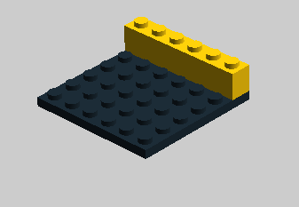

Sub-Sub-Section
This is Chapter 1, Sub-Sub-Section 1.2.2.2.

Headings and subheadings must never appear at the bottom of the page without at least one, preferably two lines of text underneath. Instead, move the heading to the next page, even if it means leaving a larger lower margin on the preceding page.
Heading 6 for Sub-Sub-Sub-Section Title

Body of Thesis

This is the Body of the Thesis. For the purposes of this template, only one body chapter has been included (Chapter 2). However, you may have as many body chapters as you and your supervisor decide are necessary.

The account of the research should be presented in a manner suitable for the field and include the following:
- A coherent structure that flows logically and smoothly from chapter to chapter
- A brief synopsis at the beginning of each research chapter
- A description of methods used, in sufficient detail to enable a reader to understand how the data were gathered and to apply similar methods in another study
- A complete account of the research presented in a systematic manner typical of the field of study
Students should consult with their supervisors for further guidance about how to structure their particular thesis.

Section
This is Chapter 2, Section 2.1. It includes Figure 2.1.

Figure 2.1 Sample caption for Figure 1

Sub-Section
This is Chapter 2, Section 2.1.1. I’d like to make a reference to Table 2.1 here, but I’d like it to be linked to the caption for that table. How should I do that?

Subject | Age | Average Response Time (ms) | Number Correct (out of 100) | Favourite Response | Level of Anxiety (out of 10) | Gender | Nationality | Last known academic experience
JA | 35 | 500 | 52 | C | 9 | M | Canadian | 10 years ago
JB | 27 | 450 | 78 | C | 4 | F | Australian | 12 years ago
AJ | 19 | 420 | 67 | D | 10 | M | Norwegian | Last week
DC | 52 | 600 | 98 | C | 6 | F | Unknown | No academic experience

Table 2.1 A sample of a table in Chapter 2

Section
This is Chapter 2, Section 2.2.

Sub-Section
This is Chapter 2, Sub-Section 2.2.1.
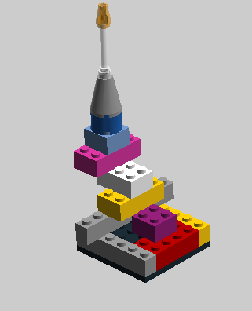
Image 2.1 Final step of construction

Conclusion

In this section the student must demonstrate his/her mastery of the field and (for doctoral candidates) his/her contribution to knowledge in the broader discipline.

The section includes the following:
- Overall analysis and integration of the research and conclusions of the thesis in light of current research in the field
- Conclusions regarding goals or hypotheses of the thesis that were presented in the Introduction, and the overall significance and contribution of the thesis research
- Comments on strengths and limitations of the thesis research
- Discussion of any potential applications of the research findings
- An analysis of possible future research directions in the field drawing on the work of the thesis

Section
This is Chapter 3, Section 3.1. I’d really like to have the header appear on the next page too; how do I do that?

Subject | Age | Average Response Time (ms) | Number Correct (out of 100) | Level of Anxiety (out of 10) | Gender | Suitability for job
JA | 35 | 500 | 52 | 9 | M | Low
JB | 27 | 450 | 78 | 4 | F | Moderate
AJ | 19 | 420 | 67 | 10 | M | Low
DC | 52 | 600 | 98 | 6 | F | High
SM | 6 | No responses | NA | NA | F | Unknown
Table 3.1 A sample of a table in Chapter 3

Sub-Section
This is Chapter 3, Sub-Section 3.1.1.

Section
This is Chapter 3, Section 3.2.

Sub-Section
This is Chapter 3, Sub-Section 3.2.1.

Subject | Last known academic experience | Level of Anxiety  (out of 10) | Suitability for job | Likelihood of success
JA | 10 years ago | 9 | Low | 0.25
JB | 12 years ago | 4 | Moderate | 0.75
AJ | Last week | 10 | Low | 0.5
DC | No academic experience | 6 | High | 0.95

Table 3.2 Second sample of a table in Chapter 3
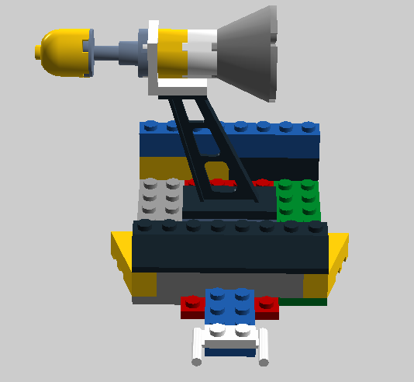
Image 3.1 A Possibility for Further Construction Designs

Bibliography

This is the bibliographic section of your thesis. What you will use as the title of this section will depend on what style of referencing you are using. “Bibliography” refers to a general list of information about sources, including both sources you have cited and sources you have consulted but not cited. “References” refers to a list of sources cited; sources consulted but not cited are not included in a reference list. “Works Cited” is the name given to a reference list in the MLA style. There must be a single bibliography for the entire thesis. For information on a variety of citation styles, please see UBC Library’s How to Cite Sources page. The bibliographic and citation style you use will be determined by the discipline you are in; consult your supervisor for advice on appropriate styles. If you are creating citations by hand and the style you are using needs a hanging indent (as shown below), select “ctrl + t” to auto-format the hanging indent.

Author, A. 2010. Title, publication details, in style permitted by your discipline. Please consult a style manual appropriate for your discipline for further details.

Author, B. 2010. Title, publication details, in style permitted by your discipline. Please consult a style manual appropriate for your discipline for further details.

Appendices
This title use Heading 1

This is Appendix A
Type a space and apply style “Heading 7” to create the title.

All appendices in the thesis must be presented together after the concluding chapter. Page numbering for appendices continues on from the body of the thesis, in sequence.
Appendices must be limited to supporting material genuinely subsidiary to the main argument of the thesis. Appendices must only include material that is referred to in the Body of the thesis.
The following are appropriate for inclusion in the appendices:
- Additional details of methodology and/or data
- Diagrams of specialized equipment developed
- Copies of questionnaires or surveys used in the research. Please ensure that personal information (e.g., names or contact information of subjects and/or researchers) is removed and/or blacked out from your questionnaire/survey copies.

Sub-Appendix
This is Appendix A, Section 1.
Sub-Appendix use Heading 8

Sub-Appendix
This is Appendix A, Section 2.

This is Appendix B.

Sub-Appendix
This is Appendix B, Section 1.

