Aluminum alloys common to automobile:
- Non heat treatable Al-Mg (EN 5xxx) and heat treatable Al-Mg-Si (EN 6xxx) alloy systems are most commonly used
Details:
- Variation in composition and processing could be used to improve corrosion resistance and formability, surface appearance and age hardening response
- Good strength/weight ratio
- Good fracture toughness and energy absorption capacity
- Good workability
- Ease of joining
- Recyclability

Application for Aluminum alloys:
- 5xxx aluminum-magnesium alloy
- Bridges
- Storage tanks
- Pressure vessels
- Automobile body panel and frame applications

Details:
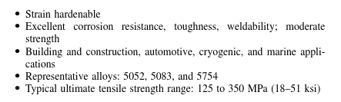
- 6xxx aluminum-magnesium-silicon alloy
- Bridge structures
- Marine frames
- Trucks parts
- Railroad cars
- pipelines
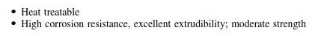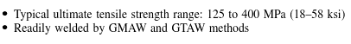
Highest volume of aluminum is in car castings (engine blocks, cylinder blocks, and chassis)

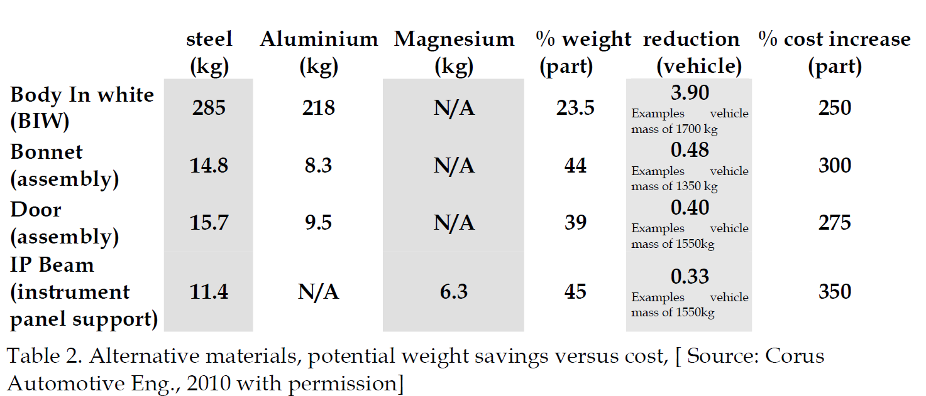
The table above shows the weight reduction and cost increase by replacing steel with aluminum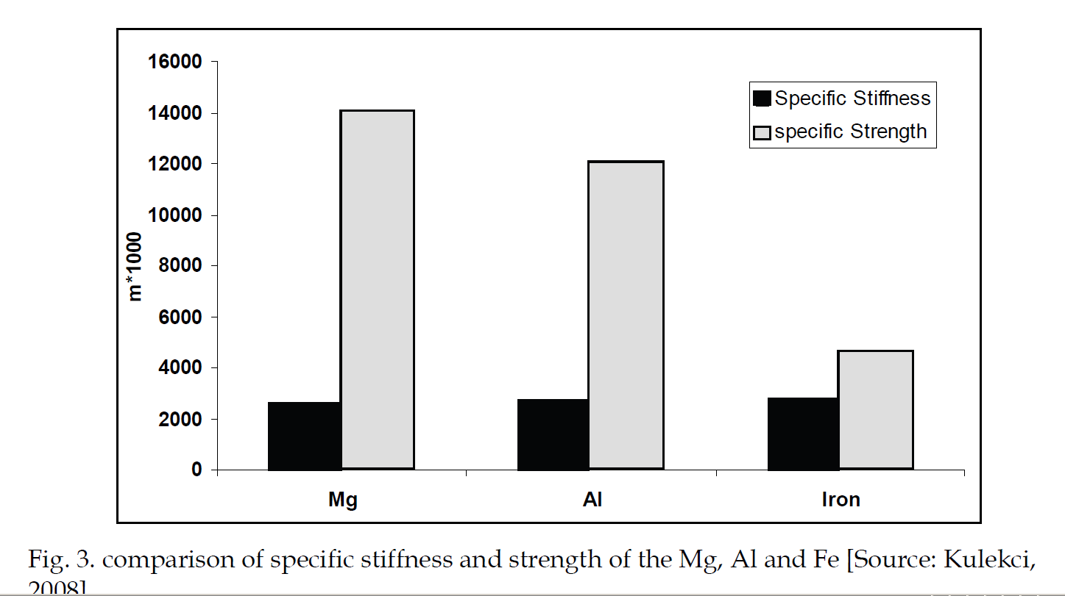
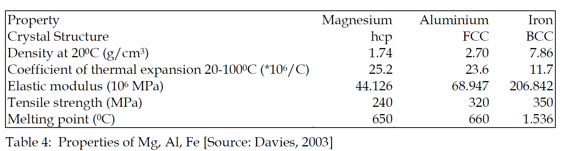

Compositions of aluminum alloys:
Typical Compositions of different 5xxx aluminum-magnesium alloy
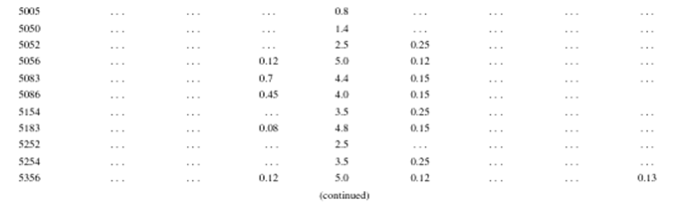
Typical compositions of different 6xxx aluminum-magnesium-silicon alloy
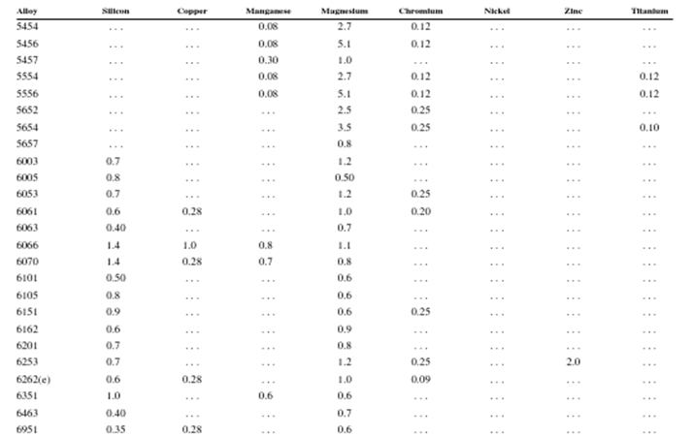
Aluminum alloy usage:
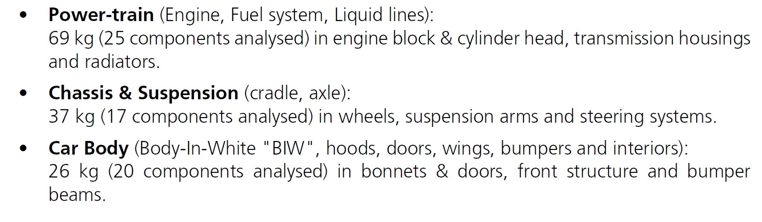
- aluminum tubes
- brake systems

