Self-Ventilating Building Skin
By Doris Kim Sung
Description:
Entire sheets of thermal bi-metal plates joined together such that there are holes that can open and close depending on temperature changes from sun light (simulates pores on skin). It could be constructed purely from metals or packaged within glass layers.
Pros: Does not require power to operate, can be used to block sunlight or ventilate air
Cons: Expensive, no manual control
Question: Would the metal material reflect or absorb a lot of heat from sunlight?
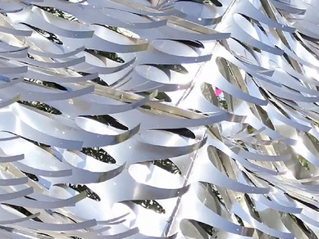

Adaptive Facade Mock-up
By Kai L Hansen
Description:
A simple double pane frit is altered by shifting only one pane with a shape memory alloy NanoMuscle (http://www.sparkfun.com/products/8782) in response to light values gathered by a single photocell.
Pros: Cheap, allows for programming different settings and manual control,
Cons: Requires power to operate, shape memory alloy needs to be put back to original position,
Question: would electric motors be more energy efficient than shape memory alloys?
