WebDAV

Obtain Utility ID (All Computers & Operating Systems)

Go to https://www.elearning.ubc.ca/plugin/index.cfm
The top of the page contains the Utility ID Account Form. Type your CWL and password and the operating system type. Click on the Submit button.

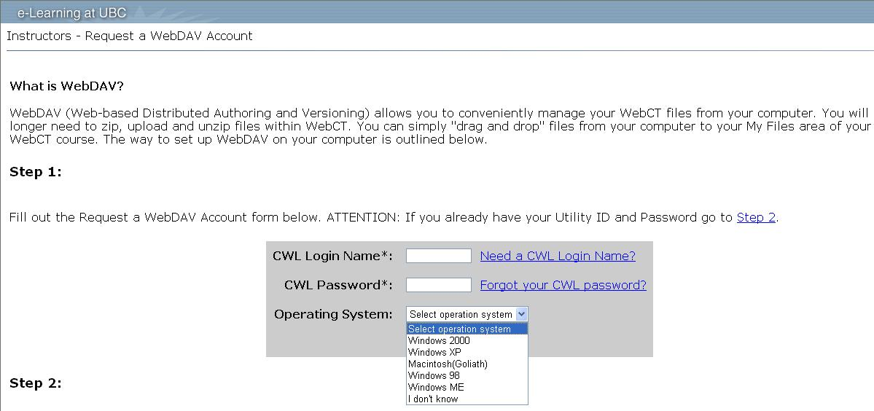

The Utility ID and password is immediately given.

Obtain The WebDAV Address/Link for the course

Log on to Vista. Click on the desired course in the myVista menu*. Click on the File Manager button under Designer Tools. Under the Action Link beside the File Manager Title, click on WebDAV info.

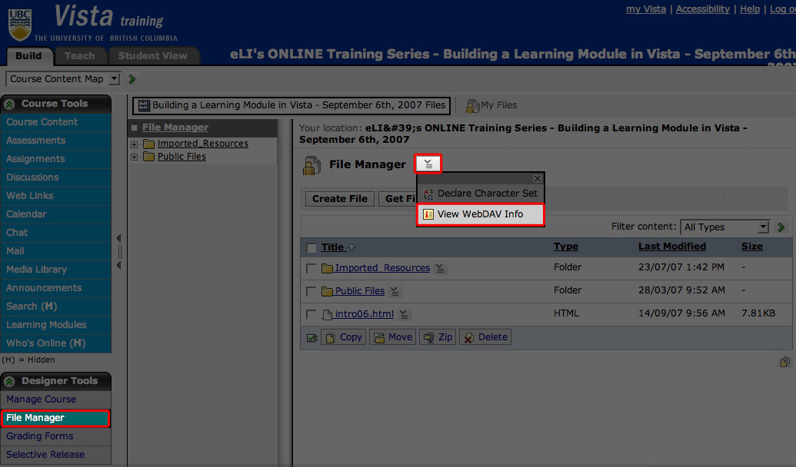

Copy the link provided in the pop-up window. This is the WebDAV link.

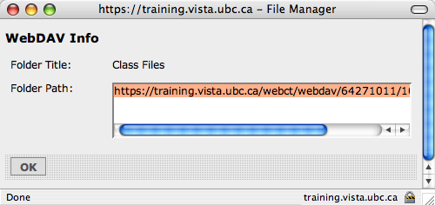

* you must have designer access to the course you wish to upload to.

Set Up WebDAV on Windows XP SP2 (PC)

Go to Start > My Network Places.

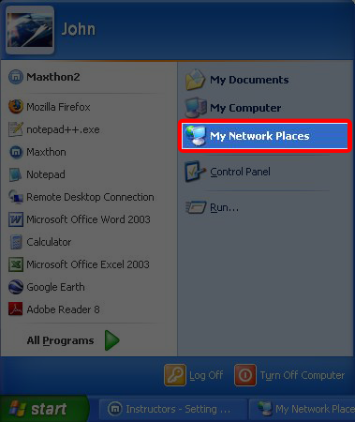

In the new window, click on Add a new network place. This will bring up the network wizard.

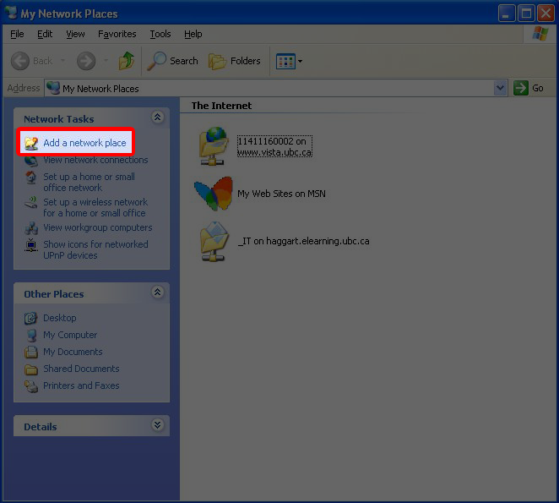

Click Next in the network wizard, then select Choose another Network Location and click Next.

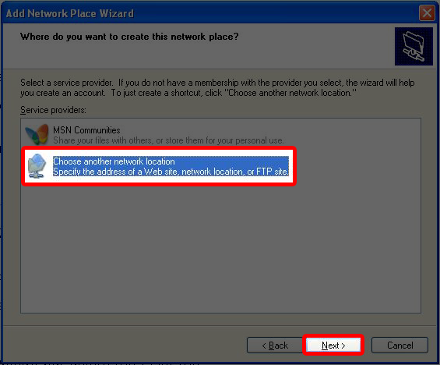

Paste the WebDAV link into the Internet or network address text box. Click Next.

Enter Utility ID and password. Click OK, then click Finish.

A drag and drop folder will be created in your My Network Places folder.

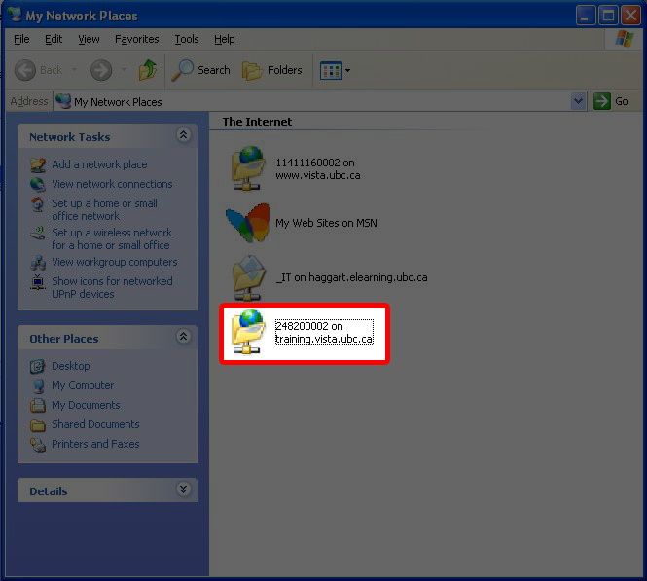

Set up WebDAV on OSX Tiger (MAC) from Finder

From the Finder click on Go > Connect to Server. Alternatively, press ⌘+K in finder.

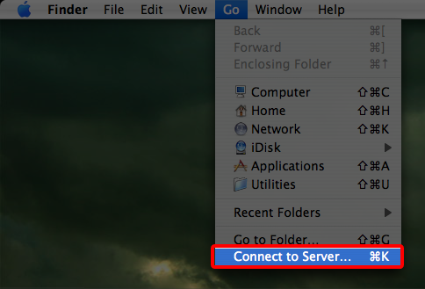

Under Server address, paste the WebDAV link. Click Connect.

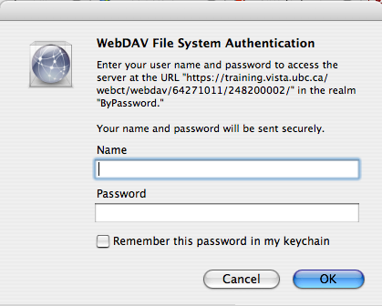

If the Verify Certificate message comes up, click Continue.

From the "Connect to" screen, type in your Utility ID and password. Click OK. A new network folder will appear on your desktop.

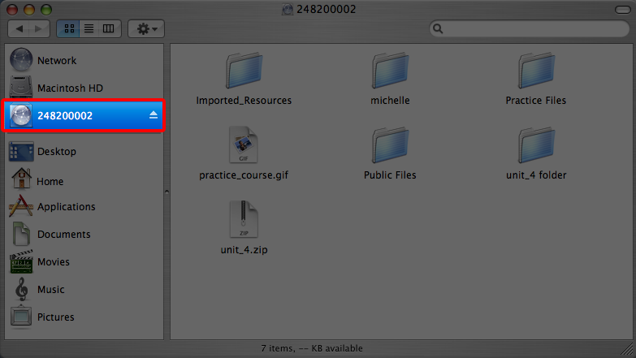

Set up WebDAV on Windows Vista (PC)

Go to www.microsoft.com/downloads/details.aspx?FamilyId=17C36612-632E-4C04-9382-987622ED1D64

In the following page, choose the appropriate download speed and click on the Download button.

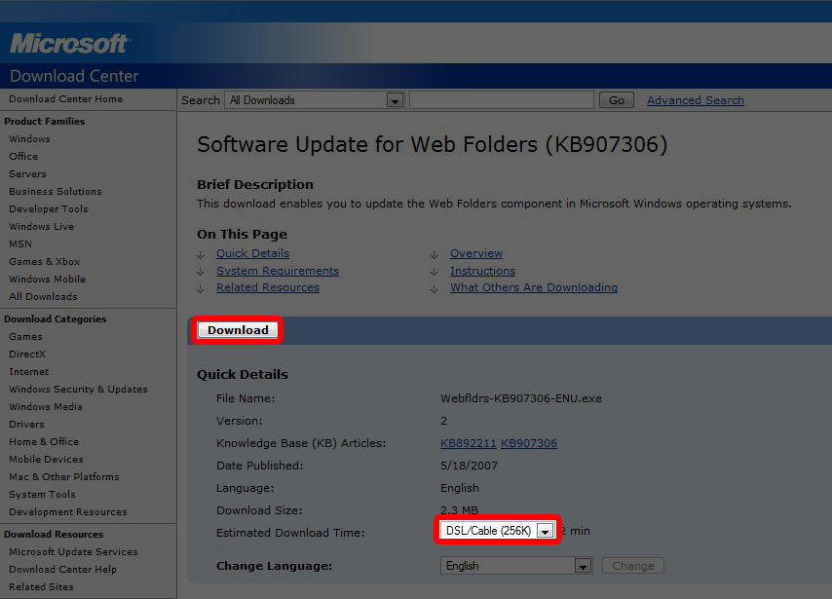

After downloading and installing the file, go to Start > Computer.

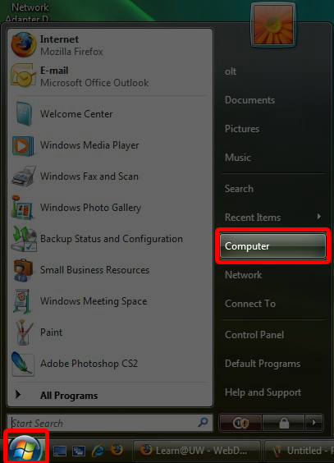

In the new window, click on Map network drive.

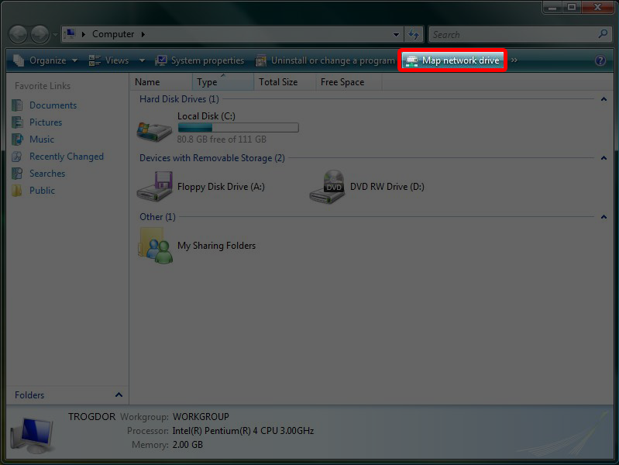

This leads to the network setup window. Click on Connect to a Web site you can use to store your document and pictures.

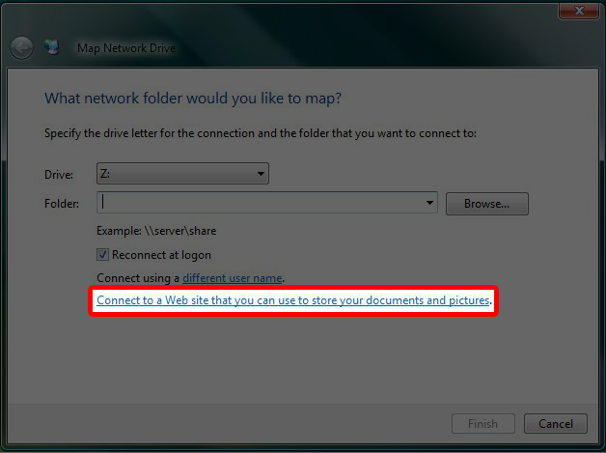

Click on Choose a custom network location and click Next.

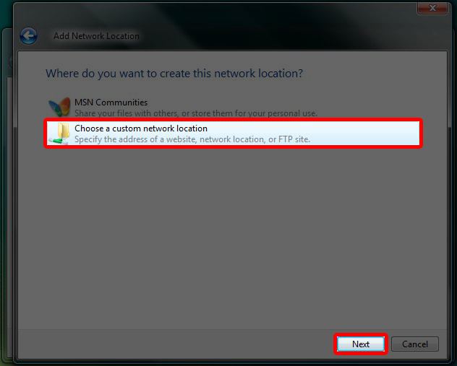

Under Internet or network address, put in the WebDAV URL then click Next. When prompted, enter your Utility ID and password and click OK.

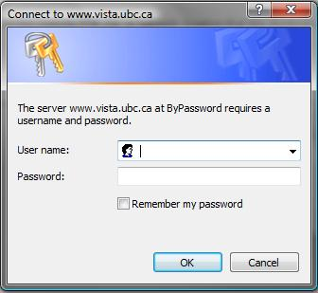

Type in a network name. This is to help you label the network to keep better track. Click Next when finished.

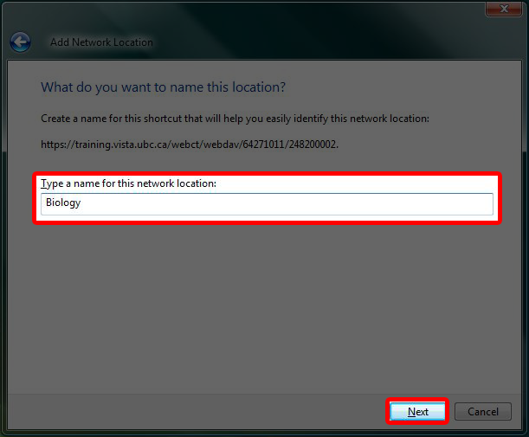

The network folder can be accessed from Start > Computer > Web Folders > Network Name.

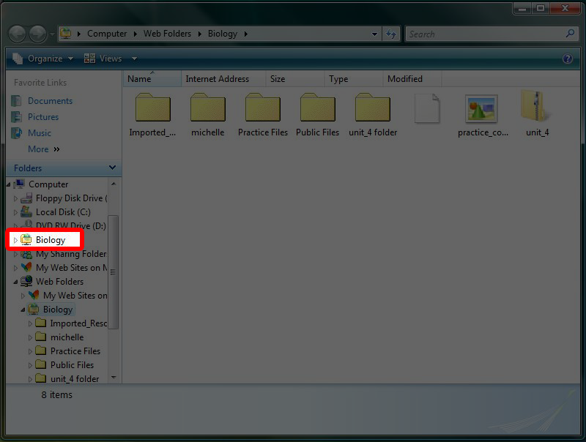

Set up WebDAV on Dreamweaver CS3

1. Open Dreamweaver CS3. Under the right hand bar, click on the Manage Sites link.
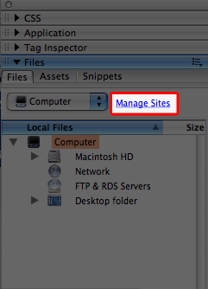

2. In the new window, click on New > Site. The Manage Sites window will pop up.

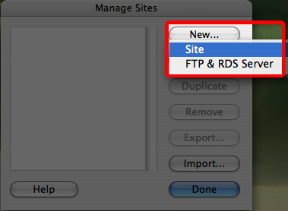

3. In the Manage Sites window, type in the name of the course under What would you like to name your site? then click Next.

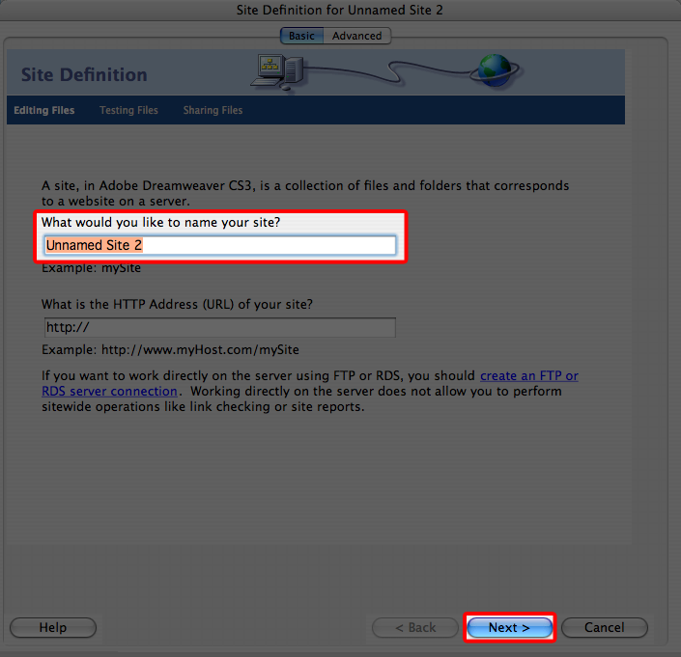

4. After selecting No, I don’t want to use a server technology, click Next. Click Next once more. (these options are defaulted…)

5. This leads to the sharing files window. Select WebDAV, type in the Utility ID and password under WebDAV login, and type in the WebDAV link in the What is the URL of your WebDAV server? field. Click Next.

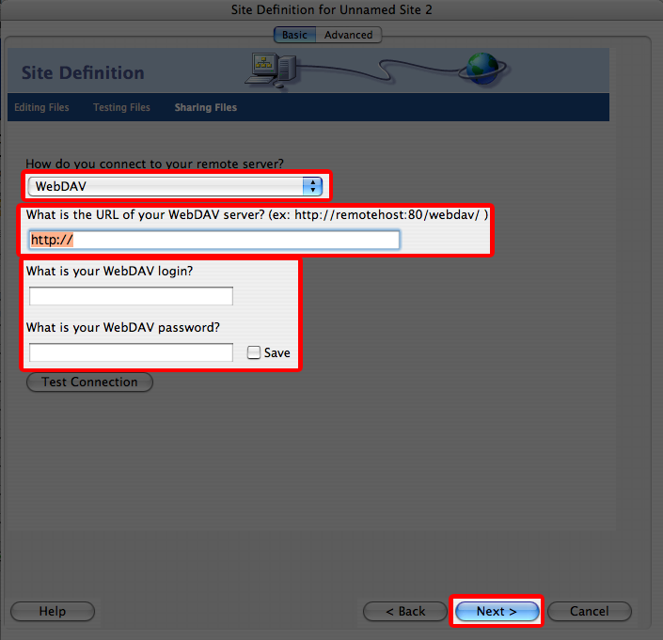

6. Click Next again, followed by the Done button. In the Manage Sites window, the added WebDAV course will be visible. Click Done in the Manage Sites window.

7. To access the newly added Webdav folder, select the folder in the right hand bar, then click Remote View to access the folder.

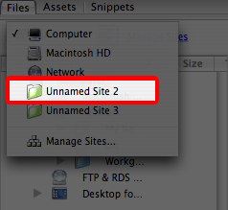

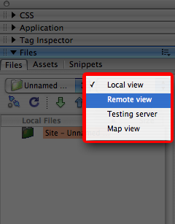

Note the following if you are using Adobe Dreamweaver CS3:

I'm using Adobe Dreamweaver CS3. When I try to make a WebDAV connection, I receive a connection fails and the message "Cannot display the remote folder: An HTTP WebDAV error occurred. Dreamweaver cannot get a listing for the folder you specified…….To try again, click the Refresh button in the Files panel." It worked with the previous version of Dreamweaver. Why doesn't it work now?

There is a fix that you will need to download from the Adobe website and apply to your computer. Follow the instructions for operating system on the WebDAV error when connecting to a server using Basic authentication for PROPFIND command page. URL: http://kb.adobe.com/selfservice/viewContent.do?externalId=kb402079&sliceId=1

Set up WebDAV on Windows XP/Vista with using IE only link in file manager

Open Internet Explorer
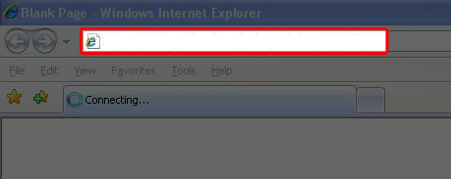

Paste the WebDAV address in the URL box.
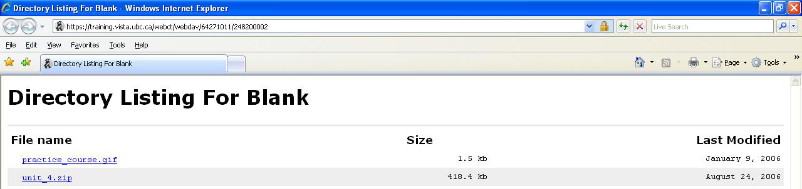

Enter the utility ID and password. Click OK. You will see a Directory listing, from which you can directly download files from.

