The first step in making an appointment is to create an account. Go to the WCOnline home page at https://ubcca.mywconline.com/ and choose the “Click here to register” option. You will come to a screen that looks like this:
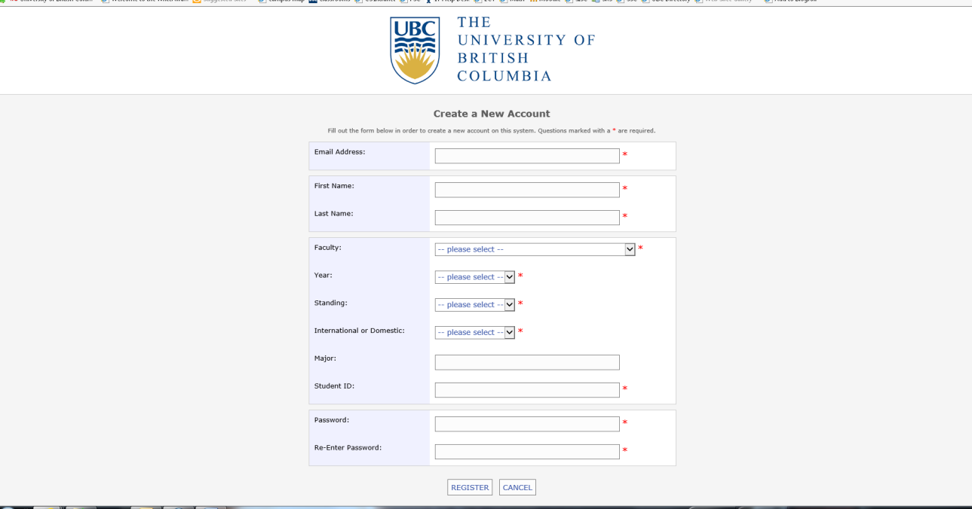
All fields marked with * are required. Once you have your account set up, you can sign in and access the calendar. When you go to the home page to log in, be sure that you have chosen the calendar corresponding to the service you wish to make an appointment with. The drop-down menu will allow you to choose:
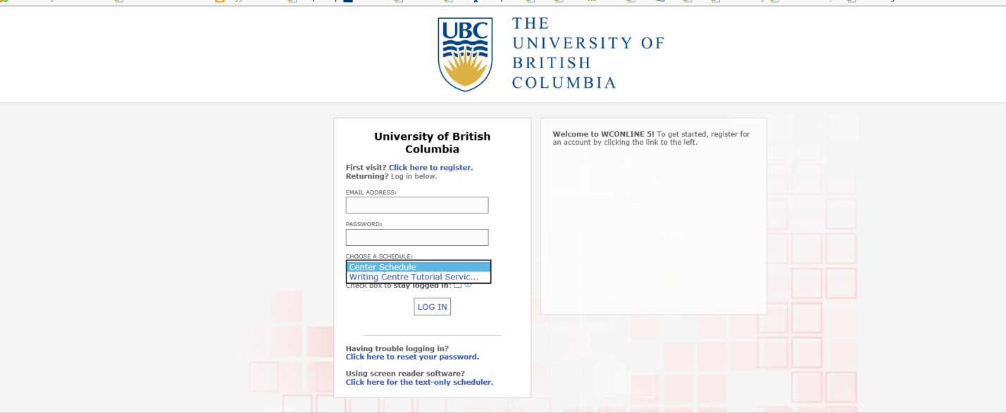

When you arrive at the calendar page, it will look something like this. The white space indicates available appointments, dark blue indicates times when tutors are unavailable, and light blue indicates appointments that are taken but have a waitlist.
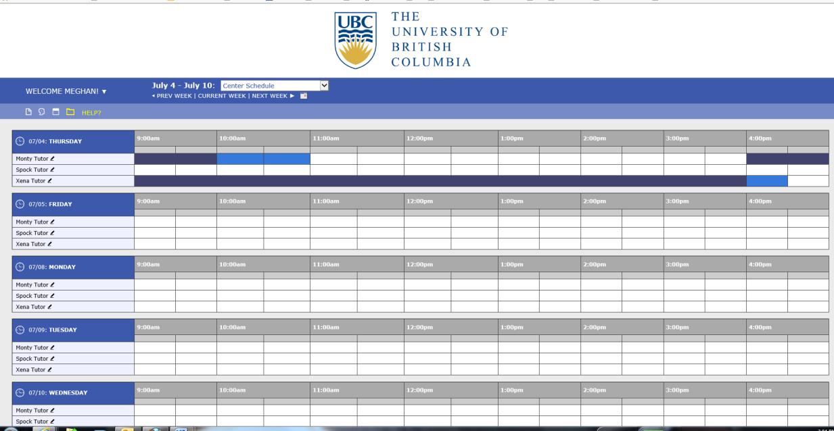

If you wish to book an appointment, click on the (open) time that suits you next to the name of the tutor you would like to book with. The tutor’s name and entire schedule for that day will be highlighted in red, and a pop-up window will appear as below, with information required for registration and information about the tutor:

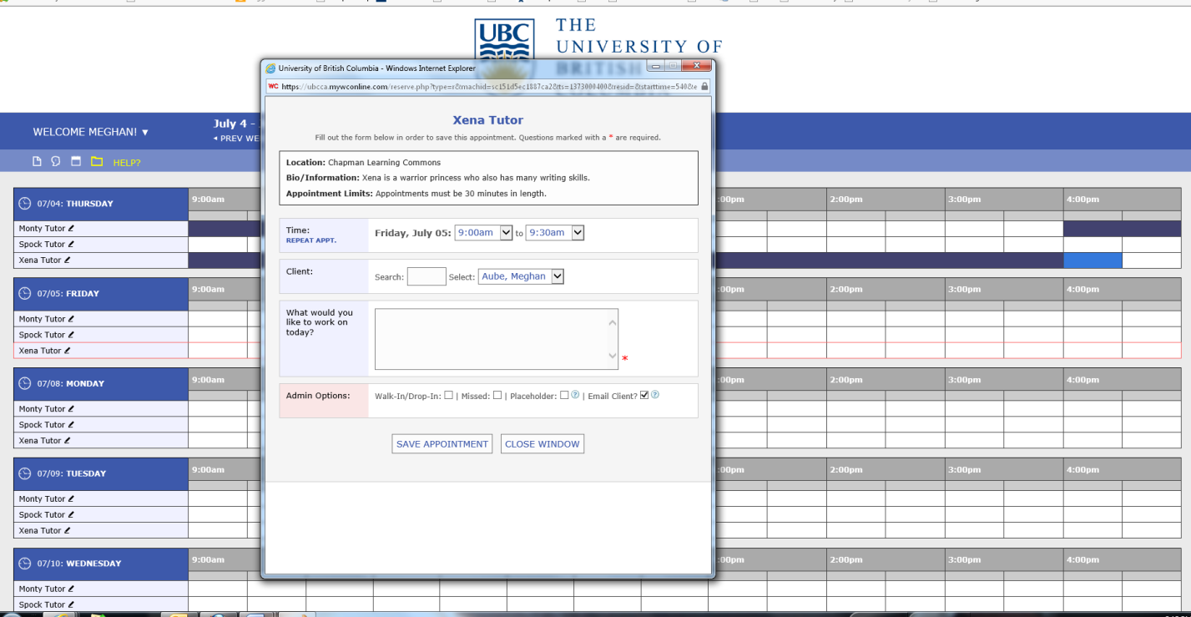
Fill in any required information (marked with an asterisk) and choose “Save Appointment”. Once you do so, your screen will look like this:
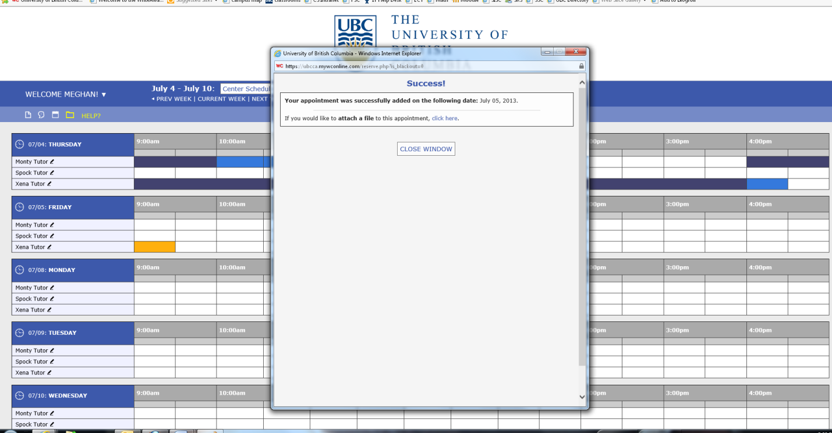
You will receive an e-mail notification immediately.
If you wish to cancel an appointment, click on the time slot that needs cancellation. Your appointment window will reappear. Simply click on “Cancel this Appointment” and confirm:
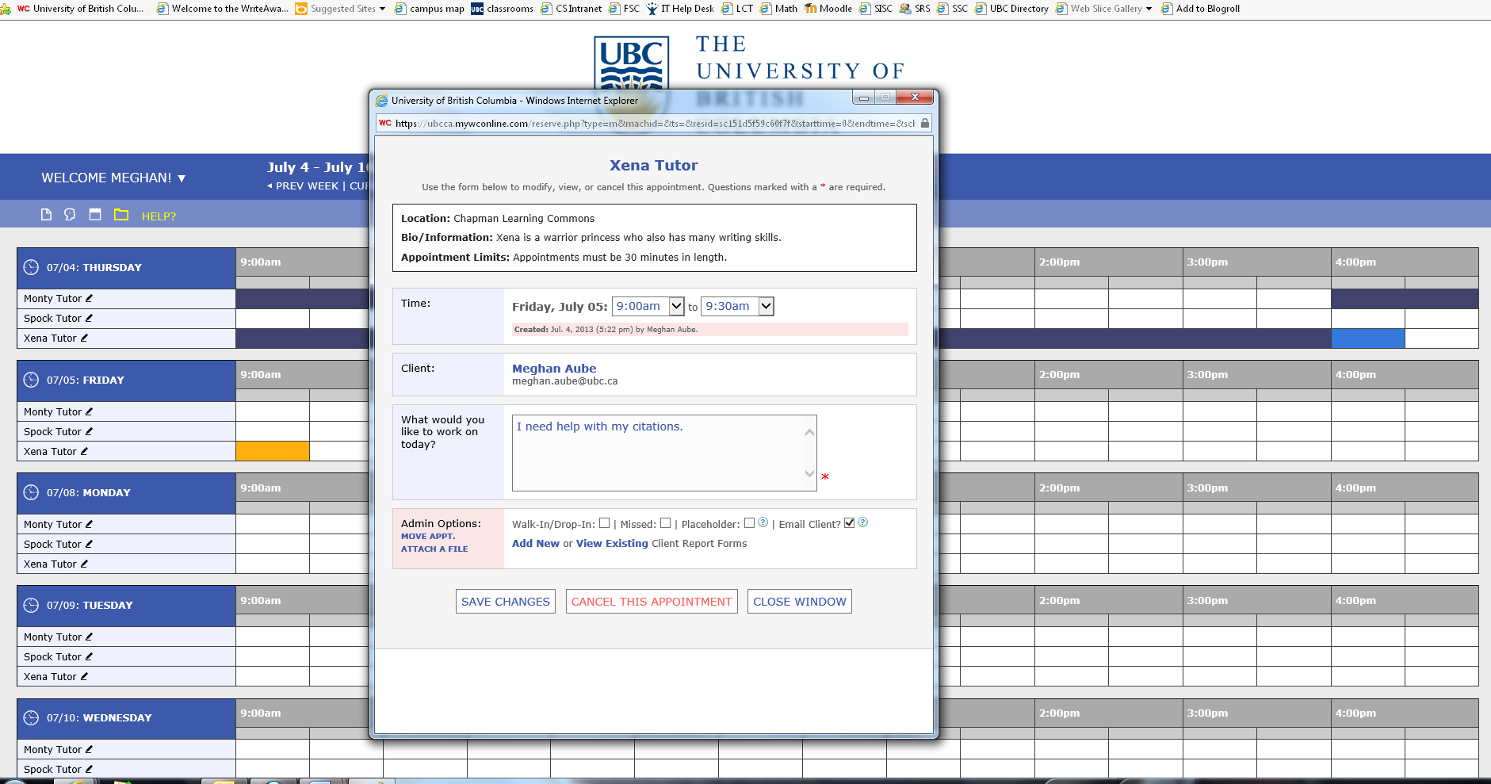
If you wish to add yourself to a waitlist for an appointment that has already been taken, click on the clock icon in the top left corner of the box that indicates day of the week. A new window will appear that offers all of the waitlist options available to you. If you do not want to receive a text message, you will receive an e-mail:
